**i-Factor Project**

**Business Requirement Specifications (BRS)**

**Table of Content**

内部资料

注意保密

Chapter 1 SME Application Process 1

1. SME registration 1

**1.1** **Function description** 1

**1.2** **Operation process** 1

**1.3** **Process description** 1

**1.4** **Business rules** 2

**1.5** **Inputs and outputs** 2

2. SME application 5

**2.1** **Function description** 5

**2.2** **Operation process** 5

**2.3** **Process description** 5

**2.4** **Business rules** 6

**2.5** **Inputs and outputs** 6

3. Completeness and correctness check 8

**3.1** **Function description** 8

**3.2** **Operation process** 9

**3.3** **Process description** 10

**3.4** **Business rules** 12

**3.5** **Inputs and outputs** 13

4. Check against blacklist 13

**4.1** **Function description** 13

**4.2** **Operation process** 14

**4.3** **Process description** 15

**4.4** **Business rules** 17

**4.5** **Inputs and outputs** 17

5. SME check from CIC 18

**5.1** **Function description** 18

**5.2** **Operation process** 18

**5.3** **Process description** 19

**5.4** **Business rules** 20

**5.5** **Inputs and outputs** 20

6. SME financial statement input and eligibility check 21

**6.1** **Function description** 21

**6.2** **Operation process** 21

**6.3** **Process description** 22

**6.4** **Business rules** 23

**6.5** **Inputs and outputs** 23

7. Apply rating 24

**7.1** **Function description** 24

**7.2** **Operation process** 24

**7.3** **Process description** 25

**7.4** **Business rules** 25

**7.5** **Inputs and outputs** 26

8. Field Visit 27

**8.1** **Function description** 27

**8.2** **Operation process** 27

**8.3** **Process description** 28

**8.4** **Business rules** 29

**8.5** **Inputs and outputs** 30

9. Document signing, verification of signed documents, bank account opening and auction function activation 30

**9.1** **Function description** 30

**9.2** **Operation process** 31

**9.3** **Process description** 32

**9.4** **Business rules** 34

**9.5** **Inputs and outputs** 35

Chapter 2 Investor Application Process 36

1. User registration and investor application 36

**1.1** **Function description** 36

**1.2** **Operation process** 36

**1.3** **Process description** 37

**1.4** **Business rules** 38

**1.5** **Inputs and outputs** 38

2. Completeness and correctness check 45

**2.1** **Function description** 45

**2.2** **Operation process** 45

**2.3** **Process description** 47

**2.4** **Business rules** 49

**2.5** **Inputs and outputs** 50

3. Checking against blacklist 51

**3.1** **Function description** 51

**3.2** **Operation process** 51

**3.3** **Process description** 52

**3.4** **Business rules** 53

**3.5** **Inputs and outputs** 54

4. Confirmation of the buyer’s identity 55

**4.1** **Function description** 55

**4.2** **Operation process** 55

**4.3** **Process description** 56

**4.4** **Business rules** 57

**4.5** **Inputs and outputs** 57

5. Documents signing, verification of signed documents, bank account opening and auction function activation 58

**5.1** **Function description** 58

**5.2** **Operation process** 59

**5.3** **Process description** 60

**5.4** **Business rules** 61

**5.5** **Inputs and outputs** 62

Chapter 3 Invoice Delivery Process 63

1. Invoice Delivery 63

**1.1** **Phase 1** 63

1.1.1 Function Description 63

1.1.2 Operation Process 64

1.1.3 Process Description 66

1.1.4 Business Rules 72

1.1.5 Inputs and Outputs 72

**1.2** **Phase 2** 73

1.2.1 Function Description 73

1.2.2 Operation Process 73

1.2.3 Process Description 74

1.2.4 Business Rules 76

1.2.5 Inputs and Outputs 76

Chapter 4 Auction Process 77

1 Auction for VPBank 77

**1.** **Function description** 77

**2.** **Operation Process** 78

**3.** **Process description** 79

**4.** **Business rules** 82

**5.** **Inputs and outputs** 82

2 Auction for investors 82

**1.** **Function description** 82

**2.** **Operation Process** 83

**3.** **Process description** 83

**4.** **Business rules** 89

**5.** **Inputs and outputs** 89

Chapter 5 Reporting 90

1 Functional Description 90

2 Operation process 90

3 Process description 90

**4.1** **Invoices report** 91

4.1.1 Report List 91

4.1.2 Description 92

**4.2** **Disbursement report** 95

4.2.1 Report List 95

4.2.2 Description 95

4.2.3 Template report 96

**4.3** **In-auction invoice report** 96

4.3.1 Report List 96

4.3.2 Description 96

4.3.3 Report Template 96

**4.4** **Settle invoice report** 97

4.4.1 Report List 97

4.4.2 Description 97

4.4.3 Report Template 98

**4.5** **Overdue report** 98

4.5.1 Report List 98

4.5.2 Description 98

4.5.3 Report Template 99

**4.6** **Debtor report** 100

4.6.1 Report List 100

4.6.2 Description 101

4.6.3 Report Template 102

**4.7** **Seller report** 103

4.7.1 Report List 103

4.7.2 Description 104

4.7.3 Report Template 104

**4.8** **Buyer report** 106

4.8.1 Report List 106

4.8.2 Description 107

4.8.3 Report Template 107

4 Business rules 109

5 Inputs and Outputs 110

6 Other template report 111

Chapter 6 Payment Process for VPB buyer 1

1. Function description 1

2. Operation process 2

3. Process description 5

4. Business rules 7

5. Inputs and Outputs 7

Chapter 7 Payment Process for Investor Buyer 8

1. Function description 8

2. Operation process 8

3. Process description 15

4. Business rules 18

5. Inputs and Outputs 18

Chapter 8 Payment Process for Debtor 19

1. Reminding phase 19

**1.1** **Function description** 19

**1.2** **Operation process** 19

**1.3** **Process description** 19

**1.4** **Business rules** 20

**1.5** **Inputs and Outputs** 20

2. Settlement phase 20

**2.1** **Function description** 20

**2.2** **Operation Process** 20

**2.3** **Process description** 21

**2.4** **Business rules** 21

**2.5** **Inputs and Outputs** 22

3. Collection Management process 22

**3.1** **Function description** 22

**3.2** **Operation process** 22

**3.3** **Process description** 23

**3.4** **Business rules** 24

**3.5** **Inputs and Outputs** 24

# **requirement change records**

Deatil as below，



# **Chapter 1 SME Application Process**

1. **SME registration** 
   1. **Function description**

If SME would like to become registered SME of i-Factor platform, they are required to fill in the registration form. After finish the registration form, the system will automatically send an activation email to the SME’s registered email address. After activating the account, SME can log in and start filling in the application form.

* 1. **Operation process**

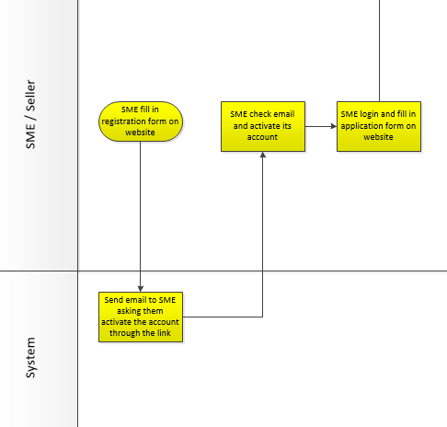

* 1. **Process description**

1. SME open registration UI
2. SME click on “Become a seller” on main website.
3. Legal disclaimer will pop-up on the window automatically, if SME click “Accept”, then SME is allowed to fill in registration form.
4. SME fill in registration form, if any error input occurs, (e.g. passwords not matched, email not correct…), then the screen will show in red the error immediately to ask SME to modify the incorrect information. The detail of the data fields, please refer to Inputs and Outputs below.
5. After SME finish registration form, click on “Register”, the system should be able to send an automatic email with the activation link to SME registered email address. For the email content, please refer to Inputs and Outputs.
6. SME open email to activate account
7. SME click on the activation link in the email to activate the account.
8. After clicking on that link, SME should be brought to login UI on website.
   1. **Business rules**
9. SME must activate the account using the link in the email sent by the system before login.
10. The information inputted in the registration form will be captured in the application stage and cannot be modified until the application is successful. After become successful seller, SME can manage their account information.
11. The username should be unique thus we suggest that email address of SME should be used as the username.
12. Whether the registration/application is successful or not, they will be logged. The log will be found in the server internal management system.
    1. **Inputs and outputs**
13. Homepage UI



1. Pop-up legal disclaimer UI

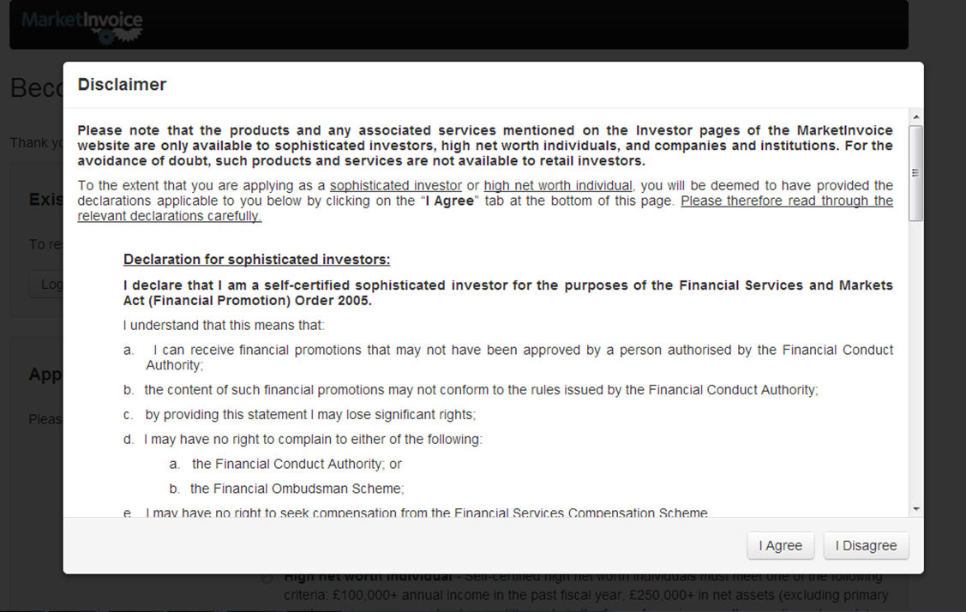

1. Registration UI

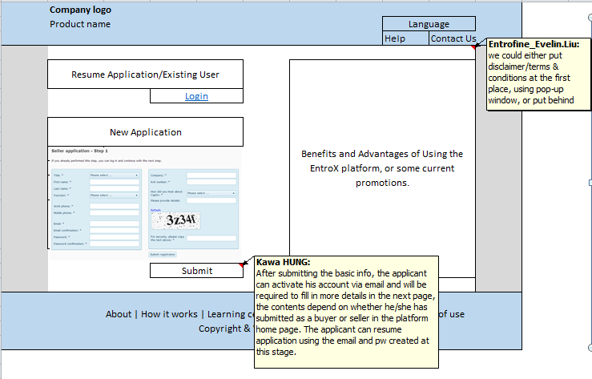

1. Registration form

|  |  |  |  |  |  |  |
| --- | --- | --- | --- | --- | --- | --- |
| **No.** | **Data field name** | **Mandatory** | **Input/output** | **Missing value** | **Type/length** | **Remark** |
| 1 | Title | * | drop down list: Mr, Mrs, Ms, Miss, Undefined (TBD) |  |  |  |
| 2 | First Name | * | Text box |  |  |  |
| 3 | Last Name | * | Text box |  |  |  |
| 4 | Gender |  | Text box |  |  |  |
| 5 | DOB |  | Text box |  |  |  |
| 6 | Country | * | Text box |  |  |  |
| 7 | ID type | * | drop down list: domestic ID card, passport |  |  |  |
| 8 | ID number | * | Text box |  |  |  |
| 9 | Work Phone | * | Text box |  |  |  |
| 10 | Mobile Phone | * | Text box |  |  |  |
| 11 | Position | * | Text box |  |  |  |
| 12 | Email | * | Text box |  |  |  |
| 13 | Confirm Email | * | Text box |  |  |  |
| 14 | Password | * | Password box |  | on the page | Your password must be at least 8 characters long and include 1 or more non-alphabetic characters (symbols or numbers). |
| 15 | Confirm Password | * | Password box |  |  | error msg |
| 16 | Company Name | * | Text box |  | on the page | must be exact the same name as what is stated in company license document |
| 17 | Company Registration Number | * | Text box |  |  |  |
| 18 | Company Tax Code | * | Text box |  |  |  |
| 19 | How did you hear about us? | * | drop down list: TBD |  |  |  |
| 20 | Through other channels to hear about us, please provide details |  | Text box |  |  |  |

1. Email activation UI

Paste email content UI

|  |  |  |  |  |  |  |
| --- | --- | --- | --- | --- | --- | --- |
| **No.** | **Data field name** | **Mandatory** | **Input/output** | **Missing value** | **Type/length** | **Remark** |
| 1 |  |  |  |  |  |  |
| 2 |  |  |  |  |  |  |
| 3 |  |  |  |  |  |  |

1. **SME application**
2. **Function description**

After SME activate their account, SME is brought to log in page and start filling seller application form and upload all the necessary documents.

1. **Operation process**



1. **Process description**
2. SME open login UI

***Option 1: 1st SME application login***

1. SME is brought to log in UI after they click the account activation link in its email
2. SME input username and password to log in its account and start filling seller application form

***Option 2: existing SME application login***

1. SME either click on “login” on website homepage or click on “resume application/existing user” on registration UI
2. SME fill in seller application form
3. SME fill in seller application form on website, system will lock the personal basic information which captured from registration form. The details of data field refer to excel “SME data field”. Detail as below,



1. If any errors occur (mandatory fields not filled, documents not uploaded…) the screen should show the error in red in order for the investor to modify the incorrect information.
2. All the data fields are grouped under relevant category. SME could either click on “save” or “next” to pause/continue to fill in the application form (SME is allowed to save whatever they have filled in this stage and log in later to finish the application).
3. If SME do not finish the application in one sitting, the application status should be “To be submitted”. SME click on “Save as draft” to save the application and click on “Log out” to close application filling and should be brought back to login webpage. If the SME do not finish the application within 60 days, the system should automatically drop it.
4. SME upload all required documents one by one. For each requirement of document uploading, SME should click on “Browse” to select the document and click on “Upload” to upload into the system .
5. After filling and uploading, there should be a summary screen.
6. SME double check, if there is anything wrong, click “edit” to modify.
7. After checking all the information, SME tick one box of “I have confirmed all the above information is correct”.
8. SME click on “Submit”, the system will automatically pop up a window saying that “Your application has been successfully submitted”.
9. After SME click on “Submit”, the application should be automatically sent to the underwriting team for reviewing.
10. SME should receive the email/SMS after The SME has completed their application and the application was approved.
11. **Business rules**
12. The key information of name, email address and password inputted in the registration form will be captured in the application stage and cannot be modified until the application is successful. After become successful seller, SME can manage their account information.
13. If the investor do not finish filling in the application after 60 days, the application should be dropped automatically by the system.
14. Whether the registration/application is successful or not, they will be logged. The log will be found in the server internal management system.
15. **Inputs and outputs**
16. Homepage UI



1. Registration UI



1. SME application form UI

Paste the updated form here

1. Documents required

Paste the updated list here

1. Confirmation page

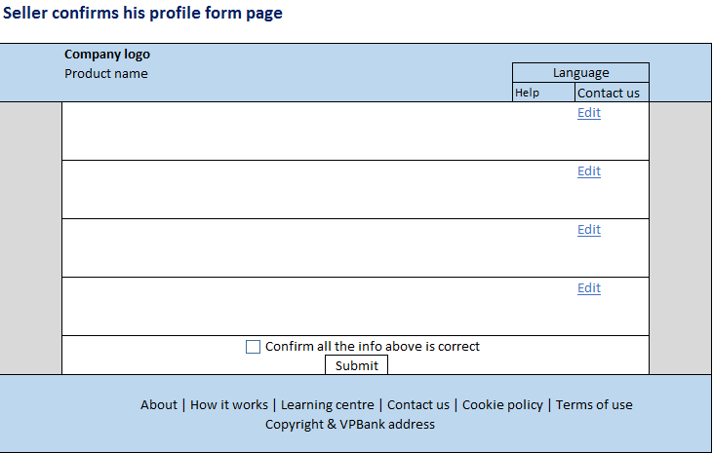

1. Email content UI

Paste email content UI

|  |  |  |  |  |  |  |
| --- | --- | --- | --- | --- | --- | --- |
| **No.** | **Data field name** | **Mandatory** | **Input/output** | **Missing value** | **Type/length** | **Remark** |
| 1 |  |  |  |  |  |  |
| 2 |  |  |  |  |  |  |
| 3 |  |  |  |  |  |  |

1. **Completeness and correctness check**
   1. **Function description**

After the SME fill in the application online, it is checked for completeness and correctness. The underwriting perform the first round checking. The approval team perform the second round checking.

* 1. **Operation process**

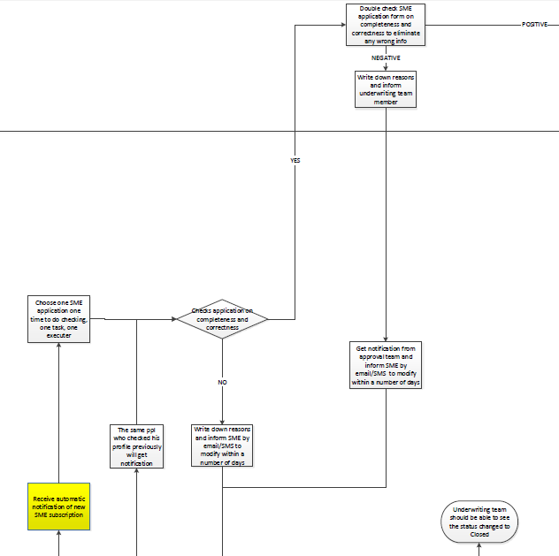

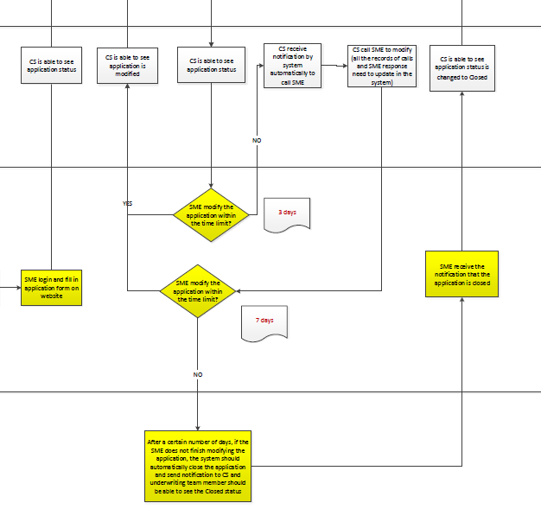



* 1. **Process description**

1. i-Factor underwriting team members receive automatic notification of new SME application
2. After the SME finish the application form and click “Submit”, the application should be saved and submitted to the i-Factor underwriting team member to check and verify.
3. The underwriting team receive an automatic notification of new SME application submitted.
4. The application status should be “Pending for completeness and correctness check”. CS should be able to see this status.
5. Check application completeness and correctness
6. One underwriting team member select one application at a time to perform the completeness and correctness check.
7. All underwriting team members should be able to see how many new applications there are and which ones are pending for checking.
8. The screen should show the application form and the documents uploaded side-by-side for the underwriting team member to check easily.
9. There should be a box next to each data field for the underwriting team member to tick in case the data is complete and correct. If not, leave the box un-ticked.
10. If the application is complete and all the information is correct, the underwriting team member should be able to “Save” the application and “Submit” to approval team for the approval team to double check. The application status should be “Passed by underwriting team”. Go to step 8.
11. If the application is not complete or any information is incorrect, go to step 3.
12. Write down reasons and inform the SME
13. If any information is missing or incorrect, there should be a box for the underwriting team member to write down the reason. There should be a button called “Require SME modification” for the verification to click on.
14. After the underwriting team click the “Require SME modification” button, the investor should be informed by SMS/email to modify the application online. The application status should be “Pending for SME to modify”.

Paste the SMS/email format, contents here.

1. The CS team should also be able to see the status changed and the reason.
2. SME modify within the time limit (3 days)?
3. After 3 days, if the SME do not modify the application as requested, the application status should change automatically to “Pending for CS to contact”.
4. The system should automatically send a notification to the CS to contact the SME for modification.
5. The CS team member should contact the SME on the phone to require them to modify the application. The application status should be “Contacted by CS”.
6. If the SME finish modifying within the time limit, go to step 6C.
7. SME modify within the time limit (7 days) after get contacted by CS?
8. After get contacted by CS, after 7 days, if the SME do not finish modifying the application, the system should be able to automatically close the application and send notification to the SME.
9. The status should change to “Application closed”.
10. If the SME finish modifying within the time limit, go to step 6C.
11. SME modify the application
12. After get informed by SMS/email and/or CS, the SME should be able to log in to modify the application.
13. The screen should only show the data fields that require modification (the data fields whose boxes are left unticked in the checking process), correct data fields should be locked.
14. After finishing the modification, the SME should click on “Submit” to send the application to the underwriting team member who checked the application previously. The application status should be “Modified by SME”.
15. If the SME do not modify the application after a 7 days the application should automatically be rejected.
16. Check application completeness and correctness again
17. After receiving the modified application, the underwriting team member should check the modified information.
18. The modified information should be highlighted.
19. The relevant documents should be put side-by-side with the application form to allow the underwriting team member to check easily.
20. If the application is complete and all the information is correct, the underwriting team member should be able to “Save” the application and “Submit to approval team” for the approval team to double check. The application status should be “Passed by underwriting team”. Go to step 8.
21. If the information is not complete or correct, go back to step 3.
22. Double check application completeness and correctness
23. The approval team member receive the applications submitted from the team member for double checking.
24. The screen should show the application form and the documents uploaded side-by-side for the underwriting team leader to check easily.
25. The should be a box next to each data field for the approval team member to tick in case the data is complete and correct. If not, leave the box un-ticked.
26. If the double gives negative result, go to step 9. If the check gives positive result, the application will be passed on to check for validity of business license and against blacklists.
27. Write down reasons and inform underwriting team member
28. If any information is missing or incorrect, there should be a box for the underwriting team member to write down the reason.
29. There should be a button called “Send to underwriting team” to allow the approval team member to inform the underwriting team member to contact the SME to modify the application.
30. Get notification and send SMS/email to the SME
31. The underwriting team member should be able to receive the following message from the approval team:

Paste the message contents here.

1. There should be a button called “Inform the SME” for the underwriting team member to click on to inform the SME by SMS/email to modify the application online.

Paste the SMS/email format, contents here.

1. The process goes back to step 4 above until the application is complete.
   1. **Business rules**
2. The CS should only contact the SME to modify the application after a 3 days. The application will be automatically dropped if left unmodified after 7 days from the day that CS contact the SME.
3. The email notifying the SME of modification requirement should include the data fields which need to be modified.
4. The application form should only show data fields which require modification, the correct data fields should be locked by the system.
5. The SME should be able to save during the modification stage.
6. Only underwriting team an receive notification of new application subscription.

* Underwriting team, approval team and CS team always can see the application status updates anytime.
* Only underwriting and approval team have rights to update verification status of the application.
* I-factor CS can see the status updated by underwriting and approval team all the time, but only have rights to update the contact result of the application, no rights to update verification status.

1. The members in the i-Factor approval team has the right to distribute the work responsible by a i-Factor underwriting team member to another i-Factor underwriting team member, in case the underwriting team member cannot continue with his/her work for various reasons (this function should be allowed to be turned off in case the bank does not allow it)
   1. **Inputs and outputs**
2. Underwriting team member completeness and correctness check UI
3. Underwriting team group leader completeness and correctness check UI
4. CS get notification and application status update UI
5. **Check against blacklist**
   1. **Function description**

After the application passed the completeness and correctness check, it should be passed on for the license validity check and blacklist checks.

* 1. **Operation process**

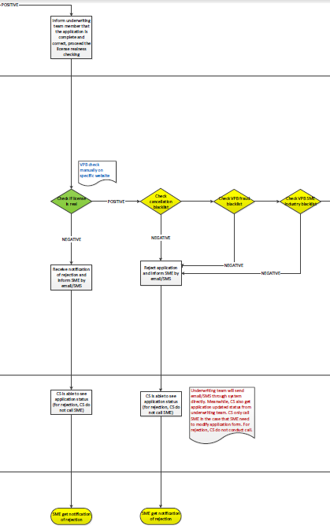



* 1. **Process description**

1. Check validity of business registration license
2. After the application pass the completeness and correctness double check by the approval team, the approval team member should be able to “Save” the application, inform the underwriting team member of the status changed and to perform the license validity check. The status should be “Pending for license validity check”.

Paste the notification contents here.

1. The check is performed outside of i-Factor but the application should be updated to “Passed license validity check” in order to move on the blacklist checks. If the license validity check fails, the application should be rejected.
2. Check cancellation blacklist
3. After the application pass the license validity check, there should be a button called “Check cancellation blacklist” for the underwriting team member to click on.
4. The system send back a message according to the result of the check.
5. If the result is positive: “The applicant is not in cancellation blacklist” and there should be a button called “Check fraud blacklist” for the underwriting team member to click on to move on to check fraud blacklist. The application status should be “Passed cancellation blacklist check”.
6. If the result is negative: “The applicant is in the cancellation blacklist” and there should be a button called “Reject” for the underwriting team member to reject the application.
7. Check fraud blacklist
8. The underwriting team member click on “Check fraud blacklist” (if the result of cancellation blacklist check is positive).
9. The system send back a message according to the result of the check.
10. If the result is positive: “The applicant is not in fraud blacklist” and there should be a button called “Check industry blacklist” for the underwriting team member to click on to check industry blacklist. The application status should be “Passed fraud blacklist”.
11. If the result is negative: “The applicant is in the fraud blacklist” and there should be a button called “Reject” for the underwriting team member to reject the application.
12. Check industry blacklist
13. The underwriting team member click on “Check industry blacklist” (if the result of fraud blacklist check is positive).
14. The system send back a message according to the result of the check.
15. If the result is positive: “The applicant is not in industry blacklist” and there should be a button called “Input CIC data” for the underwriting team member to click on to move on to CIC data inputting. The application status should be “Pending for CIC data”.
16. If the result is negative: “The applicant is in the industry blacklist” and there should be a button called “Reject” for the underwriting team member to reject the application.
17. Reject application
18. If the either of the license validity or blacklist checks give negative results, the underwriting team member click on “Reject” to reject the application. The application status should be “Application rejected”.
19. The system should be able to interface with VPBank’s SMS and email systems to send automatic SMS/email to the investor to inform rejection

Paste the SMS/email format, contents here.

1. The CS team should be able to see the status changed
   1. **Business rules**
2. Underwriting team, approval team and CS team always can see the application status updates anytime.
3. Only underwriting and approval team have rights to update verification status of the application.
4. I-factor CS can see the status updated by underwriting and approval team all the time, but only have rights to update the contact result of the application, no rights to update verification status.
5. The underwriting team member can only:

* move on to cancellation blacklist check should the result of the license validity check is positive and;
* move on to the fraud blacklist check should the result of the cancellation blacklist check is positive and;
* move on the industry blacklist check should the result of the fraud blacklist check is positive.

1. The members in the i-Factor approval team has the right to distribute the work responsible by a i-Factor underwriting team member to another i-Factor underwriting team member, in case the underwriting team member cannot continue with his/her work for various reasons (this function should be allowed to be turned off in case the bank does not allow it)
   1. **Inputs and outputs**
2. System blacklist check UI
3. Underwriting team member get notification and application status update UI
4. CS application status update UI
5. **SME check from CIC**
   1. **Function description**

After the application passes the blacklist checks, the underwriting team member perform the CIC data check. This is done outside of the system. After underwriting team member get the data from CIC, they will manually input the data into i-Factor. Part of the data will be used for the KO factor checking, the other part is used for rating.

* 1. **Operation process**

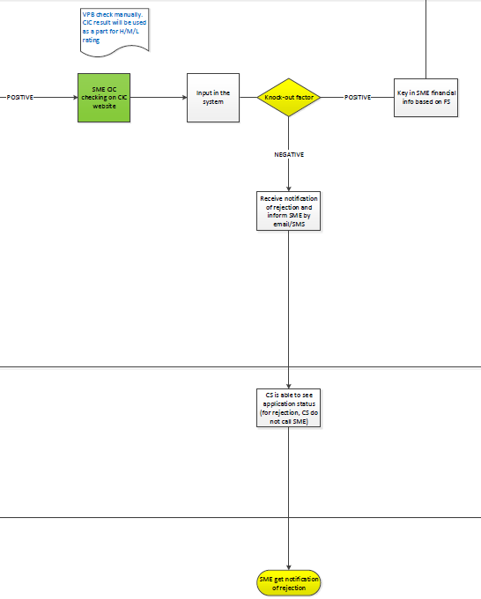



* 1. **Process description**

1. CIC data checking on CIC website
2. This is performed outside the system
3. Input the CIC data into the system
4. The underwriting team member input the CIC data into i-Factor. The data details are as followed:
5. For KO checking:

|  |  |
| --- | --- |
|  | Question |
| KO 1 | Do customers have bad debts (group 3-5) within the last 12 months? |
| KO 2 | Do customers have group 2 debts at the time of documents’ submission? |
| KO 3 | How many times (how many months) do customers incur debts in group 2 within the last 12 months? |

1. For rating:

|  |  |
| --- | --- |
|  | Question |
| 1 | How many financial institutions is the customer currently having loans with? (by CIC report) |

1. If no CIC information found, the underwriting team member should be able to select “No CIC information found”. The KO factor check will in this case be skipped.
2. KO factor application
3. After the underwriting team member input the data into the system, they should be able to initiate the KO factor check.
4. The KO factor check is performed by the system. The details are as followed:

|  |  |  |  |  |
| --- | --- | --- | --- | --- |
|  | Question | Answer | Answer respondent to KO Qs | Evidence |
| KO 1 | Do customers have bad debts (group 3-5) within the last 12 months? | Yes/ No | No | Summarized by CIC |
| KO 2 | Do customers have group 2 debts at the time of documents’ submission? | Yes/ No | No | Summarized by CIC |
| KO 3 | How many times (how many months) do customers incur debts in group 2 within the last 12 months? | State the frequency (0, 1…) | 0, 1 | Based on the 12-month report of CIC  Calculated based on the number of months that customers have incurred debts in group 2 |

1. If any of the KO factors is not satisfied (‘Yes’ for KO1 and KO2,’ >=2’ for KO3), the application should be rejected.
2. The underwriting team member should be able to see the result: “The application does not pass the KO factors check”. There should be a “Reject” button for the underwriting team member to click on to reject the application and at the same time, inform the SME the rejection in the form of SMS and/or email.

Paste the SMS/email contents here.

1. If the result of the KO factor check is positive (all questions passed), the underwriting team member will move on the next step where they have to key in the FS details into i-Factor.
   1. **Business rules**
2. The application must pass all the KO factors in order to move on to the eligibility check. If either of the KO factor is not passed, the application must be rejected.
3. Underwriting team, approval team and CS team always can see the application status updates anytime.
4. Only underwriting and approval team have rights to update verification status of the application.
5. I-factor CS can see the status updated by underwriting and approval team all the time, but only have rights to update the contact result of the application, no rights to update verification status.
6. The members in the i-Factor approval team has the right to distribute the work responsible by a i-Factor underwriting team member to another i-Factor underwriting team member, in case the underwriting team member cannot continue with his/her work for various reasons (this function should be allowed to be turned off in case the bank does not allow it)
   1. **Inputs and outputs**
7. **SME financial statement input and eligibility check**
   1. **Function description**

After the KO factors check, if the result is positive, the underwriting team member should be able to key in the FS details into the system. After the FS details is double checked by the approval team, the system should then perform the eligibility check. Eligibility check includes checking the establishment period of the SME (no less than 2 years).

* 1. **Operation process**

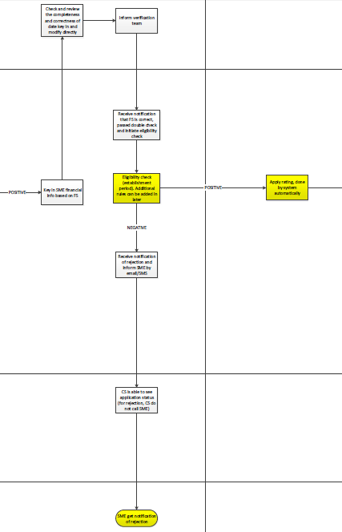



* 1. **Process description**

1. Key in SME financial information based on FS
2. If the result of the KO factors check is positive, the underwriting team member should be able to select “Key in financial details” and key in financial statement details.
3. The data fields should be the same as the FS standard template.



1. After filling the FS details , the underwriting team member select the type of SME : SME or MME, system should be provide 2 type to choice.
2. After filling the FS details, the underwriting team member should be able to “Submit to team leader” for reviewing completeness and correctness.
3. Review FS details for completeness and correctness and modify directly
4. The approval team should be able to receive the FS details submitted from the underwriting team member and review for completeness and correctness.
5. The screen should be able to show the details filled in and the upload FS side-by-side for the approval team member to check easily.
6. The approval team member should be able to “Edit” should there be any wrongly inputted or missing information.
7. After reviewing the FS details keyed in, the approval team member should be able to “Save” the details and at the same time, inform the underwriting team member to initiate the eligibility check.

Paste the notification content here.

1. Eligibility check
2. The underwriting team member should be able to receive the notification from the approval team member and initiate the eligibility check.
3. The eligibility check is performed by the system. It checks the establishment period of the SME. The period cannot be less than 2 years.
4. If the establishment of SME is less than 2 years, the application should be rejected.
5. The underwriting team member should be able to see the result: “The application does not pass the eligibility check”. There should be a “Reject” button for the underwriting team member to click on to reject the application and at the same time, inform the SME the rejection in the form of SMS and/or email.

Paste the SMS/email contents here.

1. If the result of the eligibility check is positive, the underwriting team member will move on the next step where SME rating is performed.
   1. **Business rules**
2. The only business rule for eligibility check is now the establishment period cannot be less than 2 years. Other business rules for the eligibility check can be defined in the future.
3. Underwriting team, approval team and CS team always can see the application status updates anytime.
4. Only underwriting and approval team have rights to update verification status of the application.
5. I-factor CS can see the status updated by underwriting and approval team all the time, but only have rights to update the contact result of the application, no rights to update verification status.
6. The members in the i-Factor approval team has the right to distribute the work responsible by a i-Factor underwriting team member to another i-Factor underwriting team member, in case the underwriting team member cannot continue with his/her work for various reasons (this function should be allowed to be turned off in case the bank does not allow it)
   1. **Inputs and outputs**
7. **Apply rating**
   1. **Function description**

If the application passes the eligibility check, the system will then apply rating based on the keyed FS details and CIC information and automatically map the rating to High, Medium, Low risk level.

* 1. **Operation process**

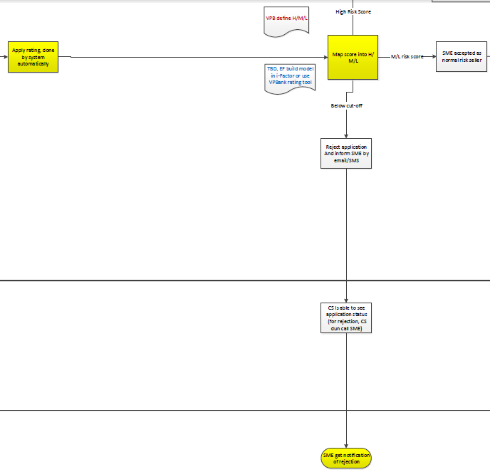



* 1. **Process description**

1. Apply rating
2. After the application passes the eligibility check, the underwriting team member should be able to click on “Apply rating” to score the SME.
3. This is performed by the system automatically.
4. The scorecards are built within the system.
5. Map score into H/M/L risk level
6. The system will then automatically map the ratings given by the scorecards into different risk levels.
7. If the rating is below the cut-off, the application will be rejected. The underwriting team member should be able to see the result: “The rating is below the cut-off”. There should be a “Reject” button for the underwriting team member to click on to reject the application and at the same time, inform the SME the rejection in the form of SMS and/or email.

Paste the SMS/email contents here.

1. If the rating is mapped into Medium or Low risk level, the SME will be accepted as normal risk seller. The underwriting team member should be able to see the result: “The risk level is Low/Medium”. There should be a button called “Accept as normal risk seller” for the underwriting team member to click on to accept the seller.
2. If the rating is mapped into High risk level, the application will be submitted to the approval team for field visit checking review. The underwriting team member should be able to see the result: “The risk level is High”. There should be a button called “Submit to approval team” for the team member to click to submit the application to the approval team to review whether field visit is required.
   1. **Business rules**
3. Underwriting team, approval team and CS team always can see the application status updates anytime.
4. Only underwriting and approval team have rights to update verification status of the application.
5. I-factor CS can see the status updated by underwriting and approval team all the time, but only have rights to update the contact result of the application, no rights to update verification status.
6. The members in the i-Factor approval team has the right to distribute the work responsible by a i-Factor underwriting team member to another i-Factor underwriting team member, in case the underwriting team member cannot continue with his/her work for various reasons (this function should be allowed to be turned off in case the bank does not allow it)
   1. **Inputs and outputs**
7. **Field Visit**
   1. **Function description**

After risk rating has been applied to the SME, if the risk rating is high, the application will be passed to the i-Factor approval team to decide if a field visit to the client’s office needs to be conducted. The decision whether a field visit is required is made outside of the system.

* 1. **Operation process**

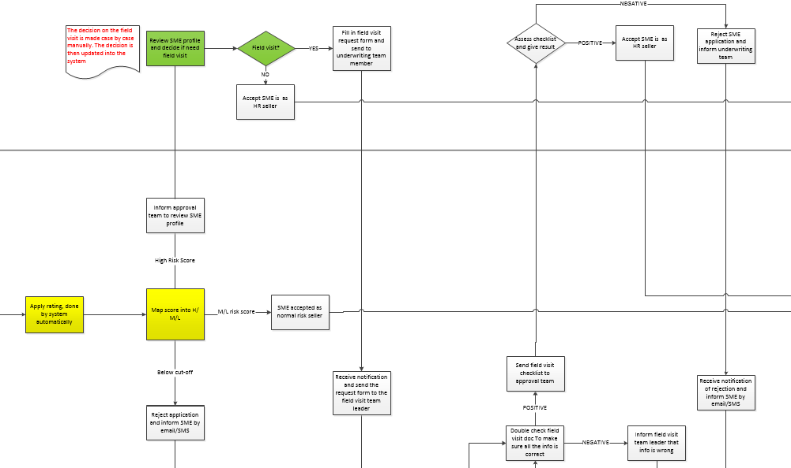

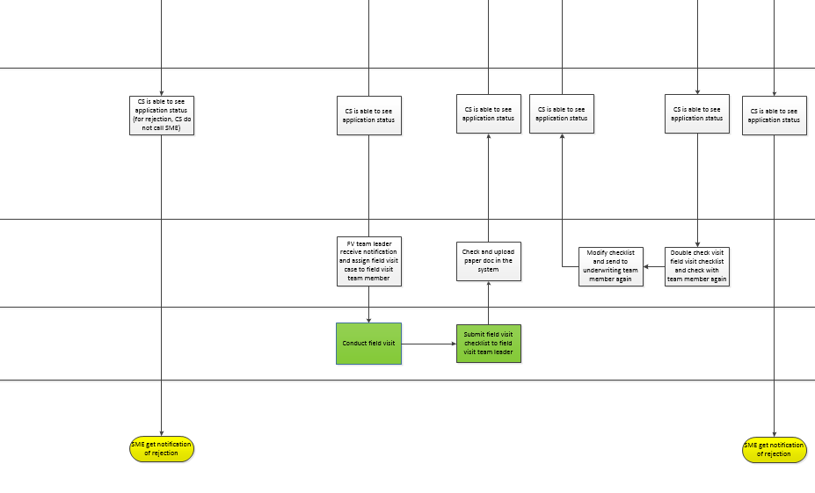



* 1. **Process description**

1. Review SME profile and decide if need field visit
2. The i-Factor approval team will receive notification on those applications that are classified as high-risk after scoring.
3. The i-Factor approval team will decide whether the application require field visit or not case by case and update the decision in the system. The team member should be able to click on the buttons “Field Visit Required” and “Field Visit Not Required” after reviewing the SME profile.
4. If the i-Factor approval team member clicks “Field Visit Not Required”, the SME will be accepted as High risk seller.
5. If the supervisor clicks “Field Visit Required”, the approval team member must be able to fill in the built in Field visit request form and send to the same underwriting team member, who has been processing the application.
6. Receive notification and inform field visit team leader about field visit request
7. The underwriting team member, after receiving the decision of field visit made by the approval team, will be able to “Send Field Visit Request” (sending the request form filled in by the approval team member) to the Field visit team leader.
8. Field visit team leader assign to specific team member
9. The field visit team leader should have access to the i-Factor system, and he will be able to see the field visit request. He will also be able to see the information of the SME on which field visit is required.
10. The field visit team leader will assign a staff from the team for field visit, and change the status of the application in the system to “Assigned field visit”.
11. The field visit team leader check and upload the answered field visit request form in the system
12. After the field visit team leader receives the filled checklist from the staff assigned to conduct the field visit, the document will be uploaded using his authorized account, and send to the same member in the underwriting team who has sent him the field visit request.
13. Double check field visit doc and inform approval team member:
14. The underwriting team member will receive the filled field visit checklist from the field visit team leader, and he should double-check that the checklist has no problem before submitting to the approval team member who made the field visit decision.
15. After the underwriting team member double-checking the field visit checklist, he will have 2 options: “Submit” to the approval team member or “Return” to the field visit team leader.
16. If the underwriting team member selects “Return” to the field visit team member, he will need to state the reason, and send back to the leader to modify with the FV staff at branch who performed the field visit. They will send the checklist to the same person again after checking.
17. If the underwriting team member finds no problem with the field visit checklist, he will select “Submit” to the approval team member.
18. Assess checklist and give result:
19. The approval team member will receive notification on field visit checklist that has been completed and checked by the underwriting team member.
20. If the result is positive, the team supervisor should be able to “Accept the SME as high risk seller”.
21. If the result is negative, the approval team member should be able to “Reject” the application. At the same time, by clicking “Reject” the system should inform the SME the rejection in the form of SMS and/or email.

Paste the SMS/email contents here.

* 1. **Business rules**

1. Underwriting team, approval team and CS team always can see the application status updates anytime.
2. Only underwriting and approval team have rights to update verification status of the application.
3. I-factor CS can see the status updated by underwriting and approval team all the time, but only have rights to update the contact result of the application, no rights to update verification status.
4. The field visit team leader should only be able to change the status of “Field visit staff assigned” and “Field visit documents uploaded”.
5. The members in the i-Factor approval team has the right to distribute the work responsible by a i-Factor underwriting team member to another i-Factor underwriting team member, in case the underwriting team member cannot continue with his/her work for various reasons (this function should be allowed to be turned off in case the bank does not allow it)
   1. **Inputs and outputs**
6. Approval team member field visit assessment UI
7. Underwriting team member get notification and application status update UI
8. I-Factor CS get notification and application status update UI
9. Field visit team leader get notification and field visit assignment UI
10. Field visit team leader update field visit status UI
11. **Document signing, verification of signed documents, bank account opening and auction function activation**
    1. **Function description**

After the SME application is accepted, the legal representative of the SME is required to go to branch to sign the legal documents. After the SME sign, the MBO/SBO/i-Factor sales team is required to open a VPBank bank account (in case of new customers) for the SME. In case of existing VPBank customer, ask for the SME for VPBank account details and fill in the i-Factor system and the contract. The SME is required to have enough money in the bank account (amount is defined by VPBank) to cover cancellation fees…). The SME is also given an i-Factor package. Lastly, after the documents are signed by the Head of SME center/ Head of i-Factor and verified by the underwriting team, the auction function will be activated.

* 1. **Operation process**

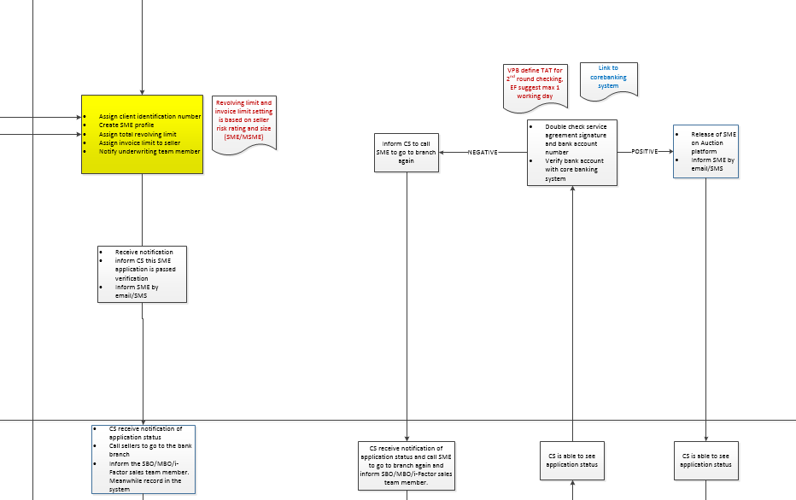

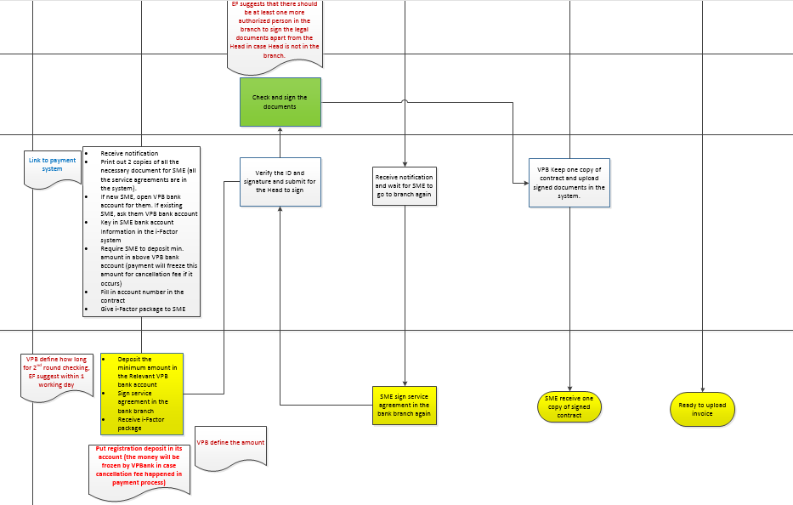



* 1. **Process description**

1. Assign client ID and create SME profile
2. After the SME is accepted as either Normal or High risk seller, the system should automatically assign client ID and create SME profile.
3. The system should also be able to automatically assign the total revolving limit and invoice limit to each of the seller profile according to the rating and the size of the SME.

|  |  |  |
| --- | --- | --- |
| **Seller** | **Max invoice amount/1 invoice *unit: VND bio*** | |
| **Micro SME** | **Small SME** |
| H | ??? | ??? |
| L(include M and L) | ??? | ??? |

|  |  |  |
| --- | --- | --- |
| **Seller** | **Revolving limit/year for 1 customer *unit: VND bio*** | |
| **MSME** | **SME** |
| H | ??? | ??? |
| L(include M and L) | ??? | ??? |

1. For newly accepted Sellers, until the first invoice is settled, the sellers cannot have more than 1 outstanding invoice at the same time. The first invoice amount must be within the invoice amount limit per invoice defined above. After the first invoice is settled, sellers will be able to upload multiple invoices, as long as the invoice amount per invoice and total invoice amounts are within the above limits. However, there should be a way for VPBank staffs
2. The underwriting team member should be able to see the details of the SME client ID, profile and limits.
3. Inform CS to contact SME
4. The underwriting team member should inform the CS to contact SME to go to branch to sign the legal documents by clicking on “Inform CS” button.

Paste the notification content here

1. Inform SME by email/SMS
2. There should be a button called “Inform SME” for the underwriting team member to click on to inform the SME that the application is passed, and CS will contact the SME in due course.

Paste the email content here

1. CS contact SME and inform SBO/MBO/i-Factor sales team member
2. The CS should be able to see the notification sent from the underwriting team member and contact the SME to go to branch to sign the legal documents.
3. At the same time, the CS should be able to notify the SBO/MBO (branch) or the i-Factor sales team member (HO) that the SME is coming to the branch.

Paste the notification content here

1. The SBO/MBO (branch) or the i-Factor sales team member (HO) receive the notification from CS and:
2. Select the list of necessary legal documents for SME and print them out and ask the SME to sign.
3. Open bank account for the SME in case of new VPBank customer. If existing customer, ask for bank account details.
4. Require the SME to deposit a minimum registration deposit into the bank account. The amount will be frozen.
5. Fill the bank account number into i-Factor system and the contract.
6. Give SME the i-Factor package
7. The SME then:
8. Sign the legal documents
9. Deposit the minimum registration amount as required by VPBank. The amount will be frozen.
10. Receive the i-Factor package
11. The SBO/MBO (branch) or the i-Factor sales team member (HO) verify the SME’s ID, signature and upload the legal documents into the system
12. The SBO/MBO (branch) or the i-Factor sales team member (HO) is required to verify the SME’s ID and signature.
13. The documents will then be passed on to the Head of SME center (branch) or the Head of i-Factor (HO) to check and sign.
14. The documents will then be passed on to the underwriting team member for double check.
15. The underwriting team member double check the signature and uploaded documents and Verify bank account with corebanking system
16. The underwriting team member should be able to receive notification from the SBO/MBO (branch) or the i-Factor sales team member (HO) and check the SME’s signature, legal documents and bank account number and verify the bank account number using the interface with the core banking system of the VPBank
17. If the double check gives negative results, the underwriting team member should “Inform SBO/MBO (branch) or the i-Factor sales team member (HO)” to contact the SME to come to branch again to re-sign the paperwork and/or reconfirm the bank account number

Paste the notification content here

1. The SME come to branch again to re-sign the paperwork. The flow goes back to step 6 -> SBO/MBO (branch) or the i-Factor sales team member (HO) do first round checking -> underwriting team member do second round checking until the documents are all verified.
2. If the double check result is positive, the underwriting team member should be able to click on “Activate auction” to release the SME onto the platform. By clicking this, the system will automatically send SMS/email to inform the SME of the activation.

Paste the notification content here

1. When the SME log in to the platform, they should now be able to access the auction function (upload invoices).
   1. **Business rules**
2. The auction function should be activated within the next 24 hrs.
3. The bank account of the SME should be linked the i-Factor account.
4. Underwriting team, approval team and CS team always can see the application status updates anytime.
5. Only underwriting and approval team have rights to update verification status of the application.
6. I-factor CS can see the status updated by underwriting and approval team all the time, but only have rights to update the contact result of the application, no rights to update verification status.
7. The members in the i-Factor approval team has the right to distribute the work responsible by a i-Factor underwriting team member to another i-Factor underwriting team member, in case the underwriting team member cannot continue with his/her work for various reasons (this function should be allowed to be turned off in case the bank does not allow it)
   1. **Inputs and outputs**

# **Chapter 2 Investor Application Process**

1. **User registration and investor application**
2. **Function description**

If private investors would like to become registered buyers of i-Factor platform, they are required to fill in the registration form and application form. After finish the registration form, the system will automatically send an activation email to the investor’s email address. After activating the account, the investor can log in and start fill in the application form.

1. **Operation process**

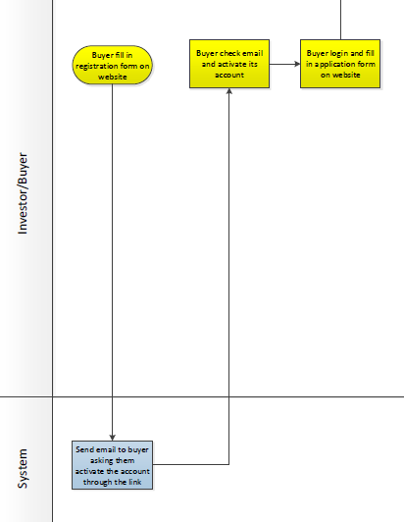

1. **Process description**
2. Investor open the platform homepage:
3. Investor click on “Become an investor”.
4. Investor accept the Legal disclaimer which will automatically appears by clicking on”I Agree”.
5. Investor fill in registration form on website:
6. The investor will perform this step. The registration form only includes some basic data fields such as Title, First name, Last name, Password, Email…
7. After filling all the required data fields, investor click on “Submit”
8. If any errors occur (e.g. passwords not matched, email not correct…) then the screen must show in red the error for the investor to modify the incorrect information.
9. If the registration is successful, the system should be able to send an automatic email with the activation link to the investor registered email address.
10. Account activation:
11. After the investor click on “Submit”, the system will automatically send an activation email to the investor’s email address.

Paste email content here

1. The investor click on the activation link in the email to activate the account
2. After clicking on the link, the investor should be brought to a screen showing: “Your account has been activated”
3. Investor log in and fill in the application form:
4. First time log-in: after clicking on the activation link, the investor should be brought the log in screen
5. Existing Investor application login

Investor either click on “Login” on website homepage or click on “Resume application/existing user” on registration UI

1. The investor log in and start filling in the application form
2. Investor upload all required documents one by one. For each requirement of document uploading, the investor should click on “Browse” to select the document and click on “Upload” to upload into the system .
3. After filling and uploading, there should be a summary screen.
4. Investor double check, if there is anything wrong, click “edit” to modify.
5. After checking all the information, investor tick one box of “I have confirmed all the above information is correct” and click “Submit”, the application should be saved and submitted to the i-Factor underwriting team member to check and verify
6. The investor can “Save” unfinished application and log in later to finish it. There should be a button called “Continue with your application” for investor to click on to continue filling in the necessary information and uploading necessary documents.
7. If the investor do not finish the application in one sitting, the application status should be “To be submitted”. The investor click on “Save as draft” to save the application and click on “Log out” to close application filling and should be brought back to login webpage. If the investor do not finish the application within 60 days, the system should automatically drop it.
8. If any errors occur (mandatory fields not filled, documents not uploaded…) the screen should show the error in red in order for the investor to modify the incorrect information.
9. If the application is successful, the application should be automatically sent to the underwriting team for reviewing.
10. Buyer should receive the email/SMS after The Buyer has completed their application and the application was approved.
11. **Business rules**
12. The investor must activate the account using the link in the email sent by the system before logging in.
13. The information inputted in the registration form will be captured in the application stage and cannot be modified until the application is successful.
14. The username should be unique thus we suggest that email address of the investor should be used as the username.
15. If the investor do not finish filling in the application after 60 days, the application should be dropped automatically by the system.
16. Whether the registration/application is successful or not, they will be logged. The log will be found in the server internal management system.
17. **Inputs and outputs**
18. Platform homepage



1. Legal disclaimer

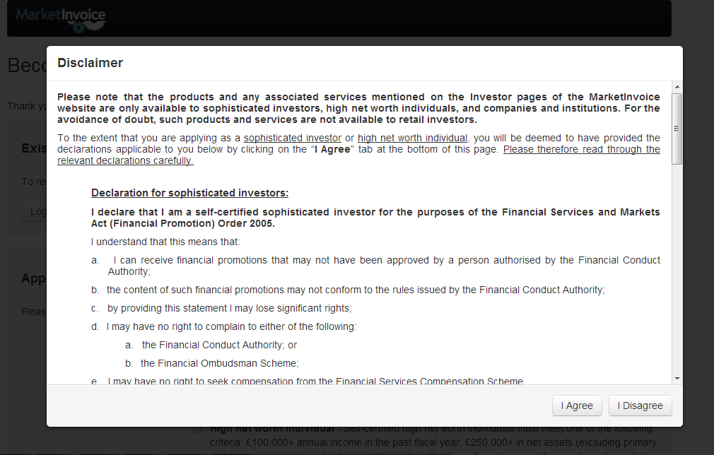

1. Log in UI

|  |  |  |  |  |  |  |  |  |  |
| --- | --- | --- | --- | --- | --- | --- | --- | --- | --- |
|  | **Company logo** | |  |  |  |  |  |  |  |
|  | Product name | |  |  |  |  | Language | |  |
|  |  |  |  |  |  |  | Help | Contact Us |  |
|  |  |  |  |  |  |  |  |  |  |
|  |  |  |  |  |  |  |  |  |  |
|  |  | Email/ID |  |  |  |  |  |  |  |
|  |  | Password |  |  |  |  |  |  |  |
|  |  | SIGN IN | | | |  |  |  |  |
|  |  | Stay signed in | | Forget Password? | |  |  |  |  |
|  |  |  |  |  |  |  |  |  |  |
|  |  |  |  | Open a new account | |  |  |  |  |
|  |  |  |  |  |  |  |  |  |  |
|  |  |  |  |  |  |  |  |  |  |
|  |  |  |  |  |  |  |  |  |  |
|  |  |  |  |  |  |  |  |  |  |
|  | About | How it works | Learning centre | Contact us | Cookie policy | Terms of use | | | | | | | |  |
|  |  |  | Copyright & VPBank address | | |  |  |  |  |
|  |  |  |  |  |  |  |  |  |  |

1. Registration UI



1. Registration form

|  |  |  |  |  |  |
| --- | --- | --- | --- | --- | --- |
| **Category 1** | **Mandatory** | **filling type** | **UI Page** | **Remark** | **UI setup** |
| Title | * | drop down list: Mr, Mrs, Ms, Miss, Undefined (TBD) |  |  |  |
| First Name | * |  |  |  |  |
| Last Name | * |  |  |  |  |
| Phone |  |  |  |  |  |
| Mobile phone | * |  |  |  |  |
| Email | * |  |  |  |  |
| Confirm Email | * |  |  | error msg: email does not match | on the page |
| Password | * |  |  | error msg: Password does not match | on the page |
| Confirm Password | * |  |  | Your password must be at least 8 characters long and include 1 or more non-alphabetic characters (symbols or numbers). | on the page |
| Invest as | * | Drop down list: Private investor, Company/institution |  | this choose will affect application form, private investor and company have its own data field respectively |  |
| How did you hear about us? | * | Drop down list: TBD |  |  |  |
| If other please specify | * |  |  |  |  |

1. Application form

Detail as below











1. Confirmation page



1. Email content UI

Paste email content UI

|  |  |  |  |  |  |  |
| --- | --- | --- | --- | --- | --- | --- |
| **No.** | **Data field name** | **Mandatory** | **Input/output** | **Missing value** | **Type/length** | **Remark** |
| 1 |  |  |  |  |  |  |
| 2 |  |  |  |  |  |  |
| 3 |  |  |  |  |  |  |

1. **Completeness and correctness check**
   1. **Function description**

After the investor finish filling in the application form, the underwriting team member should receive an automatic notification of new buyer application and perform the completeness and correctness check. The underwriting team member perform the first round checking. The approval team perform the second round checking.

* 1. **Operation process**

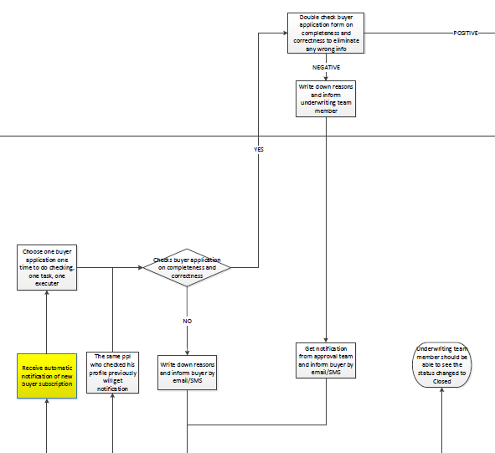

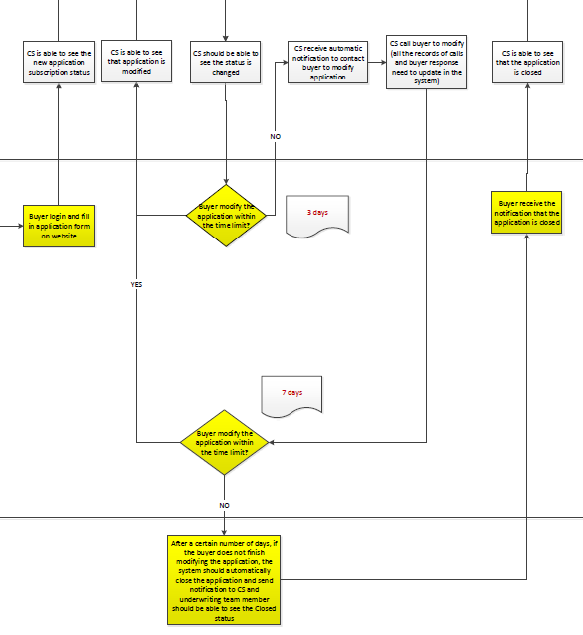



* 1. **Process description**

1. i-Factor underwriting team member receive automatic notification of new buyer application
2. After the investor finish the application form and click “Submit”, the application should be saved and submitted to the i-Factor underwriting team member to check and verify
3. The underwriting team receive an automatic notification of new buyer application submitted
4. The application status should be “Pending for completeness and correctness check”. CS should be able to see this status.
5. Check application completeness and correctness
6. One underwriting team member select one application at a time to perform the completeness and correctness check.
7. All underwriting team members should be able to see how many new applications there are and which ones are pending for checking
8. The screen should show the application form and the documents uploaded side-by-side for the underwriting team member to check easily.
9. There should be a box next to each data field for the underwriting team member to tick in case the data is complete and correct. If not, leave the box un-ticked.
10. If the application is complete and all the information is correct, the underwriting team member should be able to “Save” the application and “Submit” to approval team for the approval team to double check. The application status should be “Passed by underwriting team”. Go to step 8.
11. If the application is not complete or any information is incorrect, go to step 3.
12. Write down reasons and inform the investor
13. If any information is missing or incorrect, there should be a box for the underwriting team member to write down the reason. There should be a button called “Require investor modification” for the verification to click on.
14. After the underwriting team click the “Require investor modification” button, the investor should be informed by SMS/email to modify the application online. The application status should be “Pending for investor to modify”.

Paste the SMS/email format, contents here.

1. The CS team should also be able to see the status changed and the reason.
2. Investor modify within the time limit (3 days) ?
3. After 3 days, if the investor do not modify the application as requested, the application status should change automatically to “Pending for CS to contact”.
4. The system should automatically send a notification to the CS to contact the investor for modification.
5. The CS team member should contact the investor on the phone to require them to modify the application. The application status should be “Contacted by CS”. The details of the call should be recorded by the system.
6. If the investor finish modifying within the time limit, go to step 6C
7. Investor modify within the time limit (7 days) after get contacted by CS?
8. After get contacted by CS, after 7 days, if the investor do not finish modifying the application, the system should be able to automatically close the application and send notification to the investor.
9. The application status should change to “Application closed”.
10. If the investor finish modifying within the time limit, go to step 6C.
11. Investor modify the application
12. After get informed by SMS/email and/or CS, the investor should be able to log in to modify the application.
13. The screen should only show the data fields that require modification, correct data fields should be locked.
14. After finishing the modification, the investor should click on “Submit” to send the application to the underwriting team member who checked the application previously. The application status should be “Modified by investor”.
15. If the investor do not modify the application after 7 days the application should automatically rejected.
16. Check application completeness and correctness again
17. After receiving the modified application, the underwriting team member should check the modified information.
18. The modified information should be highlighted.
19. The relevant documents should be put side-by-side with the application form to allow the underwriting team member to check easily.
20. If the application is complete and correct, go to step 8. Otherwise go back to step 3.
21. Double check application completeness and correctness
22. The approval team member receive the applications submitted from the team member for double checking.
23. The screen should show the application form and the documents uploaded side-by-side for the approval team to check easily.
24. If the double check gives negative result, go to step 9. If the check gives positive result, the application will be passed on to check against blacklists.
25. Write down reasons and inform underwriting team member
26. If any information is missing or incorrect, there should be a box for the underwriting team member to write down the reason.
27. There should be a button called “Send to underwriting team” to allow the approval team to inform the underwriting team member to contact the investor to modify the application.
28. Get notification and send SMS/email to the investor
29. The underwriting team member should be able to receive the following message from the approval team:

Paste the message contents here.

1. There should be a button called “Inform the investor” for the underwriting team member to click on to inform the investor by SMS/email to modify the application online.

Paste the SMS/email format, contents here.

1. The process goes back to step 4 above until the application is complete.
   1. **Business rules**
2. The CS should only contact the investor to modify the application after a 3 days. The application will be automatically dropped if left unmodified after 7 days from the day that CS contact the investor.
3. The email notifying the buyer of modification requirement should include the data fields which need to be modified.
4. The application form should only show data fields which require modification, the correct data fields should be locked by the system.
5. The investor should be able to save during the modification stage.
6. Only underwriting team an receive notification of new application subscription.

* Underwriting team, approval team and CS team always can see the application status updates anytime.
* Only underwriting and approval team have rights to update verification status of the application.
* I-factor CS can see the status updated by underwriting and approval team all the time, but only have rights to update the contact result of the application, no rights to update verification status.

1. The members in the i-Factor approval team has the right to distribute the work responsible by a i-Factor underwriting team member to another i-Factor underwriting team member, in case the underwriting team member cannot continue with his/her work for various reasons (this function should be allowed to be turned off in case the bank does not allow it)
   1. **Inputs and outputs**
2. **Checking against blacklist**
   1. **Function description**

After the application passed the completeness and correctness check, it should be passed on for the blacklist checks.

* 1. **Operation process**

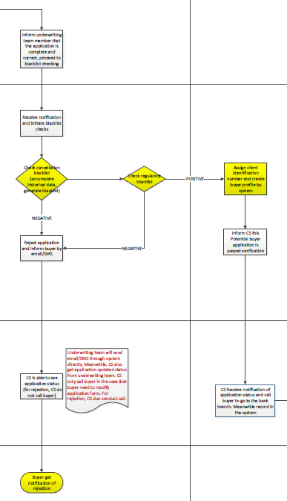



* 1. **Process description**

1. Initiation of blacklist checks
2. After the application pass the completeness and correctness double check by the approval team member, the approval team member should be able to “Save” the application, inform the underwriting team member of the status changed and to perform the blacklist checks. The status should be “Pending for blacklist check”.

Paste the notification contents here.

1. The underwriting team member should be able to receive the notification and initiate the blacklist checks.
2. Check cancellation blacklist
3. After receiving the notification from the approval team member, there should be a button called “Check cancellation blacklist” for the underwriting team member to click on
4. The system send back a message according to the result of the check
5. If the result is positive: “The applicant is not in cancellation blacklist” and there should be a button called “Check regulatory blacklist” for the underwriting team member to click on to move on to check regulatory blacklist. The application status should be “Passed cancellation blacklist check”
6. If the result is negative: “The applicant is in the cancellation blacklist” and there should be a button called “Reject” for the underwriting team member to reject the application
7. Check regulatory blacklist
8. The underwriting team member click on “Check regulatory blacklist” (if the result of cancellation blacklist check is positive)
9. The system send back a message according to the result of the check
10. If the result is positive: “The applicant is not in regulatory blacklist” and there should be a button called “Accept as potential buyer” for the underwriting team member to accept the application. The application status should be “Accepted as potential buyer”
11. If the result is negative: “The applicant is in the regulatory blacklist” and there should be a button called “Reject” for the underwriting team member to reject the application
12. Reject application
13. If the either of the blacklist checks give negative results, the underwriting team member click on “Reject” to reject the application. The application status should be “Application rejected”
14. The system should be able to interface with VPBank’s SMS and email systems to send automatic SMS/email to the investor to inform rejection

Paste the SMS/email format, contents here.

1. The CS team should be able to see the status changed
2. Eligibility checking

Develop a new function as eligibility checking of SME application process, include as below:

1. Input column： result and reason
2. Button：pass，reject and save
   1. **Business rules**
3. The underwriting team member can only move on to check regulatory blacklist if the result of cancellation blacklist check give positive result
4. CS should always be able to the see the status of the application
5. Underwriting team, approval team and CS team always can see the application status updates anytime.
6. Only underwriting and approval team have rights to update verification status of the application.
7. I-factor CS can see the status updated by underwriting and approval team all the time, but only have rights to update the contact result of the application, no rights to update verification status.
8. The members in the i-Factor approval team has the right to distribute the work responsible by a i-Factor underwriting team member to another i-Factor underwriting team member, in case the underwriting team member cannot continue with his/her work for various reasons (this function should be allowed to be turned off in case the bank does not allow it)
   1. **Inputs and outputs**
9. **Confirmation of the buyer’s identity**
   1. **Function description**

After the application passes the completeness and correctness check, the underwriting team member should be informed by the team leader to accept the investor. The system will then automatically assign client identification number and create investor profile. The Customer service team will then be required to confirm the identity of the investor and call them to go to branch to sign the paperwork.

* 1. **Operation process**

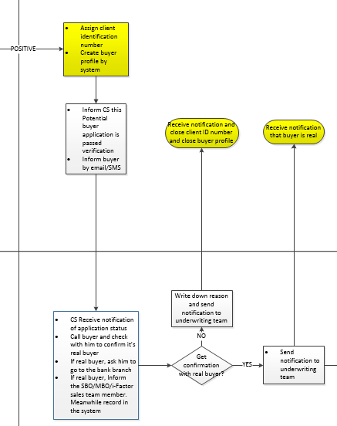



* 1. **Process description**

1. Assign client ID and create investor profile
2. The underwriting team member should be able to click on “Accept as potential buyer” the application pass blacklist checks
3. After the clicking that button, the system should automatically generate client ID and create investor profile for the investor
4. Inform CS to call the investor to go to branch
5. The underwriting team member should be able to notify the CS team to contact the investor on the phone to confirm the investor’s identity and ask them to go to branch

Paste the content of the message here

1. Inform Buyer by SMS/email
2. There should be a button called “Inform Buyer” for the underwriting team member to click on to inform the buyer that the application has passed and CS will contact the buyer in due course.

Paste the content of the SMS/email here

1. CS receive notification and contact the investor
2. The CS team member should be able to see the message sent from the underwriting team member on the screen
3. The CS team member should contact the investor by phone and change the contact status.
4. Get confirmation of the buyer’s identity
5. The CS team member is responsible for confirming the buyer’s identity
6. If the buyer is not real, the CS team member should be able to click on “Buyer’s identity unconfirmed” and messages will be automatically sent to the underwriting team with the following content:

Paste the content of the message here

1. The underwriting team member should be able to see the message on the screen and close the Client ID and investor profile
2. If the buyer is real, the CS team member should be able to click on “Buyer’s identity confirmed” and messages will be automatically sent to the underwriting team and MBO/SBO/i-Factor sales team member with the following content:

Paste the content of the message here

1. The underwriting team member and MBO/SBO/i-Factor sales team member should be able to see the messages on the screen.
   1. **Business rules**
2. Client ID must be unique
3. Underwriting team, approval team and CS team always can see the application status updates anytime.
4. Only underwriting and approval team have rights to update verification status of the application.
5. I-factor CS can see the status updated by underwriting and approval team all the time, but only have rights to update the contact result of the application, no rights to update verification status.
6. The members in the i-Factor approval team has the right to distribute the work responsible by a i-Factor underwriting team member to another i-Factor underwriting team member, in case the underwriting team member cannot continue with his/her work for various reasons (this function should be allowed to be turned off in case the bank does not allow it)
   1. **Inputs and outputs**
7. **Documents signing, verification of signed documents, bank account opening and auction function activation**
   1. **Function description**

After the buyer’s identity is confirmed, they are required to go to branch to sign the necessary documents. After the investor sign, the MBO/SBO/i-Factor sales team is required to open a VPBank bank account (in case of new customers) for the investor. In case of existing VPBank customer, ask for the investor VPBank account details and fill in the i-Factor system and the contract. The investor is required to have enough money in the bank account (amount is defined by VPBank) to cover cancellation fees…). The investor is also given an i-Factor package Lastly, after the documents are signed by the Head of SME center/ Head of i-Factor and verified by the underwriting team, the auction function will be activated within the next 24 hours and the investor should be ready to bid for invoice.

* 1. **Operation process**

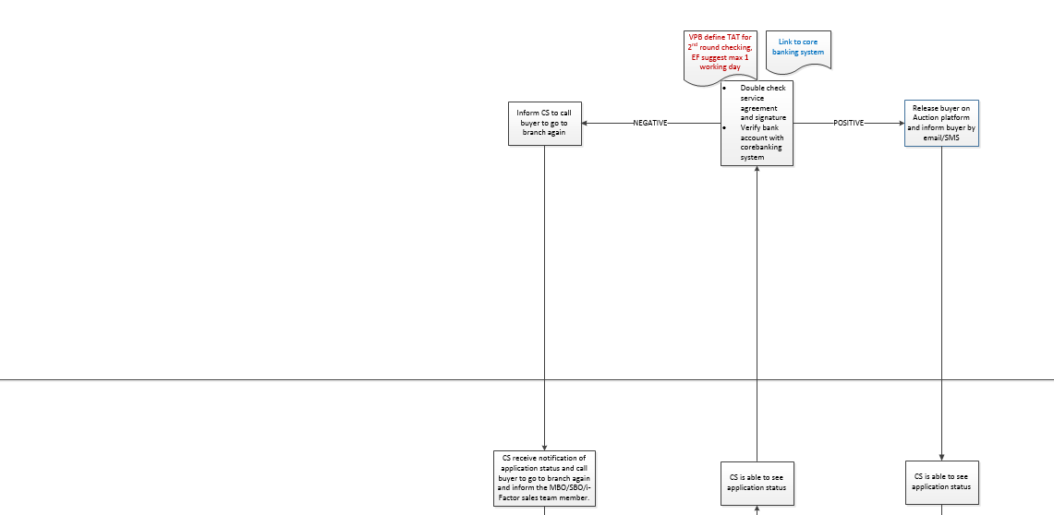

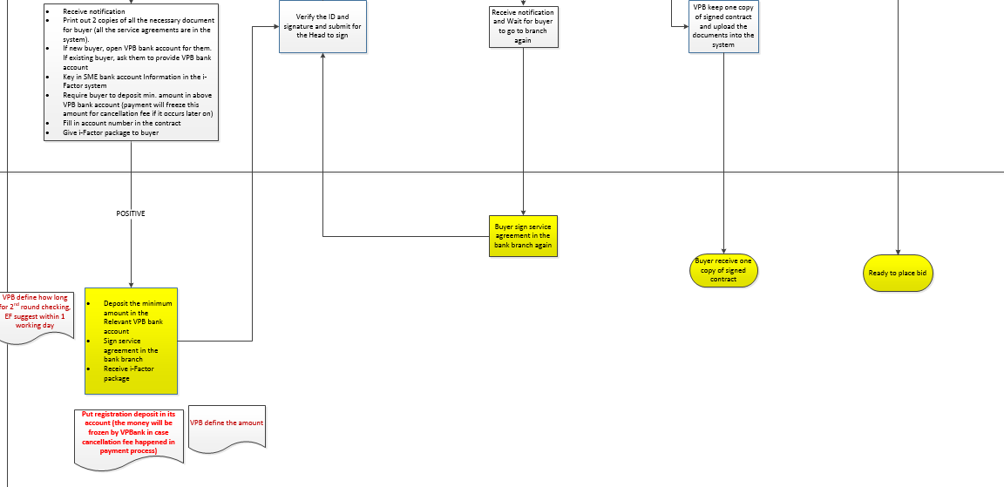



* 1. **Process description**

1. The SBO/MBO (branch) or the i-Factor sales team member (HO) receive the notification from CS and:
2. Select the list of necessary legal documents for buyer and print them out and ask the buyer to sign.
3. Open bank account for the buyer in case of new VPBank customer. If existing customer, ask for bank account details.
4. Require the buyer to deposit a minimum registration deposit into the bank account. The amount will be frozen.
5. Fill the bank account number into i-Factor system and the contract.
6. Give buyer the i-Factor package
7. The buyer then:
8. Sign the legal documents
9. Deposit the minimum registration amount as required by VPBank. The amount will be frozen.
10. Receive the i-Factor package
11. The SBO/MBO (branch) or the i-Factor sales team member (HO) verify the buyer’s ID, signature and upload the legal documents into the system
12. The SBO/MBO (branch) or the i-Factor sales team member (HO) is required to verify the buyer’s ID and signature.
13. The documents will then be passed on to the Head of SME center (branch) or the Head of i-Factor (HO) to check and sign.
14. The documents will then be passed on to the underwriting team member for double check.
15. The underwriting team member double check the signature and uploaded documents and verify the bank account number through the interface with VPBank core banking system
16. The underwriting team member should be able to receive notification from the SBO/MBO (branch) or the i-Factor sales team member (HO) and check the buyer’s signature, legal documents and verify bank account number using the interface with VPBank core banking system.
17. If the double check gives negative results, the underwriting team member should “Inform SBO/MBO (branch) or the i-Factor sales team member (HO)” to contact the buyer to come to branch again to re-sign the paperwork.

Paste the notification content here

1. The buyre come to branch again to re-sign the paperwork. The flow goes back to step 3->MBO/SBO/i-Factor sales team member do first round checking -> underwriting team member do second round checking until the documents are all verified.
2. If the double check result is positive, the underwriting team member should be able to click on “Activate auction” to release the buyer onto the platform. By clicking this, the system will automatically send SMS/email to inform the buyer of the activation.

Paste the notification content here

1. When the buyer log in to the platform, they should now be able to access the auction function (bid for invoices).
   1. **Business rules**
2. The auction function should be activated within the next 24 hrs.
3. The bank account of the investor should be linked to his i-Factor account
4. Underwriting team, approval team and CS team always can see the application status updates anytime.
5. Only underwriting and approval team have rights to update verification status of the application.
6. I-factor CS can see the status updated by underwriting and approval team all the time, but only have rights to update the contact result of the application, no rights to update verification status.
7. The members in the i-Factor approval team has the right to distribute the work responsible by a i-Factor underwriting team member to another i-Factor underwriting team member, in case the underwriting team member cannot continue with his/her work for various reasons (this function should be allowed to be turned off in case the bank does not allow it)
   1. **Inputs and outputs**

# **Chapter 3 Invoice Delivery Process**

# **Invoice Delivery**

* 1. **Phase 1**

### **Function Description**

After SMEs are approved to be invoice sellers, they will have the right to upload invoice. After the approval of the invoice, the invoices will be available for auction. The first stage is to ensure that the invoices submission is complete and correct.

### **Operation Process**



The status change of the process please find as below:



### **Process Description**

1. SMEs that have been approved to upload invoices can click “Submit Invoice” and upload the necessary documents, invoice details, and the mandatory ready-to-sell conditions:
   1. During the invoice delivery process, the staff in the underwriting team and approval team can always be able to see the SME profile that has been created during SME admission process, because the two teams will compare the company profile information with the invoice details that are submitted for underwriting purpose.
   2. SMEs who have not been approved, SMEs who have reached the maximum number of invoices that they can upload, SMEs with remaining factoring limit (Factoring limit – total amount of outstanding invoices that the SME has uploaded) less than the minimum invoice amount allowed, or SMEs in the cancellation blacklist should not be allowed to submit new invoices;
   3. The maximum number of invoices that the SME can upload is 1 at first. Only the first invoice of the SME has been settled, the maximum invoice number limit will be removed.
   4. The detail of the data fields are as follows:

|  |  |  |  |  |  |
| --- | --- | --- | --- | --- | --- |
| **Category 2** | **Mandatory** | **filling type** | **UI Page** | **Remark** | **UI setup** |
| **SELLER INFORMATION** | **\*** |  |  |  |  |
| Name of your Company | * | System fills in automatically name of seller | page 1 |  |  |
| Represented by | * | drop down list: Mr, Mrs, Ms, Miss drop down list:  The names of seller's authorized users | page 1 |  | To be allowed only one of the names of seller's authorized users. |
| **DEBTOR INFORMATION** | * |  |  |  |  |
| Name of debtor | * | drop down list sorted by alphabetical order:  Debtors predefined list | page 1 | SME can only select debtors that are on the drop-down list. At this stage all debtors not on the list will not be accepted. |  |
| Address | * | Separate fields for: Street, No, City, Province, Country, Code. | page 1 |  | Separate fields for: Street, No, City, Province, Country, Code. |
| Business registration no | * |  | page 1 |  | To be accepted only VN format of Business registration no |
| Tax code | * |  | page 1 |  | To be accepted only VN format of Tax code |
| **FINANCING INFORMATION** | * |  |  |  |  |
| Sticker ID | * | Type in: 6 digits number | page 1 |  | 6 digits number |
| VAT Invoice Number | * |  | page 1 |  |  |
| Invoice issuance date | * | Calendar predefined | page 1 | *"Please choose invoice issuance date to be previous the current date."* |  |
| Invoice amount | * | Let SME key in | page 1 | *If the SME types in number outside of the range, "The invoice amount allowed: XXX-XXX" pops up.* | Minimum amount limit = USD 5 k .  Maximum invoice amount limit = 0.8 b TBD by VPBank  ! Invoice amount accepted if:  1. Total value of outstanding invoices is below factoring limit 2. Each invoice amount doesn't exceed Maximum invoice amount limit  Maximum invoice amount deviations will be allowed up to 5% for low and medium risk sellers.  Marking those invoices with deviation in the system. The following is the rules:  i. Invoice amount - platform allows deviation of maximum 5% of the invoice amount limit. Therefore for micro SME, invoice amount between 0.8-0.84 is deviation. Bigger than 0.84 can never be accepted.  ii. Invoice term - platform allows deviation from 35 days invoice term to 25 days invoice term.[Need calendar] Therefore, term between 25-35 is deviation. Less than 25 days can never be accepted.  iii. The system needs to tell the person in the approval team if the invoice is within deviation. If he/she clicks “accept” button, the system should be able to tell that this is a case where deviation is accepted. iv. If the invoice term is in deviation, and the staff in the approval team accepts it, the system should assign a different cut-off date (22 days) for this invoice from other invoices. |
| Object of invoice | * | Drop down list: TBD Recommendation: Services delivery; Goods delivery - perishable; Goods delivery - nonperishable | page 1 |  |  |
| Due date according to the contract | * | Calendar predefined | page 1 |  |  |
| Expected Payment Date | * | Calendar predefined | page 1 | The estimated date from the SME, because the debtor in Vietnam usually pay later than the date stated in the contract. We do not allow to input an expected payment date more than 30 days later than the due date in the contract.  The expected payment date: contract date + max. 30 days |  |
| Remaining maturity term | * | To be automatically calculated by the system as number of days between current date (invoice upload date) and invoice due date. | page 1 |  | Minimum term limit: 35 days .   Maximum term limit: 120 days  Low and medium risk sellers can have deviation of 25 days as the minimum term. |
| **READY TO SELL** | * |  | page 1 |  |  |
| Advance | * | Percentage box | page 1 | *"Maximum accepted advance percentage: 90%."* | The maximum accepted advance percentage: 90%  Advance setting should allow following rates: 90%, 85%, 80%, 75%, 70%. |
| Interest | * | Percentage box | page 1 | *"Minimum accepted interest: 0.25%."* | Minimum interest: 0.25% Interest setting should allow following rates: 0.5%, 0.75, 1%, 1.25, 1.5%,…, 20%. |

* 1. The system can support the uploads of 4 documents: 1. Scan of invoice (Mandatory); 2. Scan of contract (Mandatory); 3. Delivery confirmation (Mandatory); 4. The acknowledgement from the debtor (Mandatory for high-risk sellers, but not for other sellers, so the invoice submission form for high-risk invoice sellers always have one more required document) ;
  2. Restriction on file type uploaded to: PDF, JPG, DOC
  3. The system should perform logic check according to what is specified in the invoice upload form above;
  4. There should be ‘Upload’ buttons next to the documents that they need to upload; ‘Save’ button at the bottom that enables saving invoice submission progress (The status will become “To be submitted”, and ‘Submit’ button that submit the invoice to VPBank for approval (The status will become “New invoice submitted”);
  5. Invoice submission will be allowed if all the mandatory fields have been filled in and passed the logic checking;
  6. The system needs to flag the invoice submissions that have invoice terms or invoice amounts that are in the deviation range defined by the bank. System should Point out the invoices with deviation, Comparison of the contract date and the pass date through the time difference within 35 days after verification team pass the invoice.
  7. SME should receive the email/SMS after upload has completed.

1. After the SME completes and submits the invoice, it will be sent to the shared invoice submission box in the system automatically, with the status “New Invoice Submitted”:
   1. All staff in the i-Factor underwriting team have the right to access the invoice submission box;
   2. Once a member in the i-Factor underwriting team opens a new submission, the name of the member and the open time will be logged. Only he/she can to continue with this invoice submission completeness and correctness checking and underwriting. Other members will not be able to see this invoice in the shared box again because the responsibility has been taken by a member already;
2. Once a team member in the i-Factor underwriting team opens an invoice submission, he will be able to see all the detail of the information submitted by the SME:
   1. He should be able to see the invoice image on one side, and the data fields on the other side for easy comparison and checking;
   2. Next to each data field and document uploaded, a checkbox should be available for the i-Factor underwriting members to check (tick) if that particular entry has passed the completeness and correctness check or not;
   3. The i-Factor underwriting team members are allowed to click on 2 buttons “Submit” and “Save”; the former is for them to submit the checking result, and the latter is for them to save the checking progress;
   4. When the i-Factor underwriting team members click “Submit”, the system will check if every entry has passed the correctness and completeness check, according to the result of the checkbox;
   5. If all entries have pass the correctness and completeness check, the invoice will be passed to the status of “Manual Underwriting in Progress”;
   6. If any entry has not passed the correctness and completeness checking, the system will capture which entry has and which entry has not passed the checking according to the result in the checkbox. They need to write down the reason for the failure to pass the checking and the system needs to record it. The system will automatically generate an email with the list of entries that require modification according the checkbox result, and a standard SMS to the SME via VPBank’s communication channel;
3. After the SMEs are notified that the invoices have not passed the completeness and correctness check, they will log in i-Factor system and open the same invoice submission again to resubmit:
   1. All those entries that have passed the i-Factor underwriting team check will be locked and turned gray. The SMEs will not be able to change those entries again because there is no need to change them;
   2. The SMEs will be able to edit those entries that have not passed the completeness and correctness check;
   3. After the SMEs confirm and resubmit the invoice, this modified submission will be sent to the same member in the i-Factor underwriting team who has been processing the same invoice submission;
4. If the SME has not modified within 3 days, the i-Factor customer service will need to contact SME for incomplete or incorrect information:
   1. Invoices staying at status “Pending for SME to modify” for more than 3 days should be changed to the status “Pending for CS to contact” automatically by the system;
   2. The invoices with this status should appear in the shared contact seller request box in the system automatically. All staff in the i-Factor CS team have the right to access the shared contact seller request box;
   3. Once a member in the i-Factor CS team opens the request, the name of the member and the open time will be logged. Other members will not be able to see this new contact SME request in the shared box again;
   4. After contacting the SME successfully, the member in the i-Factor customer service needs to check a box in the request that says “SME has been contacted”, so that the status will be changed from “Pending for CS to contact” to “Contacted by CS”;
5. If the SME has not modified within 7 days after i-Factor CS has contacted him/her, the invoice submission will be dropped:
   1. Invoices staying at status “Contacted by CS” for more than 7 days should be changed to the status “Submission Dropped” automatically by the system;
   2. The system should automatically send an email and a SMS to the SME that the invoice submission has been dropped from the system;
   3. The SME will no longer be able to continue with the same invoice submission
6. After the SME modified their invoice submission, the invoice submission will be sent to the same person in the i-Factor underwriting team to check for completeness and correctness again
   1. That member of the i-Factor underwriting team should be able to see which entries are modified by the invoice sellers, and which entries have already passed the completeness and correctness check before;
   2. If all entries have pass the correctness and completeness check this time, the invoice will be passed to the status of “Manual Underwriting in Progress”. If not passed, then the submission needs to pass through the modification process again until all the entries have passed the checking.
7. After the completeness and correctness check has been passed by the member in the i-Factor underwriting team, the status of the invoice will become “Manual Underwriting in Progress”, and the same member in the i-Factor underwriting team will perform manual underwriting outside the system.
   1. The member in the i-Factor underwriting team will check the invoice submission according to a list of invoice eligibility checking criteria that are outside the system;
   2. After the member in the i-Factor underwriting team has finished the checking, he/she will open the invoice submission and have a screen where he/she can click “Accept” or “Reject”;
   3. In the same screen, the system should have a function to allow the member in the i-Factor underwriting team to upload documents of manual underwriting, in case the bank wants the system to keep a soft copy record of the manual underwriting result. This function can be turned off if the bank thinks it is not necessary;
   4. If the member in the i-Factor underwriting team clicks “Reject”, he needs to select from a pre-defined drop-down list of rejection reasons. The system needs to record the reason internally, and the system will send a rejection email and SMS to the SME. The list drop-down list of reasons is as follows, and it will be subject to changes:
      1. Goods of contract & invoice is on the industry’s blacklist
      2. Contract/invoice arising from illegal agreement/transaction
      3. Contract/invoice arising from in dispute agreement/transaction
      4. Seller business industry is unrelated to invoice’s goods
      5. Seller’s industry is not suitable to the business license
      6. Info on the uploaded documents does not match
      7. Transferrable invoice as per the Law and Contract/Invoice is not prohibited for transfer
      8. Contract/Invoice provides special regulations like “contract under form of consignment”; “ returnable goods”, “payment upon installation and good test only”. Seller’s responsibilities are not deemed completed upon delivery of goods.
      9. Invoice was collateralized, mortgaged
      10. Invoice period is not within contract’s payment period
      11. Seller and Debtor are related
   5. If the member in the i-Factor underwriting team clicks “Accept”, it indicates that the underwriting has been passed, and the invoice submission will be sent for the i-Factor approval team for double checking.
8. After the invoice submission has passed manual underwriting performed by the i-Factor underwriting team member, the submission will be passed to the i-Factor approval team to double-check on completeness and correctness:
   1. The i-Factor approval team member should have the authority to change the decisions made by the i-Factor underwriting team member if he finds that an entry actually fails to pass the completeness and correctness check;
   2. If the i-Factor approval team member finds any problem with the invoice submission, he/she should write down the reason for not passing the check, and notify the same member of the i-Factor underwriting team member who has been performing the checking;
   3. The i-Factor underwriting team member will get notified from the i-Factor approval team member, and the rest of the process is the same as when the i-Factor underwriting team members themselves ask for the modification of the invoice submission;
   4. After the i-Factor approval team member gives the approval of the invoice submission’s completeness and correctness, the invoice submission will be ready for the next stage of invoice delivery.

### **Business Rules**

1. Only i-Factor underwriting team can receive notification of new application subscription.
2. i-Factor underwriting team, i-Factor approval team and i-Factor CS always can see the application status updates anytime.
3. Only i-Factor underwriting team and i-Factor approval team have rights to update verification status of the application.
4. I-factor CS team can see the status updated all the time, but only have rights to update the contact result of the application, no rights to update verification status.
5. For those invoices staying at the “To be submitted” for more than 60 days, the system should drop the invoice automatically.
6. The members in the i-Factor approval team has the right to distribute the work responsible by a i-Factor underwriting team member to another i-Factor underwriting team member, in case the underwriting team member cannot continue with his/her work for various reasons (this function should be allowed to be turned off in case the bank does not allow it)

### **Inputs and Outputs**

* 1. **Phase 2**

### **Function Description**

After an invoice submission has passed the completeness and correctness check, the invoice will undergo further approval to decide if the invoice is eligible for auction. At the same time, SME could send the original invoice to verification team to check. Deail as below,

Original invoice verification:  
 i. The staff in the underwriting team need to have the right to tick in a checkbox when the original invoice has been received. This checkbox can be ticked anytime once an invoice is uploaded to the system by the SME. This checkbox only affects the disbursement decision, but not whether the invoice will be approval or whether the auction will be closed if price is matched.  
ii. The system should support the function of searching by 1. unique invoice ID, 2. SME company name, 3. SME tax code, so that when the original invoice is sent to VPBank, the staff in the underwriting team can be able to find which invoice submission does it refer to.

### **Operation Process**



The status chart of the invoice acceptance/rejection please find as below:



### **Process Description**

1. After an invoice’s completeness and correctness has been ensured, the invoice should be checked against various blacklists on the debtors by the i-Factor approval team:
   1. The debtor blacklists include:
      1. VPBank internal blacklist (Fraud Blacklist), which will be maintained by VPBank staff regularly by uploading excel files to the system once it has been updated;
      2. I-Factor bad payment history blacklist. This will be defined after the platform runs for a period of time, when we observe that some debtors do not pay regularly, or simply default on some invoice payment;
      3. Other blacklists to be decided.
   2. The checking against the debtor blacklists will be done by the system with the tax code/business registration code automatically by clicking “Run” button after the completeness and correctness has been ensured;
   3. The blacklists need to include at least name of debtors, tax code/business registration number;
   4. If the system shows that the debtor is on the blacklist, the i-Factor approval team member can only have the option to reject the invoice, and generate rejection SMS/email to the SME automatically by the system. The i-Factor underwriting team member who has been performing the checking will be notified by the system of the rejection result and reason as well, and the reason in this case is “Debtor on the blacklist”.
   5. If the invoice debtor is not on the blacklist, then the invoice will be proceeded to the i-Factor approval team’s double-checking of the manual invoice underwriting that has been done by the i-Factor underwriting team.
2. If the invoice has passed the debtor blacklist check, the i-Factor approval team will double-check the manual invoice underwriting that has been done by the i-Factor underwriting team:
   1. The double checking of the criteria of invoice criteria in the underwriting by i-Factor approval team should be done outside the system;
   2. If the bank wants the manual checking result by the i-Factor underwriting team to be uploaded to the system, the i-Factor approval team should be able to see the checking result uploaded, so that he can double check based on the document uploaded;
   3. The screen for the i-Factor approval team to double check the underwriting result is very similar to the screen for the i-Factor underwriting team to do the underwriting, except that the invoices flagged at the beginning when SME submits invoices with terms and amounts that are in the deviation, should be flagged to the i-Factor approval team member. They need to take decision on whether to accept the deviation. When the i-Factor approval team member rejects the invoice because he/she does not agree with the underwriting result, on the predefined drop-down list of rejection reasons, which is the same list as the one that the i-Factor underwriting team has. However, the i-Factor approval team has one more option, which is “Deviation not accepted”, because they have the authority to approve or rejection deviation;
   4. If the i-Factor approval team member rejects the invoice because he/she doesn’t agree with the underwriting result, he/she needs to click the “Reject” button and select the reason of rejection. The system will generate rejection SMS/email to the SME automatically by the system without the reason of rejection. The i-Factor underwriting team member who has been performing the checking will be notified by the system of the rejection result and reason as well;
   5. If i-Factor approval team member approves the invoice, he/she should click “Accept” button. He/she will also be responsible for releasing the invoice for auction. Confirmation after clicking the “Accept” button should appear so remind them that the invoice will be released for auction by clicking the “Confirm” button. The invoice should be released right after he/she makes the decision of confirmation.

### **Business Rules**

1. i-Factor underwriting team, i-Factor approval team and i-Factor CS always can see the application status updates anytime.
2. Only i-Factor underwriting team and i-Factor approval team have rights to update verification status of the application.
3. I-factor CS team can see the status updated all the time, but only have rights to update the contact result of the application, no rights to update verification status.
4. Points to note for Phase 2 of i-Factor system development:
   1. The list of eligible debtors should be maintained by the bank regularly, which will at least contain the name and the tax code/business registration number of the debtors;
   2. At the beginning of the platform running, the debtor scoring is not needed. However, it is expected that the scoring of the debtor will be added in the future, and the score will be used for getting the score of the invoices as well;
   3. At the start of the platform running, the invoice submission will be rejected if the debtor of the invoice is not in the eligible debtor database. In the long run, the bank will continue to update the list of eligible debtors;
5. SME should receive the email/SMS after the invoice is accepted to aution

### **Inputs and Outputs**

**Chapter 4 Auction Process**

# **Auction for VPBank**

## **Function description**

After invoice is verified and accepted according to Invoice Delivery process, i-Factor approval team releases invoice to auction. VPB receives new invoice accepted for auction and decides if placing a bid, accept ready to sell price, send directly to investors or keep the invoice only for VPB for TAT 48 hours.

Bank has first option on invoice, auction is open with VPBank for 48 h.

## **Operation Process**

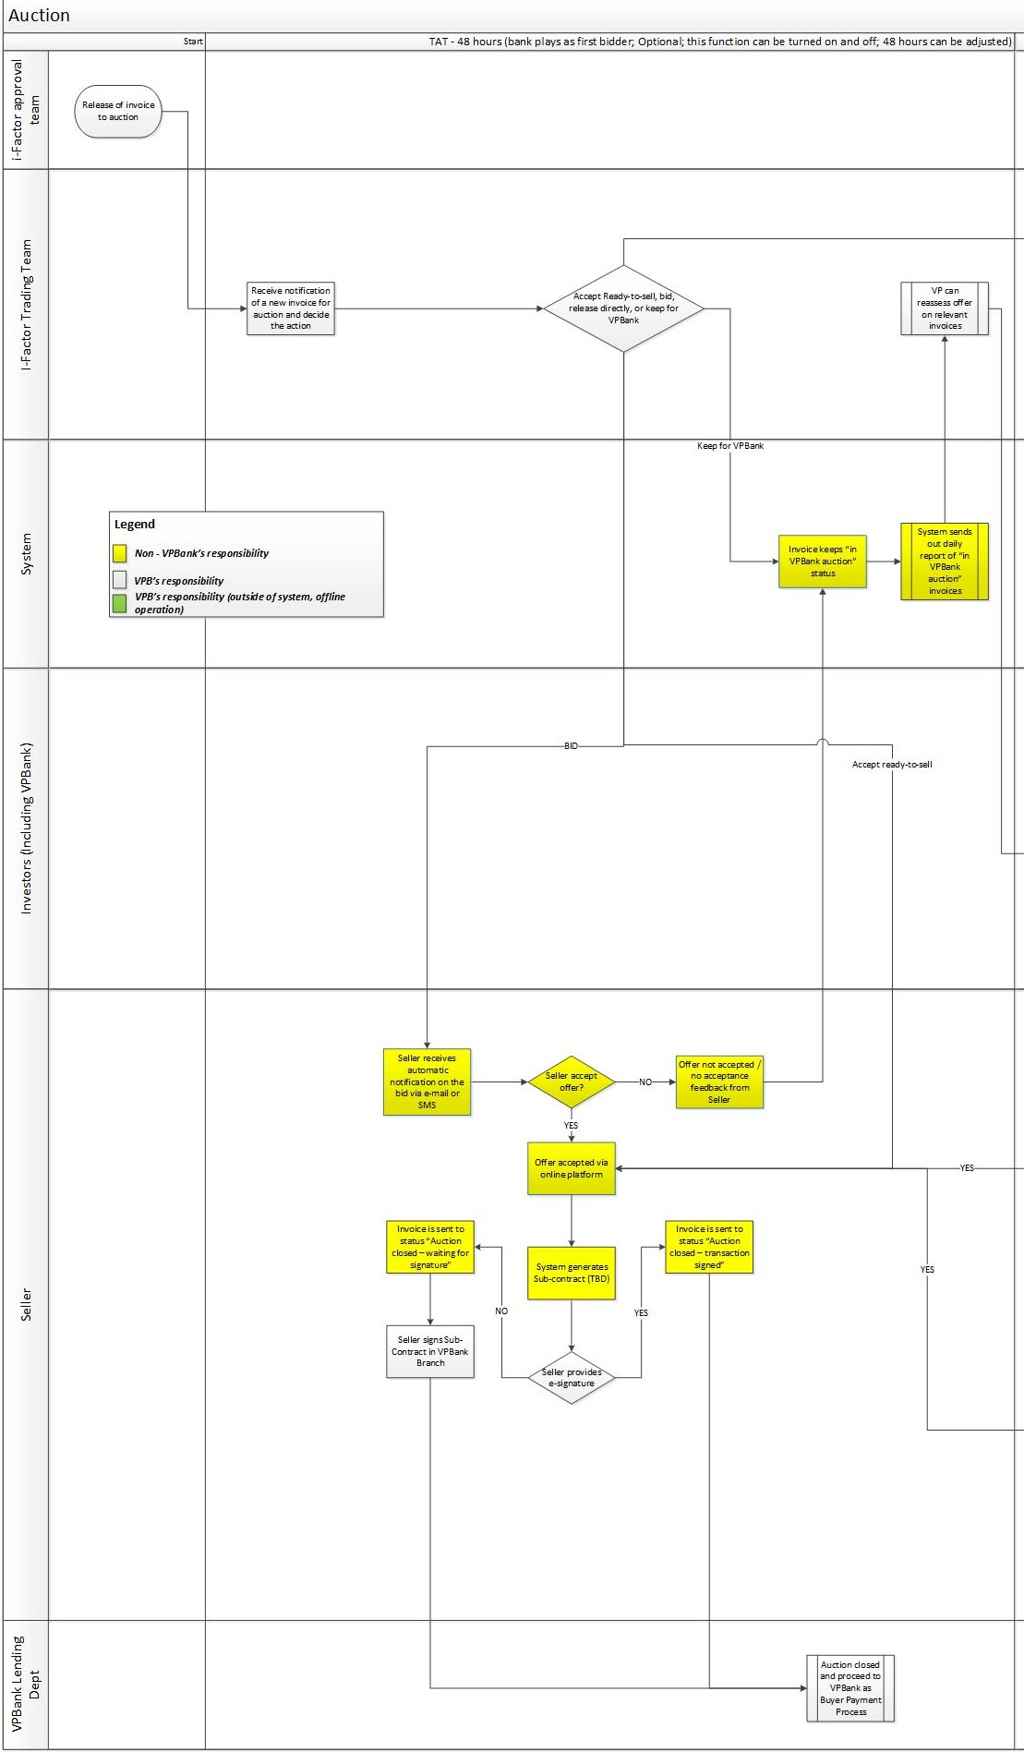

## **Process description**

1. Release invoice to auction
2. VPBank approval team releases accepted invoices to auction
3. All invoices released to auction will have the status “To auction”
4. The screen that shows “To auction” status invoices can be only accessed by i-Factor trading team
5. Receive notification of a new invoice for auction
6. Every new invoice released to auction will appear in “To auction” status screen with Bold
7. Every invoice accessed by an user and before being sent to a different status will be marked in the system and locked for other users’ access, the user name in charge can be seen

E.g.:

|  |
| --- |
| **“To Auction” screen** |
| **Invoice ID** |
| **Invoice ID** |
| Invoice ID |
| Invoice ID |
| Invoice ID |

1. On the same page every user has following options: Accept Ready-to-sell, place a bid, release directly, or keep for VPBank.
2. When an user accesses new invoice from “to auction” status, following information should be displayed:

*Invoice Profile*

* Invoice ID
* Name of Seller
* Seller’s risk rating (H, M, L)
* Name of Debtor
* Debtor’s acknowledgement (YES, if Seller uploaded debtor’s acknowledgement; NO, if Seller did not upload debtor’s acknowledgement)
* Invoice amount
* Invoice remaining term (number of days between upload date and expected payment date)
* Ready to sell (advance %, interest %)
* Attached and checked documents (only the title, e.g. VAT Invoice, Seller-Buyer Contract, Confirmation of goods delivery, Debtor Acknowledgement)

*Market profile*

* Minimum price (advance %, interest %)
* Market index rate (advance %, interest %)

*“Submit”* key

* **Option 1**: Accept Ready-to-sell
* **Option 2**: Place a bid
* **Option 3**: Open to investors
* **Option 4**: Keep with VPBank
  1. According to VPB internal procedure for bidding, releasing or keeping invoices, i-Factor trading team user takes a decision and submits one of the options mentioned above.
  2. User should be able to see Invoice profile and Market profile on the left side of the screen and *Acceptable range*, *Options* 1, 2, 3, 4 on the right of the screen.
  3. **Option 1:** Accept Ready to sell
* When accepting Ready to sell the system will automatically take Advance % = Ready to Sell Advance %, Interest % = Ready to Sell
* Once “Accept Ready to sell” is submitted, system generates automatically Sub-contract (1 doc. Page, content should be defined by VPB, Sub-contract will capture financing amount and interest%)
* System automatically sends out notification to Seller (sms/e-mail) informing on “Ready to Sell” accepted and Auction closed, disbursement will start, e-signature required.

After ready to sell accepted by VPBank, when Seller signs in on the platform he will be automatically redirected to the “After auction” page, “Ready to sell accepted” sub-page, where seller can see the accepted ready to sell.

Seller has 2 options:

* Use e-signature for transaction validation

If Seller chooses e-signature, a new window will be opened showing the Sub-contract document

Seller has to check the box ***Agree*,** if he agrees with the Sub-contract terms

After submitting ***Agree***, Seller will be redirected to the e-signature page

After e-signature is submitted system should be able to capture that Sub-contract is signed

Invoice will be sent to the status “Auction closed – transaction signed”

* Sign transaction in VPBank Branch

If Seller chooses to sign the Sub-contract, a new window will be displayed with the following content:

“In order to validate your transaction and proceed to disbursement, please visit the closest VPBank Branch, in maximum 2 days.”

Invoice will be sent to the status “Auction closed – waiting for signature”

* 1. **Option 2:** Place a bid

New screen will open, containing following fields:

New bid: Advance %, Interest %

*Conditions*

Advance% ≠ Ready to sell advance%, Interest ≠ Ready to sell interest

Advance% > Minimum price advance%, Interest < Minimum price interest%

For M (Medium), L (Low) risk Sellers: Advance < 95%, Interest > 0.25%

For H (High) risk Sellers: Advance < 90%, Interest > 0.25%

Advance can only be: 95%, 90%, 85%, 80%, 75%, **70%.**

Interest can only be: 0.25%, 0.5%, 0.75, 1%, 1.25, 1.5%,…, **20%.**

Bid using Market Index rate

If selected: Advance %, Interest % = current Market Index rate

After placing a bid invoice is sent to status “In VPBank auction”

Immediately a notification is sent to Seller (sms/e-mail) informing to check the bid details on i-Factor platform.

Maximum TAT for “In VPBank auction” status: 48 h

Seller will have 2 options in UI:

1. *Accept offer*

* System generates automatically Sub-contract (1 doc. Page, content should be defined by VPB, Sub-contract will capture financing amount and interest%)
* When Seller press button Accept offer, he has 2 options:
* Use e-signature for transaction validation

If Seller chooses e-signature, a new window will be opened showing the Sub-contract document

Seller has to check the box ***Agree*,** if he agrees with the Sub-contract terms

After submitting ***Agree***, Seller will be redirected to the e-signature page

After e-signature is submitted system should be able to capture that Sub-contract is signed

Invoice will be sent to the status “Auction closed – transaction signed”

* Sign transaction in VPBank Branch

If Seller chooses to sign the Sub-contract, a new window will be displayed with the following content:

“In order to validate your transaction and proceed to disbursement, please visit the closest VPBank Branch, in maximum 2 days.”

Invoice will be sent to the status “Auction closed – waiting for signature”

1. *Don’t accept offer*

If offer not accepted, system keeps automatically invoice status “In VPBank auction”, but the first bid placed by VPBank will be marked as not accepted, **not deleted**.

*If no answer from Seller,* system keeps automatically invoice status “In VPBank auction”

After 48 h, if offer is not accepted by Seller/ no answer from Seller, system changes automatically invoice status from “In VPBank auction” to “In public auction”.

* 1. **Option 3:** Open to investors

If selected, the invoice will be sent directly to status “In public auction”

Invoices from “In public auction” status can be seen by VPBank and by investors (buyers).

* 1. **Option 4:** Keep with VPBank

If selected, the invoice will be sent to status “in VPBank auction” and marked with no bid placed.

Maximum TAT for “In VPBank auction” status: 48 h

After 48 h system changes automatically invoice status from “In VPBank auction” to “In public auction”.

## **Business rules**

1. List of invoice statuses:
   1. “To auction” all invoices sent to auction after verification
   2. “In VPBank auction” all invoices for which VPBank placed a bid (less than 48 h TAT); all invoices for which VPBank accepted Ready to sell (less than 48 h TAT); all invoices for which VPBank decided to Keep with VPBank (less than 48 h TAT)
   3. “In public auction” all invoices sent by VPBank directly to investors and all invoices which stayed in status “In VPBank auction” and TAT 48 h expired
   4. “Auction closed – transaction signed” all invoices for which Seller accepted bid and used e-signature for signing Sub-contract
   5. “Auction closed – waiting for signature” all invoices for which Seller accepted bid but he has to go to VPBank Branch for signing the Sub-contract
2. All invoices from status “In VPBank auction” will be automatically transferred to status “In public auction” after TAT 48 h.
3. System will run daily report for invoices with TAT 24 h in status “In VPBank auction”
4. Anytime for “In VPBank auction” and “In public auction” statuses, VPBank can place bids.

## **Inputs and outputs**

# **Auction for investors**

## **Function description**

Auction can be open for investors by VPBank manually and directly from “To auction” status to “In public auction” status or automatically after 48 h TAT, if no transaction was concluded with VPBank.

Invoices from “In public auction” status can be seen by VPBank and by investors (buyers) and both can place bids. Seller has to accept best bid for auction to be closed.

## **Operation Process**

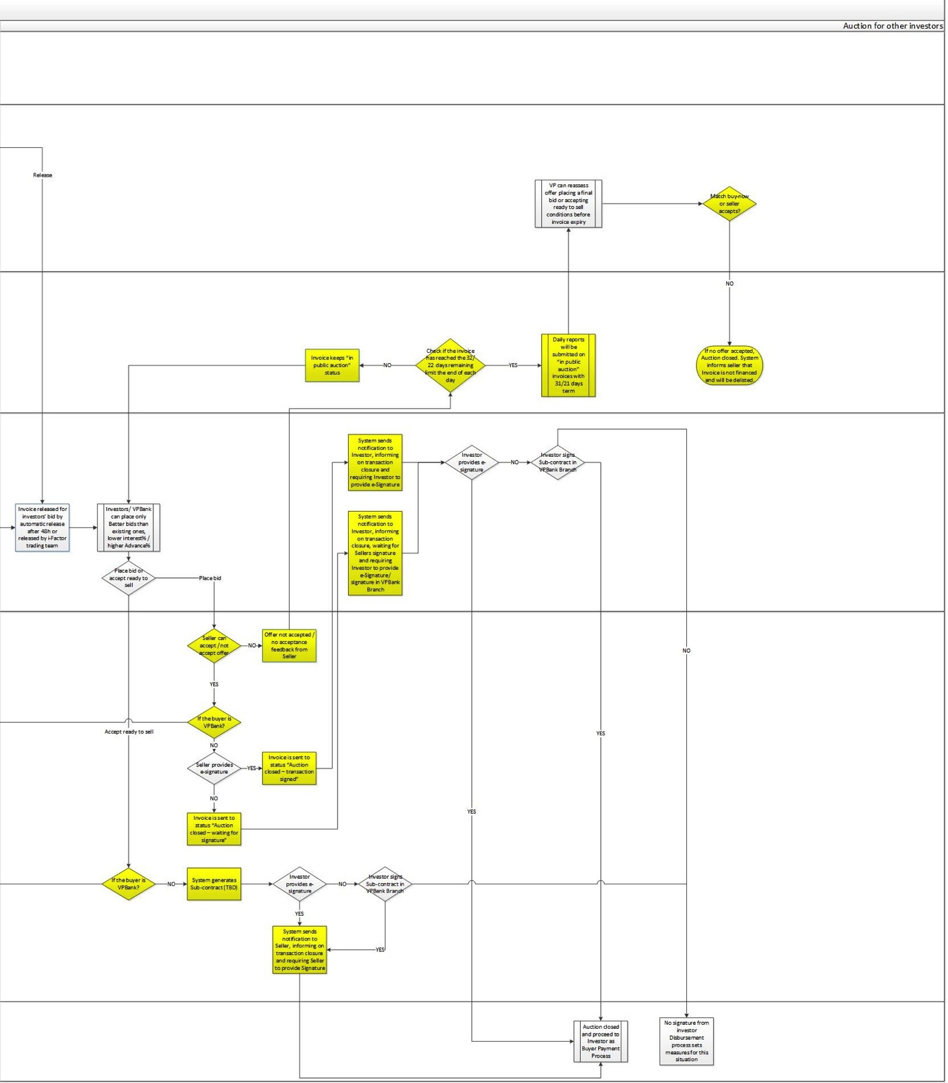

## **Process description**

1. Auction is open for investors
   1. Auction can be open for investors by VPBank manually and directly from “To auction” status to “In public auction” status
   2. Auction can be open for investors automatically after 48 h TAT, if no transaction was concluded with VPBank
2. VPBank place bid
   1. VPBank can see complete profile of the invoice (internal interface)
   2. For placing bid VPBank will follow the same process as mentioned above within 1. Auction for VPBank
   3. VPBank can only place better bids than the existing bids
3. Investors place bid
4. Investors (in UI) can see following details:

*Invoice Profile*

* Invoice ID
* Industry of Debtor
* Size of Debtor
* Invoice amount
* Remaining term
* Ready to sell (advance %, interest %)

*Market profile*

* Minimum price (advance %, interest %)
* Market index rate (advance %, interest %)
* Previous bids (advance %, interest %) – *only if existing*

*“Place bid” key: Advance %, Interest %*

*“Accept Ready to sell” key*

1. Investors should be able to see *Invoice profile* and *Market profile* on the left side of the screen and *Place a bid and Accept Ready to sell* on the right of the screen.
2. Investors can only place better bids than the existing bids
3. Investors accept Ready to Sell

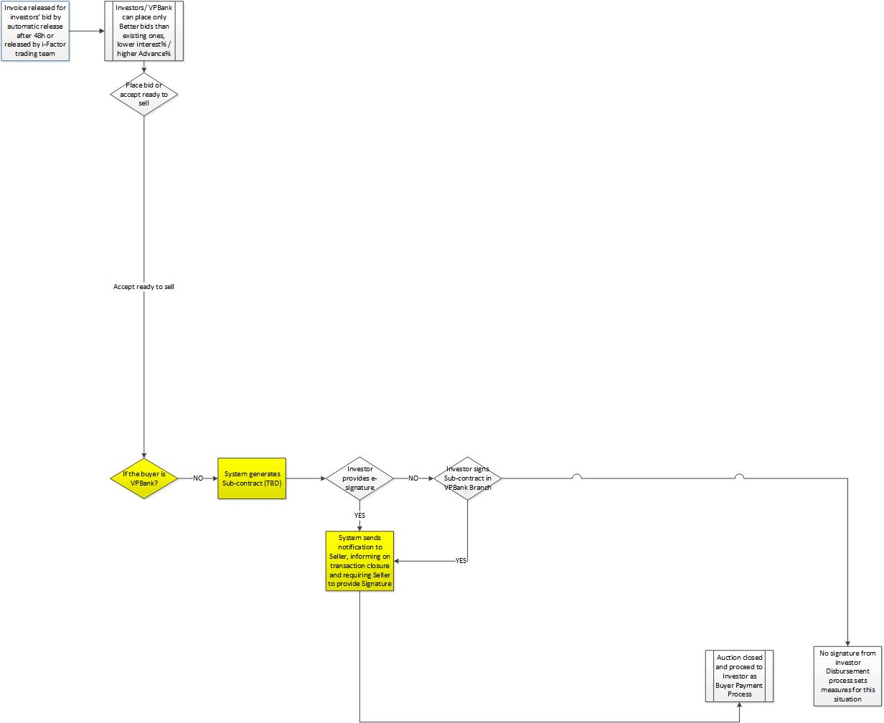

* 1. When accepting Ready to sell the system will automatically take Advance % = Ready to Sell, Interest % = Ready to Sell
  2. Once “Accept Ready to sell” is submitted, system generates automatically Sub-contract (1 doc. Page, content should be defined by VPB, Sub-contract will capture financing amount and interest%)
  3. Investor has 2 options:
     + 1. Use e-signature for transaction validation

If Investor chooses e-signature, a new window will be opened showing the Sub-contract document

Investor has to check the box ***Agree*,** if he agrees with the Sub-contract terms

After submitting ***Agree***, Investor will be redirected to the e-signature page

After e-signature is submitted system should be able to capture that Sub-contract is signed by Investor – transaction signed by Buyer

Invoice will be sent to the status “Auction closed”

* + - 1. Sign transaction in VPBank Branch

If Investor chooses to sign the Sub-contract, a new window will be displayed with the following content:

“In order to validate your transaction and proceed to disbursement, please visit the closest VPBank Branch, in maximum 2 days.”

Invoice will be sent to the status “Auction closed”

* 1. System automatically sends out notification to Seller (sms/e-mail) informing on “Ready to Sell” accepted and Auction closed, disbursement will start, e-signature required.

After ready to sell accepted by Investor, when Seller signs in on the platform he will be automatically redirected to the “After auction” page, “Ready to sell accepted” sub-page, where seller can see the accepted ready to sell.

Seller has 2 options:

* Use e-signature for transaction validation

If Seller chooses e-signature, a new window will be opened showing the Sub-contract document

Seller has to check the box ***Agree*,** if he agrees with the Sub-contract terms

After submitting ***Agree***, Seller will be redirected to the e-signature page

After e-signature is submitted system should be able to capture that Sub-contract is signed

Invoice will be sent to the status “Auction closed – transaction signed”

* Sign transaction in VPBank Branch

If Seller chooses to sign the Sub-contract, a new window will be displayed with the following content:

“In order to validate your transaction and proceed to disbursement, please visit the closest VPBank Branch, in maximum 2 days.”

Invoice will be sent to the status “Auction closed – waiting for signature”

* 1. During the Disbursement process both Seller’s and Investor’s signatures will be verified.
  2. Disbursement process sets rules for the situation that Investor/ Seller don’t provide their signature (e-signature, signature in Branch)

1. Investors place bid

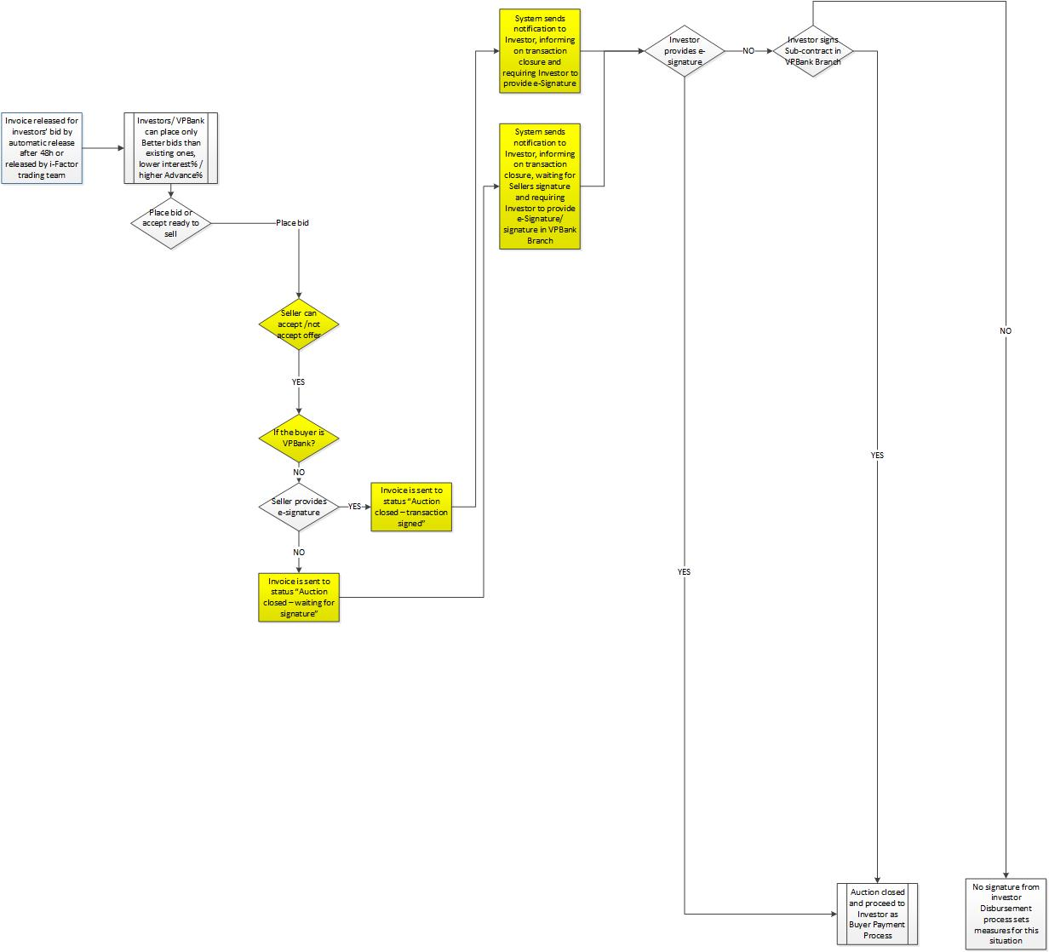

A. Conditions for *“Place bid”*

Advance% ≠ Ready to sell advance%, Interest ≠ Ready to sell interest

Advance% > Minimum price advance%, Interest < Minimum price interest%

Advance % < 90%, Interest > 0%

**Advance % > previous bids Advance %, Interest ≤ previous bids Interest %**

**Advance % = previous bids Advance %, Interest % < previous bids Interest %**

1. System sends out notification to Seller (sms/e-mail) informing to check the new bid details on i-Factor platform.
2. Seller will have 2 options in UI:
   * 1. *Accept offer*

* System generates automatically Sub-contract (1 doc. Page, content should be defined by VPB, Sub-contract will capture financing amount and interest%)
* When Seller press button *Accept offer*, he has 2 options:
* Use e-signature for transaction validation

If Seller chooses e-signature, a new window will be opened showing the Sub-contract document

Seller has to check the box ***Agree*,** if he agrees with the Sub-contract terms

After submitting ***Agree***, Seller will be redirected to the e-signature page

After e-signature is submitted system should be able to capture that Sub-contract is signed by Seller

Invoice will be sent to the status “Auction closed – transaction signed”

* Sign transaction in VPBank Branch

If Seller chooses to sign the Sub-contract, a new window will be displayed with the following content:

“In order to validate your transaction and proceed to disbursement, please visit the closest VPBank Branch, in maximum 2 days.”

Invoice will be sent to the status “Auction closed – waiting for signature”

1. If Seller accepted offer and signed the transaction system will send notification to Investor, informing on transaction closure and requiring Investor to provide e-Signature
2. If Seller accepted offer and did not sign the transaction system sends notification to Investor, informing on transaction closure, waiting for Seller’s signature and requiring Investor to provide e-Signature/ signature in VPBank Branch
3. Investor can use e-signature or sign the Sub-contract in VPBank Branch.
4. During the Disbursement process both Seller’s and Investor’s signatures will be verified.
5. Disbursement process sets rules for the situation that Investor/ Seller don’t provide their signature (e-signature, signature in Branch)
   * 1. *Don’t accept offer*

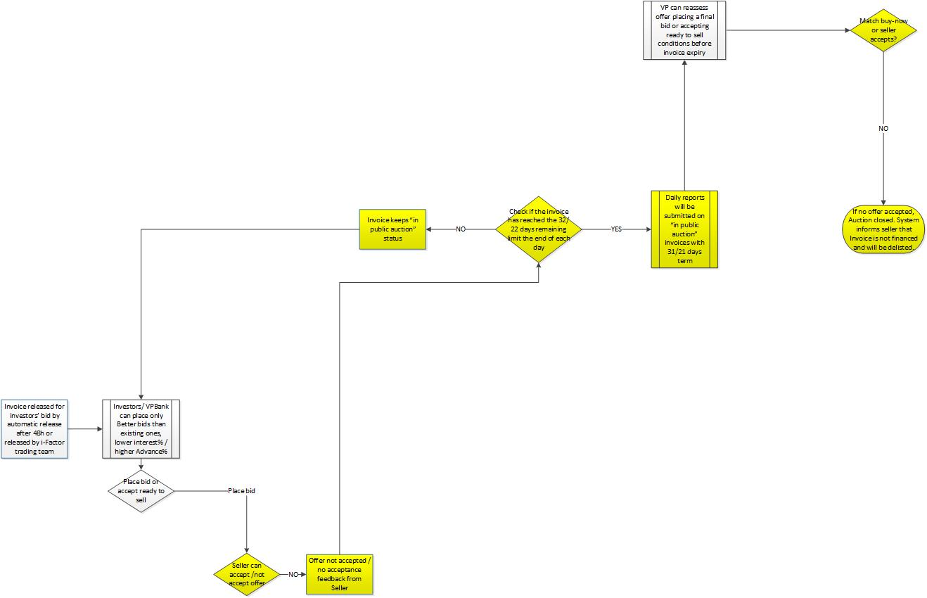

* + 1. If offer not accepted, system keeps automatically invoice status “In public auction”, but the first bid placed by VPBank will be marked as not accepted, **not deleted**.
    2. If no transaction is concluded system keeps automatically invoice status “In public auction” for maximum remaining term of 32 days
    3. In order to monitor invoice term, system will send out daily report for “In public auction” invoices with remaining term 31 days

For invoices accepted to auction on Deviation conditions system will send out daily report for “In public auction” invoices with remaining term 21 days

* + 1. VPBank can reassess invoices with remaining term 31 days and place final bid before invoice expires

For invoices accepted to auction on Deviation conditions VPBank can reassess invoices with remaining term 21 days and place final bid before invoice expires

* + 1. If no transaction is concluded and the invoice remaining term reaches 32 days or 22 days (for invoices accepted to auction on Deviation conditions) system changes automatically invoice status from “In public auction” to “Invoice expired”
    2. For “Invoice expired” system sends automatically notification to seller that invoice is not financed and will be delisted
    3. At this point, invoice can be seen only in the Seller’s UI (“After auction” page, “Expired invoices” sub-page), and in the VPBank internal interface in Seller’s invoices with status “Invoice expired”

## **Business rules**

1. List of invoice statuses:
   1. “In public auction” all invoices sent by VPBank directly to investors and all invoices which stayed in status “In VPBank auction” and TAT 48 h expired
   2. “Auction closed – transaction signed” all invoices for which Seller accepted bid and used e-signature for signing Sub-contract
   3. “Auction closed – waiting for signature” all invoices for which Seller accepted bid but he has to go to VPBank Branch for signing the Sub-contract
   4. “Invoice expired” all invoices which reached maximum remaining term of 32 days
2. System will run daily report for invoices with remaining term 31 days (to be checked with VPBank) in status “In auction”
3. For invoices accepted to auction on Deviation conditions system will send out daily report for “In public auction” invoices with remaining term 21 days
4. Seller can accept only best bid.

## **Inputs and outputs**

**Chapter 5 Reporting**

# **Functional Description**

1. This document consist of a brief overview of all transaction report of i-Factor.
2. Admin/Authorized person/User is enable review reports on user interface (UI).
3. Otherwise person/relevant department as authorized users could export reports into excel or pdf format.

# **Operation process**



# **Process description**

1. User login to User interface
2. Authorized person login to interface designed for internal using by password as provided before
3. Choosing ‘Report section’
4. User choose ‘Report section’ display on Reporting Section
5. Selecting Report group
6. After click on ‘Report Section’, the interface will go directly to the ‘Report Group’ screen that shows 8 group as below:



1. User can choose the kind of report want to see.
2. The choosing viewing report depended on the user’s authority. That means some report group is not limited.
3. Selecting the detailed report
4. After choosing the group report want to see, the interface will display to another screen as second level to show a list of detail report.
5. At that step user can do view the full detail report.
6. Other way the system can allow user do customize to see report on demand based on built up parameter template.
7. Report content will display as the time user confirm by click on ‘Show report’
8. Export or customize the report
9. After user have the report as they want, it is simply to export report to 2 optional format as excel or pdf by click on ‘ excel’ or ‘pdf’ icon

## **Invoices report**

* + 1. **Report List**

The Invoice report Group is breaking down with type of report as shown below:

|  |  |
| --- | --- |
| **Report name** | **Requirement** |
| Aggregate Invoice report by region | Summary and Detail report |
| Aggregate Invoice report by Debtor | Summary and Detail report |
| Aggregate Invoice report by Maturity date | Summary and Detail report |
| Aggregate Invoice report by SME segment | Summary and Detail report |
| Aggregate Invoice report by Seller | Summary and Detail report |
| Aggregate Invoice report by Invoice rating | Summary and Detail report |
| Aggregate Invoice report by Remaining 31 days | Summary and Detail report |
| Aggregate Invoice report by Remaining 21 days (Deviation cases) | Summary and Detail report |

* + 1. **Description**

Description as shown in table below:

|  |  |
| --- | --- |
| Query Parameter | Description |
| Submitted | Total no. and amount of invoices submitted |
| Processing | Total no. and amount of invoices in checking process |
| Rejected | Total no. and amount of invoices failed the checking requirements |
| Accepted | Total no. and amount of invoices successfully pass the checking requirements |
| In Auction (bidded) | Total no. and amount of invoices that are in auction with bid/bids |
| In Auction (un-bidded) | Total no. and amount of invoices that are in auction with no bids |
| Delisted | Total no. and amount of invoices that were delisted (no bids at all or no bids are accepted by seller) due to reaching the 35 days remaining limit |
| Sold | Total no. and amount of invoices sold. (incl. VPBank as a buyer) |
| Disbursed | Total no. and amount of disbursed invoices |
| Settlement | Total no. and amount of settled invoices |
| Overdue | Total no. and amount of overdue invoices (debtors pay late) |
| Region | Cities/Province name; allow max to 6 digits |
| Category of the Debtor | 2 parameters: SOE or Non SOE* |
| Maturity Date | the due date Debtor have to pay for invoice as agreed with Seller |
| SME segment | 3 parameters: Upper SME, SME, MSME |
| Seller rating | 3 parameters: High, Medium, Low |
| Invoice rating | 3 parameters: High, Medium, Low |
| Remaining term 31 days | All invoices have 31 days remaining day ( actual 31 days) |
| Remaining term 21 days (deviation cases) | All deviation invoices have 21 days remaining day (actual 21 days) |
| Ready to sell | The financing and interest rate are ready to sell |
| Existing bids | All the bidding rate of Buyers (financing % and interest rate %). One invoice will have a lot of bidding offers |
| Acknowledgement | YES or NO |
| Invoice ID | Invoice ID - Unique identification of each invoice |
| Seller ID | Seller ID - Unique identification of each customer |
| Debtor ID | Debtor ID - Unique identification of each debtor |

* SOE: State Owned Enterprises

* **Aggregate invoice report by region template**

|  |  |  |  |  |  |  |  |  |  |  |  |  |  |  |  |  |  |  |  |  |  |  |
| --- | --- | --- | --- | --- | --- | --- | --- | --- | --- | --- | --- | --- | --- | --- | --- | --- | --- | --- | --- | --- | --- | --- |
| **Region** | **Submitted** | | **Processing** | | **Rejected** | | **Accepted** | | **In auction (bidded)** | | **In auction (unbidded)** | | **Delisted** | | **Sold** | | **Disbursed** | | **Settled** | | **Overdue** | |
|  | # | $ | # | $ | # | $ | # | $ | # | $ | # | $ | # | $ | # | $ | # | $ | # | $ | # | $ |
| HN |  |  |  |  |  |  |  |  |  |  |  |  |  |  |  |  |  |  |  |  |  |  |
| HCMC |  |  |  |  |  |  |  |  |  |  |  |  |  |  |  |  |  |  |  |  |  |  |
| … |  |  |  |  |  |  |  |  |  |  |  |  |  |  |  |  |  |  |  |  |  |  |
| Total |  |  |  |  |  |  |  |  |  |  |  |  |  |  |  |  |  |  |  |  |  |  |

* **Aggregate Invoice report by Debtor template**

Report template as shown below:

|  |  |  |  |  |  |  |  |  |  |  |  |  |  |  |  |  |  |  |  |  |  |  |
| --- | --- | --- | --- | --- | --- | --- | --- | --- | --- | --- | --- | --- | --- | --- | --- | --- | --- | --- | --- | --- | --- | --- |
| **Category of Debtor** | **Submitted** | | **Processing** | | **Rejected** | | **Accepted** | | **In auction (bidded)** | | **In auction (unbidded)** | | **Delisted** | | **Sold** | | **Disbursed** | | **Settled** | | **Overdue** | |
|  | # | $ | # | $ | # | $ | # | $ | # | $ | # | $ | # | $ | # | $ | # | $ | # | $ | # | $ |
|  |  |  |  |  |  |  |  |  |  |  |  |  |  |  |  |  |  |  |  |  |  |  |
| Total |  |  |  |  |  |  |  |  |  |  |  |  |  |  |  |  |  |  |  |  |  |  |

* **Aggregate invoice report by Maturity date template**

Report template as shown below:

|  |  |  |  |  |  |  |  |  |  |  |  |  |  |  |  |  |  |  |  |  |  |  |
| --- | --- | --- | --- | --- | --- | --- | --- | --- | --- | --- | --- | --- | --- | --- | --- | --- | --- | --- | --- | --- | --- | --- |
| **Maturity date** | **Submitted** | | **Processing** | | **Rejected** | | **Accepted** | | **In auction (bidded)** | | **In auction (unbidded)** | | **Delisted** | | **Sold** | | **Disbursed** | | **Settled** | | **Overdue** | |
|  | # | $ | # | $ | # | $ | # | $ | # | $ | # | $ | # | $ | # | $ | # | $ | # | $ | # | $ |
|  |  |  |  |  |  |  |  |  |  |  |  |  |  |  |  |  |  |  |  |  |  |  |
| Total |  |  |  |  |  |  |  |  |  |  |  |  |  |  |  |  |  |  |  |  |  |  |

Definition of Maturity group

|  |  |
| --- | --- |
| **Group** | **Description** |
| < 45 | Less than 45 days left |
| 45-60 | From 45 days left to 90 days left |
| 60-75 | From 60 days left to 75 days left |
| 75-90 | From 4 days left to 90 days left |
| >90 | More than 90 days |

* **Aggregate invoice report by SME segment template**

Report template as shown below:

|  |  |  |  |  |  |  |  |  |  |  |  |  |  |  |  |  |  |  |  |  |  |  |
| --- | --- | --- | --- | --- | --- | --- | --- | --- | --- | --- | --- | --- | --- | --- | --- | --- | --- | --- | --- | --- | --- | --- |
| **SME segment** | **Submitted** | | **Processing** | | **Rejected** | | **Accepted** | | **In auction (bidded)** | | **In auction (unbidded)** | | **Delisted** | | **Sold** | | **Disbursed** | | **Settled** | | **Overdue** | |
|  | # | $ | # | $ | # | $ | # | $ | # | $ | # | $ | # | $ | # | $ | # | $ | # | $ | # | $ |
|  |  |  |  |  |  |  |  |  |  |  |  |  |  |  |  |  |  |  |  |  |  |  |
| Total |  |  |  |  |  |  |  |  |  |  |  |  |  |  |  |  |  |  |  |  |  |  |

* **Aggregate invoice report by Seller template**

Report template as shown below:

|  |  |  |  |  |  |  |  |  |  |  |  |  |  |  |  |  |  |  |  |  |  |  |
| --- | --- | --- | --- | --- | --- | --- | --- | --- | --- | --- | --- | --- | --- | --- | --- | --- | --- | --- | --- | --- | --- | --- |
| **Seller Rating** | **Submitted** | | **Processing** | | **Rejected** | | **Accepted** | | **In auction (bidded)** | | **In auction (unbidded)** | | **Delisted** | | **Sold** | | **Disbursed** | | **Settled** | | **Overdue** | |
|  | # | $ | # | $ | # | $ | # | $ | # | $ | # | $ | # | $ | # | $ | # | $ | # | $ | # | $ |
|  |  |  |  |  |  |  |  |  |  |  |  |  |  |  |  |  |  |  |  |  |  |  |
| Total |  |  |  |  |  |  |  |  |  |  |  |  |  |  |  |  |  |  |  |  |  |  |

* **Aggregate invoice report by Invoice rating template**

Report template as shown below:

|  |  |  |  |  |  |  |  |  |  |  |  |  |  |  |  |  |  |  |  |  |  |  |
| --- | --- | --- | --- | --- | --- | --- | --- | --- | --- | --- | --- | --- | --- | --- | --- | --- | --- | --- | --- | --- | --- | --- |
| **Invoice Rating** | **Submitted** | | **Processing** | | **Rejected** | | **Accepted** | | **In auction (bidded)** | | **In auction (unbidded)** | | **Delisted** | | **Sold** | | **Disbursed** | | **Settled** | | **Overdue** | |
|  | # | $ | # | $ | # | $ | # | $ | # | $ | # | $ | # | $ | # | $ | # | $ | # | $ | # | $ |
|  |  |  |  |  |  |  |  |  |  |  |  |  |  |  |  |  |  |  |  |  |  |  |
| Total |  |  |  |  |  |  |  |  |  |  |  |  |  |  |  |  |  |  |  |  |  |  |

* **Aggregate invoice report by Remaining term 31 days template**

|  |  |  |  |  |  |  |  |  |
| --- | --- | --- | --- | --- | --- | --- | --- | --- |
| **No.** | **Invoice ID** | **Seller ID** | **Debtor ID** | **Acknowledgement** | **Ready to sell** | | **Existing bids** | |
| Financing % | R % | Financing % | R % |
| 1 |  |  |  |  |  |  |  |  |
| 2 |  |  |  |  |  |  |  |  |

* **Aggregate invoice report by Remaining term 21 days template (Deviation cases)**

|  |  |  |  |  |  |  |  |  |
| --- | --- | --- | --- | --- | --- | --- | --- | --- |
| **No.** | **Invoice ID** | **Seller ID** | **Debtor ID** | **Acknowledgement** | **Ready to sell** | | **Existing bids** | |
| Financing % | R % | Financing % | R % |
| 1 |  |  |  |  |  |  |  |  |
| 2 |  |  |  |  |  |  |  |  |

## **Disbursement report**

* + 1. **Report List**

The Group is breaking down with type of report as shown below:

|  |  |
| --- | --- |
| **Report name** | **Requirement** |
| Invoice detailed disbursement report | Summary and Detail report |

* + 1. **Description**

This report is about to give the detailed disbursement of each invoice

Description as table below:

|  |  |
| --- | --- |
| **Query Parameter** | **Description** |
| Invoice ID | Invoice ID - Unique identification of each invoice |
| Region | Cities/Province name; allow max to 6 digits |
| Rating | Invoice Risk Rating; 3 parameters : High, Medium, Low |
| Invoice amount | Original value of the invoice |
| Disbursed Amount | Net financing amount disbursed to seller |
| Turn Around Time | The total period of time from the time the invoice is submitted to the time that it was sold |
| Deal Financing % | Deal financing; in % number |
| Deal interest rate | Deal Interest rate; in % number |
| Due Date | The invoice agreed payment date |
| Seller ID | Seller ID - Unique identification of each customer |
| Seller Rating | 3 parameters: High/Medium/Low |
| Seller transaction fee | Fees charged to Seller |
| Buyer ID | Buyer ID - Unique identification of each customer |
| Buyer transaction fee | Fees charged to Buyer – *see Free structure section* |
| Debtor ID | Debtor ID - Unique identification of each debtor |
| Debtor Rating | 3 parameters: High/Medium/Low |

* + 1. **Template report**

See the detail report at Section 14

## **In-auction invoice report**

* + 1. **Report List**

The In-Auction Invoice report Group is breaking down with type of report as shown below:

|  |  |
| --- | --- |
| **Report name** | **Requirement** |
| In-Auction invoice for VPBank report | Summary and Detail report |
| In-Auction invoice for public bidding invoice | Summary and Detail report |

* + 1. **Description**

This report is about to give the summary of in-auction invoice.

Description as table below:

|  |  |
| --- | --- |
| **Query Parameter** | **Description** |
| Invoice ID | Invoice ID - Unique identification of each invoice |
| Region | Cities/Province name; allow max to 6 digits |
| Invoice Rating | Invoice Risk Rating (H,M,L); 3 parameters: High/Medium/Low |
| Invoice amount | Original value of the invoice |
| Accepted Date | Date when the invoice is accepted (passed verification) |
| Due Date | The invoice agreed payment date |
| Days till Maturity | No. of days from now till the due date |
| No. of Bid | The total no. of bids placed by the investors |
| Seller ID | Seller ID - Unique identification of each customer |
| Seller Rating | 3 parameters: High/Medium/Low |
| Buyer Rating | 3 parameters: High/Medium/Low |
| Debtor ID | Debtor ID - Unique identification of each debtor |
| Debtor Rating | 3 parameters: High/Medium/Low |

* + 1. **Report Template**
* **In – Auction for VPBank template**

|  |  |  |  |  |  |  |  |  |  |  |  |  |  |
| --- | --- | --- | --- | --- | --- | --- | --- | --- | --- | --- | --- | --- | --- |
| **In-auction for VPBank invoices report** | | | | | | | | | | | | | |
| **No.** | **Invoice ID** | **Region** | **Rating** | **Amount** | **Accepted date** | **Due date** | **Days till maturity** | **No. of Bid** | **Seller ID** | **Seller rating** | **Buyer ID** | **Debtor ID** | **Debtor rating** |
| 1 |  |  |  |  |  |  |  |  |  |  |  |  |  |
| 2 |  |  |  |  |  |  |  |  |  |  |  |  |  |
| … |  |  |  |  |  |  |  |  |  |  |  |  |  |
| **Total** |  |  |  |  |  |  |  |  |  |  |  |  |  |

* **6.3.2. In – Auction for VPBank template**

|  |  |  |  |  |  |  |  |  |  |  |  |  |  |  |
| --- | --- | --- | --- | --- | --- | --- | --- | --- | --- | --- | --- | --- | --- | --- |
| **In-auction invoice for public report** | | | | | | | | | | | | | | |
| **No.** | **Invoice ID** | **Region** | **Rating** | **Amount** | **Accepted date** | **Due date** | **Days till maturity** | **No. of Bid** | **Seller ID** | **Seller rating** | **Buyer ID** | | **Debtor ID** | **Debtor rating** |
| 1 |  |  |  |  |  |  |  |  |  |  |  | |  |  |
| 2 |  |  |  |  |  |  |  |  |  |  |  |  | |  |
| … |  |  |  |  |  |  |  |  |  |  |  | |  |  |
| **Total** |  |  |  |  |  |  |  |  |  |  |  | |  |  |

## **Settle invoice report**

* + 1. **Report List**

The Settle invoice report Group is breaking down with type of report as shown below:

|  |  |
| --- | --- |
| **Report name** | **Requirement** |
| Settle invoice report | Summary and Detail report |

* + 1. **Description**

This report is about to give the summary of settle invoice.

Description as table below:

|  |  |
| --- | --- |
| **Query Parameter** | **Description** |
| Invoice ID | Invoice ID - Unique identification of each invoice |
| Region | Cities/Province name; allow max to 6 digits |
| Rating | Invoice Risk Rating (H,M,L); 3 parameters: High/Medium/Low |
| Invoice amount | Original value of the invoice |
| Due Date | The invoice agreed payment date |
| Debtor's payment date | The actually date when the debtor pays the money to VPB collection account. |
| Seller ID | Seller ID - Unique identification of each customer |
| Seller Rating | 3 parameters: High/Medium/Low |
| Seller transaction fee | Fees charged to Seller |
| Buyer ID | Buyer ID - Unique identification of each customer |
| Buyer transaction fee | Fees charged to Buyer |
| Debtor ID | Debtor ID - Unique identification of each debtor |
| Debtor Rating | 2 parameters: High/Medium/Low |

* + 1. **Report Template**

|  |  |  |  |  |  |  |  |  |  |  |  |  |  |
| --- | --- | --- | --- | --- | --- | --- | --- | --- | --- | --- | --- | --- | --- |
| **No.** | **Invoice ID** | **Region** | **Rating** | **Invoice amount** | **Due date** | **Debtor's payment date** | **Seller ID** | **Seller transaction fees** | **Seller rating** | **Buyer ID** | **Buyer transaction fees** | **Debtor ID** | **Debtor rating** |
| 1 |  |  |  |  |  |  |  |  |  |  |  |  |  |
| 2 |  |  |  |  |  |  |  |  |  |  |  |  |  |
| … |  |  |  |  |  |  |  |  |  |  |  |  |  |
| **Total** |  |  |  |  |  |  |  |  |  |  |  |  |  |

## **Overdue report**

* + 1. **Report List**

The Overdue invoice report Group is breaking down with type of report as shown below:

|  |  |
| --- | --- |
| **Report name** | **Requirement** |
| Overdue report by region | Summary and Detail report |
| Overdue report by Category of the debtor | Summary and Detail report |
| Overdue report by SME segment | Summary and Detail report |
| Overdue report by Seller rating | Summary and Detail report |
| Overdue report by Debtor rating | Summary and Detail report |
| Overdue report by Invoice rating | Summary and Detail report |
| Overdue report by aging rating | Summary and Detail report |

* + 1. **Description**

This report is about to give the summary of Overdue invoice.

Description as table below:

|  |  |
| --- | --- |
| **Query Parameter** | **Description** |
| Invoice ID | Invoice ID - Unique identification of each invoice |
| Region | Cities/Province name; allow max to 6 digits |
| Rating | Invoice Risk Rating (H,M,L); 3 parameters: High/Medium/Low |
| Invoice amount | Original value of the invoice |
| Due Date | The invoice agreed payment date |
| No. of overdue dates | The total number of overdue days |
| Seller | Seller ID - Unique identification of each customer |
| Debtor | Buyer ID - Unique identification of each customer |
| Overdue date group | 4 parameters: 0-30; 31-60; 61-90; > 90 |
| Category of the Debtor | 2 parameters: SOE or Non SOE |
| SME segment | 3 parameters: Upper SME, SME, MSME |
| Seller rating | 3 parameters: High/Medium/Low |
| Debtor rating | 3 parameters: High/Medium/Low |
| Invoice rating | 3 parameters: High/Medium/Low |
| SME segment | 3 parameters: Upper SME, SME, MSME |
| Seller rating | 3 parameters: High/Medium/Low |
| Debtor rating | 3 parameters: High/Medium/Low |

* + 1. **Report Template**
* **Definition of Overdue date Group**

|  |  |
| --- | --- |
| **Group** | **Description** |
| 0-30 | Number of invoice’s overdue is less than 30 days |
| 31-60 | Number of invoice’s overdue is over 30 days but less than 60 days |
| 61-90 | Number of invoice’s overdue is over 60 days but less than 90 days |
| >90 | Number of invoice’s overdue is more than 90 days |

* **Overdue invoice report by region template**

Error! Not a valid link.

* **Overdue invoice report by region template**

|  |  |  |  |  |  |  |  |  |
| --- | --- | --- | --- | --- | --- | --- | --- | --- |
| **Overdue invoices by No. of overdue days** | **0-30** | | **31-60** | | **61-90** | | **>90** | |
| **Category of the debtors** | # | $ | # | $ | # | $ | # | $ |
| SOE |  |  |  |  |  |  |  |  |
| Non-SOE |  |  |  |  |  |  |  |  |
| **Total** |  |  |  |  |  |  |  |  |

* **Overdue invoice report by SME segment template**

|  |  |  |  |  |  |  |  |  |
| --- | --- | --- | --- | --- | --- | --- | --- | --- |
| **Overdue invoices by No. of overdue days** | **0-30** | | **31-60** | | **61-90** | | **>90** | |
| **SME segment** | **#** | **$** | **#** | **$** | **#** | **$** | **#** | **$** |
| **Upper SME** |  |  |  |  |  |  |  |  |
| **SME** |  |  |  |  |  |  |  |  |
| **MSME** |  |  |  |  |  |  |  |  |
| **Total** |  |  |  |  |  |  |  |  |

* **Definition of SME segment**

|  |  |
| --- | --- |
| **Segment** | **Description** |
| Upper SME | N/a |
| SME | N/a |
| MSME | N/a |

* **Overdue invoice report by Seller rating template**

|  |  |  |  |  |  |  |  |  |
| --- | --- | --- | --- | --- | --- | --- | --- | --- |
| **Overdue invoices by No. of overdue days** | **0-30** | | **31-60** | | **61-90** | | **>90** | |
| **Seller rating** | # | $ | # | $ | # | $ | # | $ |
| High |  |  |  |  |  |  |  |  |
| Medium |  |  |  |  |  |  |  |  |
| Low |  |  |  |  |  |  |  |  |
| **Total** |  |  |  |  |  |  |  |  |

* **Overdue invoice report by Debtor rating template**

|  |  |  |  |  |  |  |  |  |
| --- | --- | --- | --- | --- | --- | --- | --- | --- |
| **Overdue invoices by No. of overdue days** | **0-30** | | **31-60** | | **61-90** | | **>90** | |
| **Debtor rating** | # | $ | # | $ | # | $ | # | $ |
| High |  |  |  |  |  |  |  |  |
| Medium |  |  |  |  |  |  |  |  |
| Low |  |  |  |  |  |  |  |  |
| **Total** |  |  |  |  |  |  |  |  |

* **Overdue invoice report by invoice rating template**

|  |  |  |  |  |  |  |  |  |  |
| --- | --- | --- | --- | --- | --- | --- | --- | --- | --- |
| **Overdue invoices by No. of overdue days** | **0-30** | | **31-60** | | **61-90** | | | **>90** | |
| **Invoice rating** | # | $ | # | $ | # | $ | # | | $ |
| High |  |  |  |  |  |  |  | |  |
| Medium |  |  |  |  |  |  |  | |  |
| Low |  |  |  |  |  |  |  | |  |
| **Total** |  |  |  |  |  |  |  | |  |

* **Overdue invoice report by aging rating template**

|  |  |  |  |  |  |  |  |  |
| --- | --- | --- | --- | --- | --- | --- | --- | --- |
| **No.** | **Invoice ID** | **Region** | **Rating** | **Amount** | **Due date** | **No of overdue days** | **Seller** | **Debtor** |
| 1 |  |  |  |  |  |  |  |  |
| 2 |  |  |  |  |  |  |  |  |
| … |  |  |  |  |  |  |  |  |
| **Total** |  |  |  |  |  |  |  |  |

## **Debtor report**

* + 1. **Report List**

The Debtor report Group is breaking down with type of report as shown below:

|  |  |
| --- | --- |
| **Report name** | **Requirement** |
| Retailed Debtor report | Detail report |
| Aggregate debtor report by region | Summary and Detail report |
| Aggregate debtor report by category of debtor | Summary and Detail report |
| Aggregate debtor report by SME segment | Summary and Detail report |
| Aggregate debtor report by Seller rating | Summary and Detail report |
| Aggregate debtor report by Debtor rating | Summary and Detail report |
| Aggregate debtor report by Invoice rating | Summary and Detail report |
| Aggregate debtor report by transaction type | Summary report |

* + 1. **Description**

This report is about to give the summary of debtor info.

Description as table below:

|  |  |
| --- | --- |
| **Query Parameter** | **Description** |
| Debtor ID | Buyer ID - Unique identification of each customer |
| Total No. of invoice | Debtor's total number of invoices |
| Invoice ID | Invoice ID - Unique identification of each invoice |
| Total Amount of invoice | Debtor's total amount of invoices |
| No. of overdue invoices | Debtor's number of overdue invoices |
| Total amount of overdue invoices | Debtor's total amount of overdue invoices |
| Number of invoice over 90 days | Debtor's number of overdue invoices over 90 days |
| Amount of the invoice over 90 days | Debtor's amount of overdue invoices over 90 days |
| Average overdue days | Debtor's average overdue days |
| Number of debtors -Never delinquent | Number of debtors which have never been delinquent |
| Number of debtors -Delinquent | Number of debtors which have been delinquent at least once |
| Number of debtors -Delinquent for over 90 days | Number of debtors which have been delinquent for over 90 days |
| Region | Cities/Province name; allow max to 6 digits |
| Rating | Invoice Risk Rating (H,M,L); 3 parameters: High/Medium/Low |
| Seller ID | Seller ID - Unique identification of each customer |
| Category of the Debtor | 2 parameters: SOE or Non SOE |
| SME segment | 3 parameters: Upper SME, SME, MSME |
| Seller rating | 3 parameters: High/Medium/Low |
| Debtor rating | 3 parameters: High/Medium/Low |
| Invoice rating | 3 parameters: High/Medium/Low |
| SME segment | 3 parameters: Upper SME, SME, MSME |
| Seller rating | 3 parameters: High/Medium/Low |
| Debtor rating | 3 parameters: High/Medium/Low |
| Delinquent | Debtor is late or overdue on a payment |
| Number of debtors -Never delinquent | Number of debtors which have never been delinquent |
| Number of debtors -Delinquent | Number of debtors which have been delinquent at least once |
| Number of debtors -Delinquent for over 90 days | Number of debtors which have been delinquent for over 90 days |
| Received Amount by Cash/others | Actual amount of money take into Seller’s account by cash or through interbank/transfer from another personal account |
| Received Amount from Debtor’s bank transfer | Actual amount of money take into Seller’s account by Debtor’s account through interbank/transfer |
| Invoice Amount | Total amount on original invoice |

* + 1. **Report Template**
* **Debtor detailed report template**

See the detail report at Section 14

* **Debtor report by region template**

|  |  |  |  |
| --- | --- | --- | --- |
| **Region** | **Number of debtors -Never delinquent** | **Number of debtors -Delinquent** | **Number of debtors -Delinquent for over 90 days** |
| Hanoi |  |  |  |
| HCMC |  |  |  |
| … |  |  |  |
| Others |  |  |  |
| **Total** |  |  |  |

* **Debtor report by category of Debtor template**

|  |  |  |  |
| --- | --- | --- | --- |
| **Category of Debtor** | **Number of debtors -Never delinquent** | **Number of debtors -Delinquent** | **Number of debtors -Delinquent for over 90 days** |
| SOE |  |  |  |
| Non SOE |  |  |  |
| **Total** |  |  |  |

* **Debtor report by SME segment template**

|  |  |  |  |
| --- | --- | --- | --- |
| **SME segment** | **Number of debtors -Never delinquent** | **Number of debtors -Delinquent** | **Number of debtors -Delinquent for over 90 days** |
| SOE |  |  |  |
| Non SOE |  |  |  |
| **Total** |  |  |  |

* **Debtor report by Seller rating template**

|  |  |  |  |
| --- | --- | --- | --- |
| **Seller rating** | **Number of debtors -Never delinquent** | **Number of debtors -Delinquent** | **Number of debtors -Delinquent for over 90 days** |
| High |  |  |  |
| Medium |  |  |  |
| Low |  |  |  |
| **Total** |  |  |  |

* **Debtor report by Debtor rating template**

|  |  |  |  |
| --- | --- | --- | --- |
| **Debtor rating** | **Number of debtors -Never delinquent** | **Number of debtors -Delinquent** | **Number of debtors -Delinquent for over 90 days** |
| High |  |  |  |
| Medium |  |  |  |
| Low |  |  |  |
| **Total** |  |  |  |

* **Debtor report by Invoice rating template**

|  |  |  |  |
| --- | --- | --- | --- |
| **Invoice rating** | **Number of debtors -Never delinquent** | **Number of debtors -Delinquent** | **Number of debtors -Delinquent for over 90 days** |
| High |  |  |  |
| Medium |  |  |  |
| Low |  |  |  |
| **Total** |  |  |  |

* **Debtor report by Transaction type**

|  |  |  |  |  |  |  |
| --- | --- | --- | --- | --- | --- | --- |
| **No.** | **Invoice ID** | **Seller ID** | **Debtor** | **Received Amount from Cash/others** | **Received Amount from Debtor’s bank transfer** | **Invoice amount** |
| 1 |  |  |  |  |  |  |
| 2 |  |  |  |  |  |  |
| … |  |  |  |  |  |  |
| **Total** |  |  |  |  |  |  |

## **Seller report**

* + 1. **Report List**

The Seller report Group is breaking down with type of report as shown below:

|  |  |
| --- | --- |
| **Report name** | **Requirement** |
| Seller detailed report | Detail report |
| Aggregate sellers report by Region | Summary and Detail report |
| Aggregate sellers report by Category of debtors | Summary and Detail report |
| Aggregate sellers report by SME segments | Summary and Detail report |
| Aggregate sellers report by Seller rating | Summary and Detail report |
| Aggregate sellers report by Debtor rating | Summary and Detail report |
| Aggregate sellers report by Invoice rating | Summary and Detail report |

* + 1. **Description**

This report is about to give the summary of seller info.

Description as table below:

|  |  |
| --- | --- |
| **Query Parameter** | **Description** |
| Seller ID | Seller ID - Unique identification of each customer |
| Region | Cities/Province name; allow max to 6 digits |
| Number of invoices submitted | Total number of invoices submitted online |
| Number of invoices accepted | Total number of accepted invoices |
| Amount | Total amount of accepted invoices |
| Number of invoices disbursed | Total number of disbursed invoice |
| Disbursed Amount | Total amount of disbursed invoice |
| Weight Average % financing | Weight Average % financing |
| Weight Average % interest | Weight Average % interest |
| Number of cancellation | Number of Seller’s cancellation |
| Category of the Debtor | 2 parameters: SOE or Non SOE |
| SME segment | 3 parameters: Upper SME, SME, MSME |
| Seller rating | 3 parameters: High/Medium/Low |
| Debtor rating | 3 parameters: High/Medium/Low |
| Invoice rating | 3 parameters: High/Medium/Low |
| SME segment | 3 parameters: Upper SME, SME, MSME |
| Seller rating | 3 parameters: High/Medium/Low |
| Debtor rating | 3 parameters: High/Medium/Low |

* + 1. **Report Template**
* **Seller detailed report template**

|  |  |  |  |  |  |  |  |  |  |  |
| --- | --- | --- | --- | --- | --- | --- | --- | --- | --- | --- |
| **No.** | **Seller ID** | **Region** | **Number of invoices submitted** | **Number of invoices accepted** | **Amount** | **Number of invoices disbursed** | **Disbursed amount** | **Weighted average % financing** | **Weighted average interest rate** | **Number of cancellations** |
| 1 |  |  |  |  |  |  |  |  |  |  |
| 2 |  |  |  |  |  |  |  |  |  |  |
| … |  |  |  |  |  |  |  |  |  |  |
|  | Total |  |  |  |  |  |  |  |  |  |

* **Seller report by region template**

|  |  |  |  |  |  |  |  |
| --- | --- | --- | --- | --- | --- | --- | --- |
| **Region** | **Applied** | **Accepted** | **Financed** | **Weighted average % financing** | **Weighted average interest rate** | **Fraud**  **blacklisted** | **Cancellation blacklisted** |
| Hanoi |  |  |  |  |  |  |  |
| HCM |  |  |  |  |  |  |  |
| … |  |  |  |  |  |  |  |
| Others |  |  |  |  |  |  |  |
| **Total** |  |  |  |  |  |  |  |

* **Seller report by category of debtor template**

|  |  |  |  |  |  |  |  |
| --- | --- | --- | --- | --- | --- | --- | --- |
| **Category of Debtor** | **Applied** | **Accepted** | **Financed** | **Weighted average % financing** | **Weighted average interest rate** | **Fraud**  **blacklisted** | **Cancellation blacklisted** |
| SOE |  |  |  |  |  |  |  |
| Non SOE |  |  |  |  |  |  |  |
| **Total** |  |  |  |  |  |  |  |

* **Seller report by category of SME segment template**

|  |  |  |  |  |  |  |  |
| --- | --- | --- | --- | --- | --- | --- | --- |
| **SME segment** | **Applied** | **Accepted** | **Financed** | **Weighted average % financing** | **Weighted average interest rate** | **Fraud**  **blacklisted** | **Cancellation blacklisted** |
| Upper SME |  |  |  |  |  |  |  |
| SME |  |  |  |  |  |  |  |
| MSME |  |  |  |  |  |  |  |
| **Total** |  |  |  |  |  |  |  |

* **Seller report by category of seller rating template**

|  |  |  |  |  |  |  |  |
| --- | --- | --- | --- | --- | --- | --- | --- |
| **Seller** | **Applied** | **Accepted** | **Financed** | **Weighted average % financing** | **Weighted average interest rate** | **Fraud**  **blacklisted** | **Cancellation blacklisted** |
| High |  |  |  |  |  |  |  |
| Medium |  |  |  |  |  |  |  |
| Low |  |  |  |  |  |  |  |
| **Total** |  |  |  |  |  |  |  |

* **Seller report by category of Debtor rating template**

|  |  |  |  |  |  |  |  |
| --- | --- | --- | --- | --- | --- | --- | --- |
| **Debtor rating** | **Applied** | **Accepted** | **Financed** | **Weighted average % financing** | **Weighted average interest rate** | **Fraud**  **blacklisted** | **Cancellation blacklisted** |
| High |  |  |  |  |  |  |  |
| Medium |  |  |  |  |  |  |  |
| Low |  |  |  |  |  |  |  |
| **Total** |  |  |  |  |  |  |  |

* **Seller report by category of Invoice rating template**

|  |  |  |  |  |  |  |  |
| --- | --- | --- | --- | --- | --- | --- | --- |
| **Invoice rating** | **Applied** | **Accepted** | **Financed** | **Weighted average % financing** | **Weighted average interest rate** | **Fraud**  **blacklisted** | **Cancellation blacklisted** |
| High |  |  |  |  |  |  |  |
| Medium |  |  |  |  |  |  |  |
| Low |  |  |  |  |  |  |  |
| **Total** |  |  |  |  |  |  |  |

## **Buyer report**

* + 1. **Report List**

The Buyer report Group is breaking down with type of report as shown below:

|  |  |
| --- | --- |
| **Report name** | **Requirement** |
| Seller detailed report | Detail report |
| Aggregate sellers report by Region | Summary and Detail report |
| Aggregate sellers report by Category of debtors | Summary and Detail report |
| Aggregate sellers report by SME segments | Summary and Detail report |
| Aggregate sellers report by Seller rating | Summary and Detail report |
| Aggregate sellers report by Debtor rating | Summary and Detail report |
| Aggregate sellers report by Invoice rating | Summary and Detail report |

* + 1. **Description**

This report is about to give the summary of Buyer.

Description as table below:

|  |  |
| --- | --- |
| **Query Parameter** | **Description** |
| Seller ID | Seller ID - Unique identification of each customer |
| Region | Cities/Province name; allow max to 6 digits |
| Number of bid placed | Number of bids that the buyer placed during a certain period of time |
| Number of bid accepted | Number of bids of the buyer which are accepted during a certain period of time |
| % of successful bid | Bid successful percentage |
| Return | Total return of the buyer during a certain period of time |
| Weighted average % financing | Weighted average % financing |
| Weighted average interest rate | Weighted average interest rate |
| Applied | Total number of buyers applied |
| Accepted | Total number of buyers accepted |
| Invested | Total number of buyers invested |
| Regulatory blacklisted | Total number of buyers regulatory blacklisted |
| Cancellation blacklisted | Total number of buyers cancellation blacklisted |
| Category of the Debtor | 2 parameters: SOE or Non SOE |
| SME segment | 3 parameters: Upper SME, SME, MSME |
| Seller rating | 3 parameters: High/Medium/Low |
| Debtor rating | 3 parameters: High/Medium/Low |
| Invoice rating | 3 parameters: High/Medium/Low |
| SME segment | 3 parameters: Upper SME, SME, MSME |
| Seller rating | 3 parameters: High/Medium/Low |
| Debtor rating | 3 parameters: High/Medium/Low |

* + 1. **Report Template**
* **Buyer detailed report template**

|  |  |  |  |  |  |  |  |  |
| --- | --- | --- | --- | --- | --- | --- | --- | --- |
| **No.** | **Buyer ID** | **Region** | **Number of bid placed** | **Number of bid accepted** | **% of successful bid** | **Return** | **Weighted average % financing** | **Weighted average interest rate** |
| 1 |  |  |  |  |  |  |  |  |
| 2 |  |  |  |  |  |  |  |  |
| … |  |  |  |  |  |  |  |  |

* **Aggregate Buyer report by region template**

|  |  |  |  |  |  |  |  |
| --- | --- | --- | --- | --- | --- | --- | --- |
| **Region** | **Applied** | **Accepted** | **Invested** | **Weighted average % financing** | **Weighted average interest rate** | **Regulatory blacklisted** | **Cancellation blacklisted** |
| Hanoi |  |  |  |  |  |  |  |
| HCM |  |  |  |  |  |  |  |
| … |  |  |  |  |  |  |  |
| Others |  |  |  |  |  |  |  |
| **Total** |  |  |  |  |  |  |  |

* **Aggregate buyer report by Category of Debtor template**

|  |  |  |  |  |  |  |  |
| --- | --- | --- | --- | --- | --- | --- | --- |
| **Category of Debtor** | **Applied** | **Accepted** | **Invested** | **Weighted average % financing** | **Weighted average interest rate** | **Regulatory blacklisted** | **Cancellation blacklisted** |
| SOE |  |  |  |  |  |  |  |
| Non-SOE |  |  |  |  |  |  |  |
| **Total** |  |  |  |  |  |  |  |

* **Aggregate Buyer report by SME segment template**

|  |  |  |  |  |  |  |  |
| --- | --- | --- | --- | --- | --- | --- | --- |
| **SME segment** | **Applied** | **Accepted** | **Invested** | **Weighted average % financing** | **Weighted average interest rate** | **Regulatory blacklisted** | **Cancellation blacklisted** |
| Upper SME |  |  |  |  |  |  |  |
| SME |  |  |  |  |  |  |  |
| MSME |  |  |  |  |  |  |  |
| **Total** |  |  |  |  |  |  |  |

* **Aggregate Buyer report by selling rating template**

|  |  |  |  |  |  |  |  |
| --- | --- | --- | --- | --- | --- | --- | --- |
| **Selling rating** | **Applied** | **Accepted** | **Invested** | **Weighted average % financing** | **Weighted average interest rate** | **Regulatory blacklisted** | **Cancellation blacklisted** |
| High |  |  |  |  |  |  |  |
| Medium |  |  |  |  |  |  |  |
| Low |  |  |  |  |  |  |  |
| **Total** |  |  |  |  |  |  |  |

* **Aggregate Buyer report by Debtor rating template**

|  |  |  |  |  |  |  |  |
| --- | --- | --- | --- | --- | --- | --- | --- |
| **Debtor**  **rating** | **Applied** | **Accepted** | **Invested** | **Weighted average % financing** | **Weighted average interest rate** | **Regulatory blacklisted** | **Cancellation blacklisted** |
| High |  |  |  |  |  |  |  |
| Medium |  |  |  |  |  |  |  |
| Low |  |  |  |  |  |  |  |
| **Total** |  |  |  |  |  |  |  |

* **Aggregate Buyer report by Invoice rating template**

|  |  |  |  |  |  |  |  |
| --- | --- | --- | --- | --- | --- | --- | --- |
| **Invoice**  **rating** | **Applied** | **Accepted** | **Invested** | **Weighted average % financing** | **Weighted average interest rate** | **Regulatory blacklisted** | **Cancellation blacklisted** |
| High |  |  |  |  |  |  |  |
| Medium |  |  |  |  |  |  |  |
| Low |  |  |  |  |  |  |  |
| **Total** |  |  |  |  |  |  |  |

# **Business rules**

1. Cut-off time of report should be 00:00:00 – 23:59:59
2. Report will be issued by user
3. Report can extract to excel or pdf format
4. User can view on internal user interface.
5. Report types

There are 2 kind of report in platform namely detail reports and summary reports.

|  |  |
| --- | --- |
| **Kind of report** | **Description** |
| Detail report | A single report with a specified time period and various query parameters. |
| Summary report | Report on data collected over a period of time. For example, you can check the number of invoices that are successful bidding over a week or month distributed by region. |
| Monthly report | From the 00:00:01 of first day of month to 23:59:00 of last day of the month |
| Daily report | From the 00:00:00 of day to 23:59:00 end of day |

1. Structural report: Reports are designed to aim to monitoring purpose that includes 3 management flows: Business Management, Operational Management and Risk Management. The table below is in detail of structural reports:

|  |  |  |
| --- | --- | --- |
|  | **Report name** | **Description** |
| 1 | Invoices Report | 6 reports |
| 2 | Disbursement report | 1 report |
| 3 | In-auction report | 2 reports |
| 4 | Settled invoices report | 1 report |
| 5 | Overdue Invoices report | 2 reports |
| 6 | Debtor report | 7 reports |
| 7 | Seller report | 7 reports |
| 8 | Seller report | 7 reports |

1. Relevant Departments for monitoring report: These reports are designed and limit for various single user from different departments to using based on each their needs for monitoring. The departments should decide person who is authorized with limitation right to access and use data from reports.

# **Inputs and Outputs**

# **Other template report**

Disbursement detailed report template – Section 5

|  |  |  |  |  |  |  |  |  |  |  |  |  |  |  |  |  |
| --- | --- | --- | --- | --- | --- | --- | --- | --- | --- | --- | --- | --- | --- | --- | --- | --- |
| **No.** | **Invoice ID** | **Region** | **Rating** | **Invoice amount** | **Disbursed amount** | **Turnaround time** | **Deal Financing %** | **Deal interest rate** | **Due date** | **Seller transaction fees** | **Seller ID** | **Seller rating** | **Buyer transaction fees** | **Buyer ID** | **Debtor ID** | **Debtor rating** |
| 1 |  |  |  |  |  |  |  |  |  |  |  |  |  |  |  |  |
| 2 |  |  |  |  |  |  |  |  |  |  |  |  |  |  |  |  |
| … |  |  |  |  |  |  |  |  |  |  |  |  |  |  |  |  |
| **Total** |  |  |  |  |  |  |  |  |  |  |  |  |  |  |  |  |

Debtor detail report template – Section 9

|  |  |  |  |  |  |  |  |  |
| --- | --- | --- | --- | --- | --- | --- | --- | --- |
| **No.** | **Debtor ID** | **Number of invoices** | **Amount** | **Number of invoices overdue** | **Amount overdue** | **Number of invoices over 90 days past due** | **Amount over 90days past due** | **Average overdue days** |
| 1 |  |  |  |  |  |  |  |  |
| 2 |  |  |  |  |  |  |  |  |
| … |  |  |  |  |  |  |  |  |
| Total |  |  |  |  |  |  |  |  |

**Chapter 6 Payment Process for VPB buyer**

# **Function description**

After auction is closed, I-Factor system has to calculate disbursement amount and interact with VPBank related departments and Core Banking System to implement the disbursement phase. This process implements payment process in case VPB is buyer.

# **Operation process**

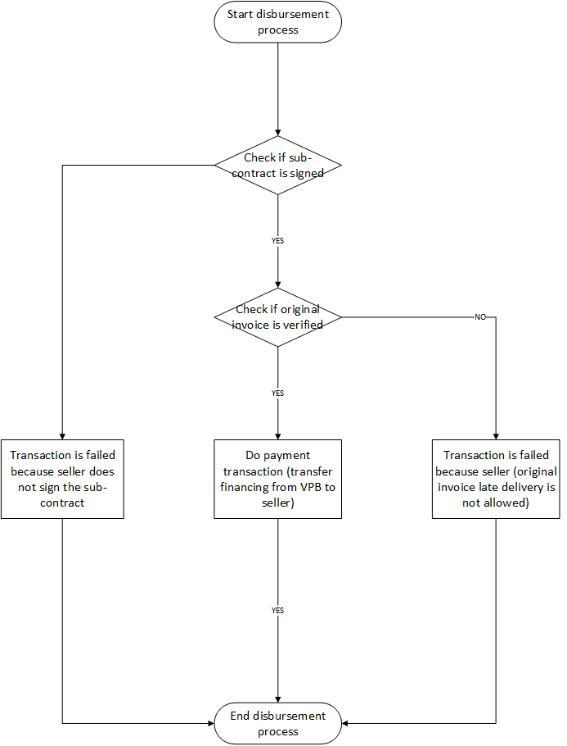  
*Figure 6.1. Overall process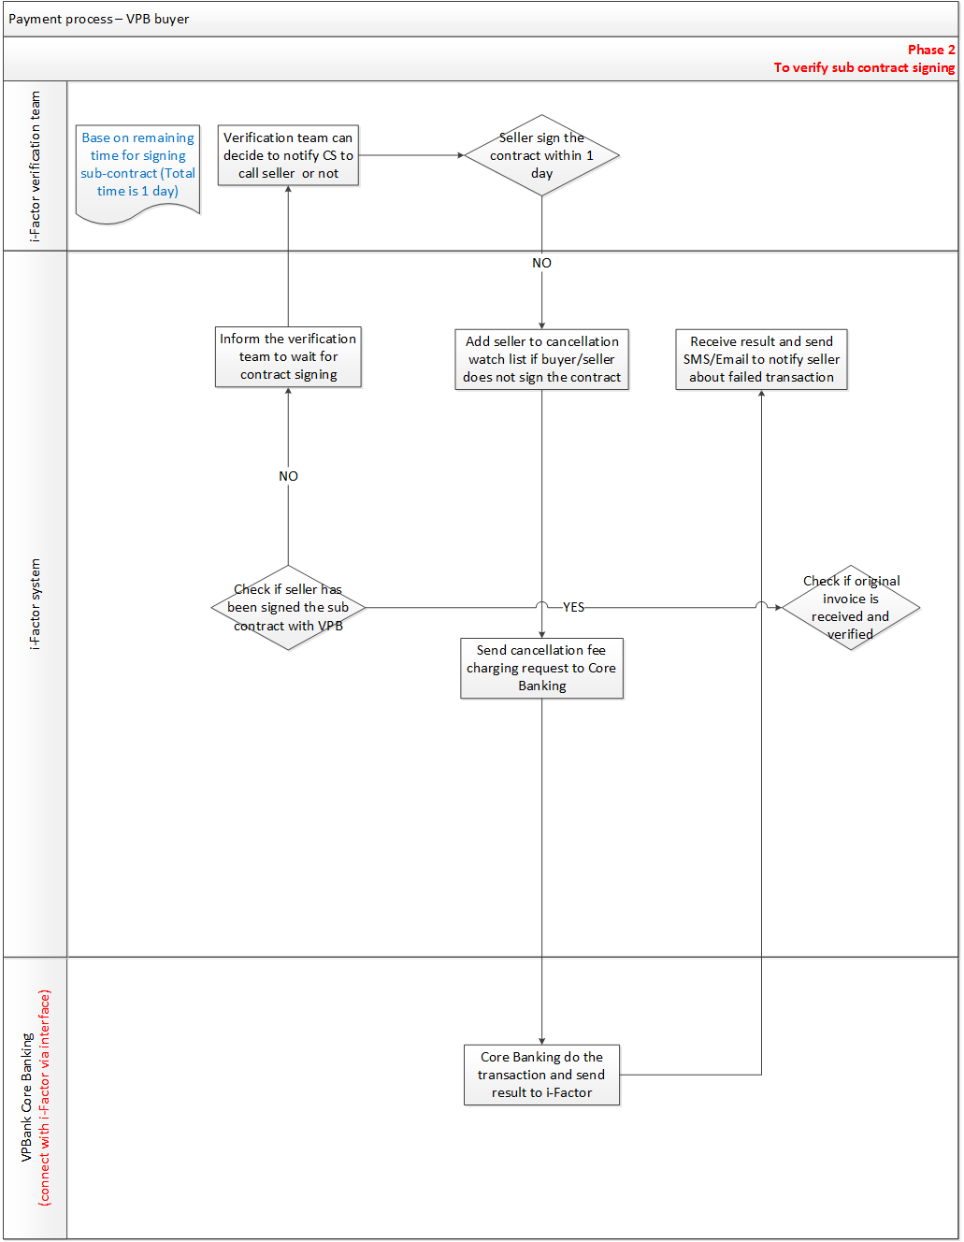 Figure 6.2. To verify sub contract signing*  
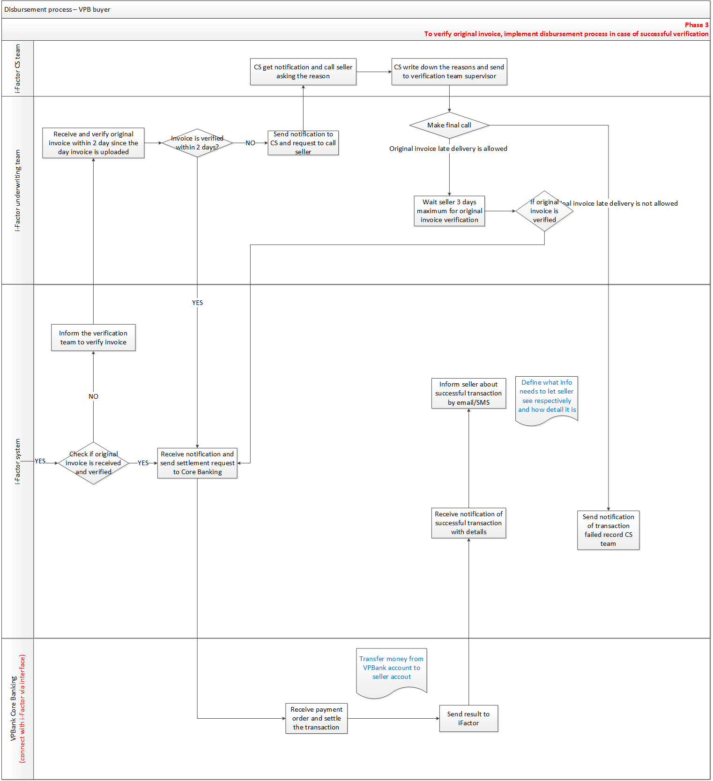 *Figure 6.3. To verify original invoice, implement disbursement process in case of successful verification*  
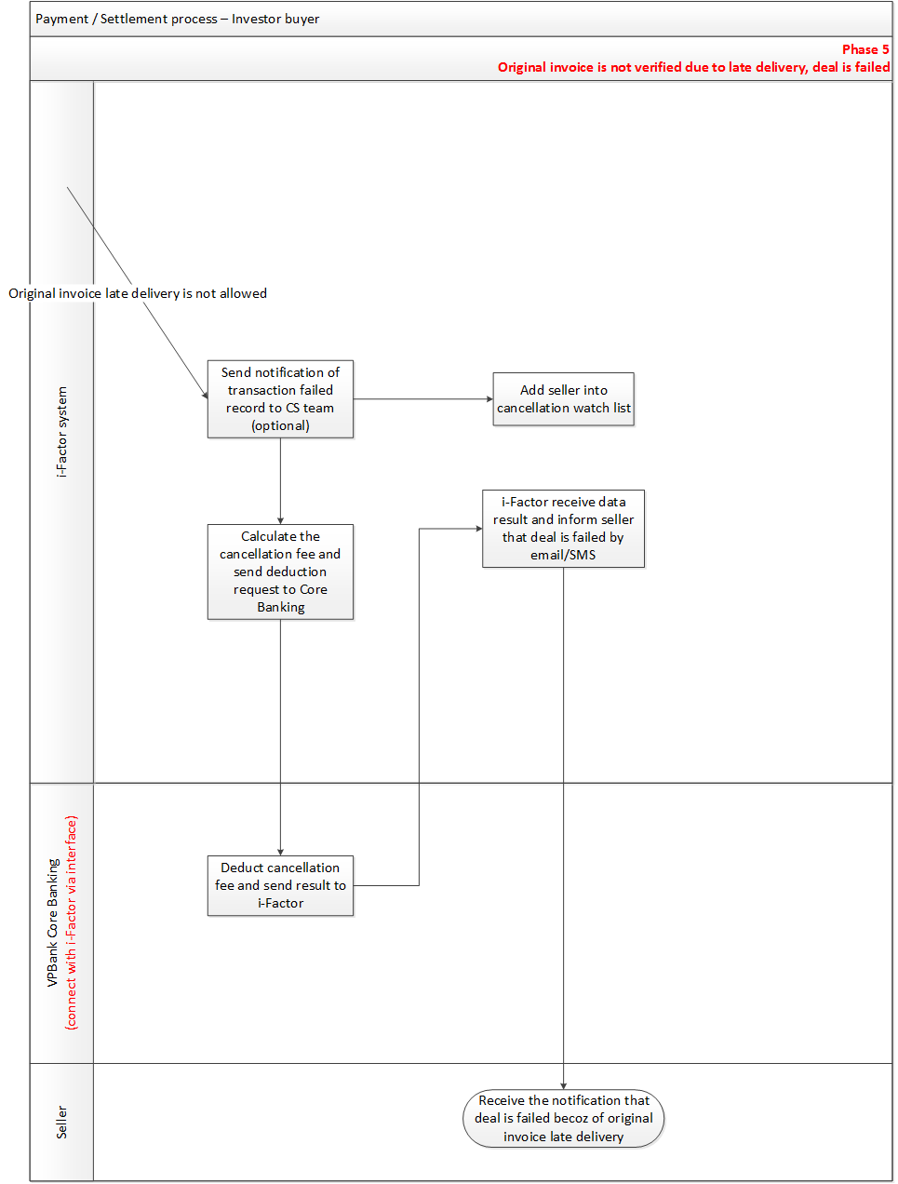*Figure 6.4 Original invoice is not verified. Deal is failed*

# **Process description**

1. **Overall process (Figure 6.1)**1. Start disbursement process  
   2. If sub-contract is not signed within 1 day from the day auction is dealt, transaction is failed  
   3. If sub-contract is signed within 1 day, continue to check verification status of original invoice.  
   4. If original invoice is not verified within certain days from uploaded day (VPB define), transaction is failed because seller does not delivery original invoice in time.  
   5. If original invoice is verified within certain days from uploaded day (VPB define), transfer money from VPB to seller. The disbursement process end.
2. **Phase 1: To calculate disbursement amount**1. I-Factor system receives deal details right after the auction is closed.  
   2. I-Factor system calculate the disbursement amount (Seller amount is financing amount deduct transaction fee).
3. **Phase 2: To verify sub contract signing (Figure 6.2)**1. I-Factor check if seller has been signed the sub contract with VPB  
   *2. If seller has been signed the sub contract, continue to verify the original invoice (phase 3)*  
   *3. If seller has not been signed the sub contract, i-Factor Inform the verification team to wait for contract signing*  
   3.1. Verification team can decide to notify CS to call seller and buyer or not  
   *3.2. If seller sign the contract within 1 day, continue to verify the original invoice (phase 3)*  
   *3.3. If seller does not sign the contract within 1 day, i-Factor add seller to cancellation*  
   3.3.1. i-Factor send cancellation fee charging request to Core Banking  
   3.3.2. Core Banking do the transaction and send result to i-Factor  
   3.3.3. i-Factor receive result and send seller notification about failed transaction via email/SMS
4. **Phase 3: To verify original invoice, implement disbursement process in case of successful verification** **(Figure 6.3)**  
   1. I-Factor check if original invoice has been received and verified  
   2. *If original invoice has been received and verified, send settlement request to Core Banking (Transfer financing deduct transaction fee from VPB account to seller account)*2.1. Core Banking receive payment order and settle the transaction, send result to i-Factor  
   2.2. i-Factor inform seller about successful transaction via email/SMS  
   3. *If original invoice has not been received or verified, i-Factor inform the underwriting team to verify the invoice*  
   3.1. Underwriting team receive inform and verify original invoice within 2 days since the day invoice is uploaded  
   *3.2. If the invoice is verified within 2 days, i-Factor send disbursement request to Core Banking, continue process of pre freeze the buyer account and checking if VPB can take over the auction (step 2)*3.3. *If the invoice is not verified within 2 days, underwriting team send notification to Customer Service (CS) team and request CS to call seller*3.3.1. CS get notification and call seller to ask for the reason of late invoice delivery.  
   3.3.2. CS get response from seller, write down the reasons and send to underwriting team supervisor.  
   3.3.3. Underwriting team make a final call to seller to decide to allow late original invoice delivery or not  
   *3.3.4. If original invoice late delivery is allowed, underwriting team wait seller 3 days maximum for original invoice verification  
   3.3.4.1. If original invoice is verified, i-Factor send settlement request to Core Banking, repeat from step 2 to 2.2  
   3.3.4.2. If original invoice is not verified, transaction is failed, i-Factor can send notification of transaction failed record to CS team (optional), continue process of transaction is failed because of seller.*  
   *3.3.5. If original invoice late delivery is not allowed, transaction is failed, continue process of transaction is failed because of seller.*
5. **Phase 4: Original invoice is not verified. Deal is failed (Figure 6.4)**1. If original invoice late delivery is not allowed (step 3.3.5, phase 3), i-Factor can send notification of transaction failed record to CS team (optional)   
   2. I-Factor add seller into cancellation watch list   
   3. I-Factor calculate the cancellation fee and send deduction request to Core Banking  
   4. Core Banking deduct cancellation fee and send result to i-Factor  
   5. I-Factor receive result and inform seller that deal is failed by email/SMS

# **Business rules**

1. Email/SMS template must be defined for each situation.
2. Period for verifying invoice should be defined in the system (by VPBank).
3. The formula of transaction fee, cancellation fee calculation should be set in i-Factor system. The fee must be calculated automatically.
4. Sub-contract can be verified using e-signature or via uploaded scanned contract. i-Factor generate sub contract, seller print out the contract, sign and stamp, scan it, then upload to i-Factor website. I-Factor verification team will verify the uploaded contract.
5. The period for verifying e-signature and sub-contract should be configured automatically in system.

# **Inputs and Outputs**

**Chapter 7 Payment Process for Investor Buyer**

# **Function description**

After auction is closed, I-Factor system has to calculate disbursement amount and interact with VPBank related departments and Core Banking System to implement the disbursement phase. This process implements payment process in case investor is buyer.

# **Operation process**

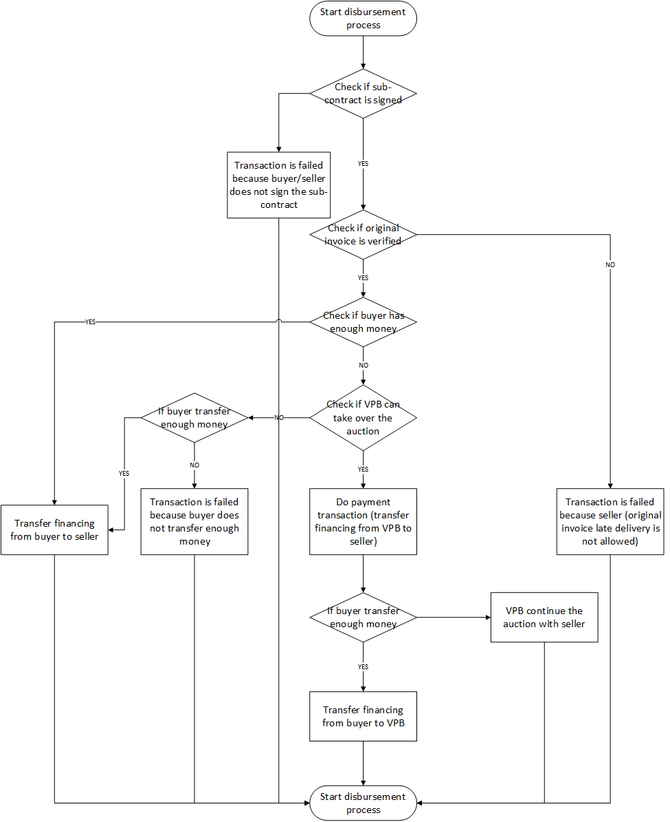  
*Figure 7.1. Overall process*

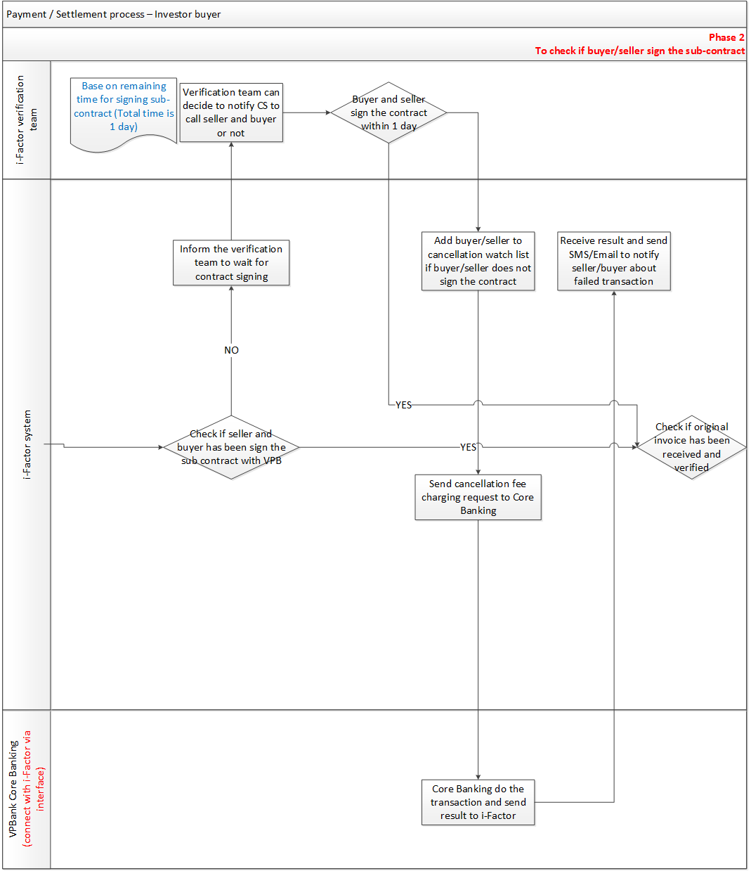 *Figure 7.2. To check if buyer/seller has been signed the sub contract*  
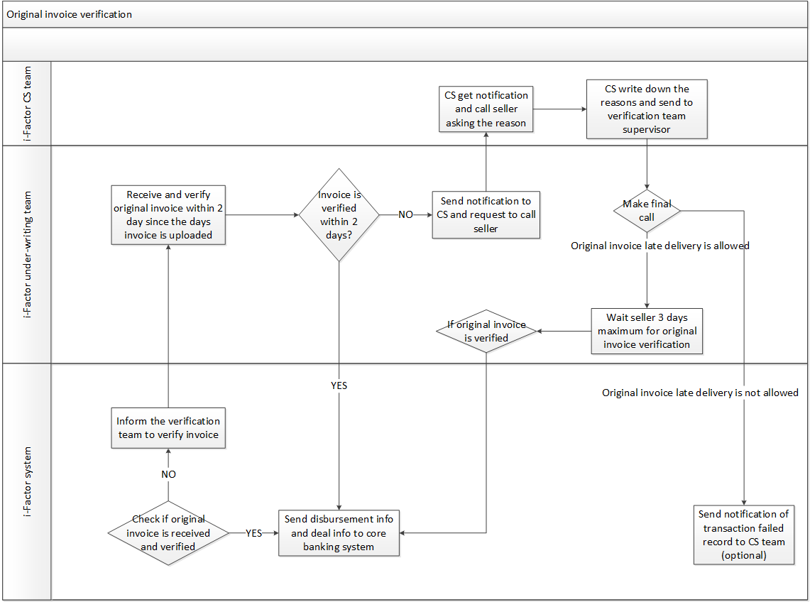

*Figure 7.3. Original invoice verification*

*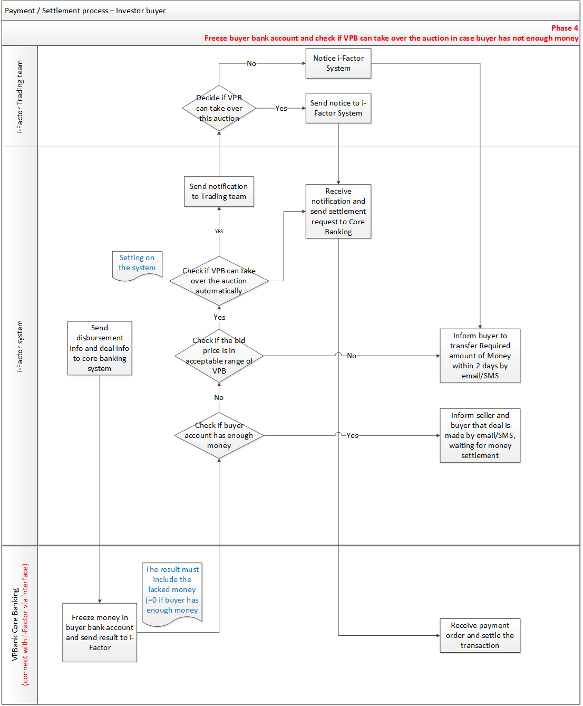Figure 7.4. Freeze buyer bank account and check if VPB can take over the auction in case buyer has not enough money*

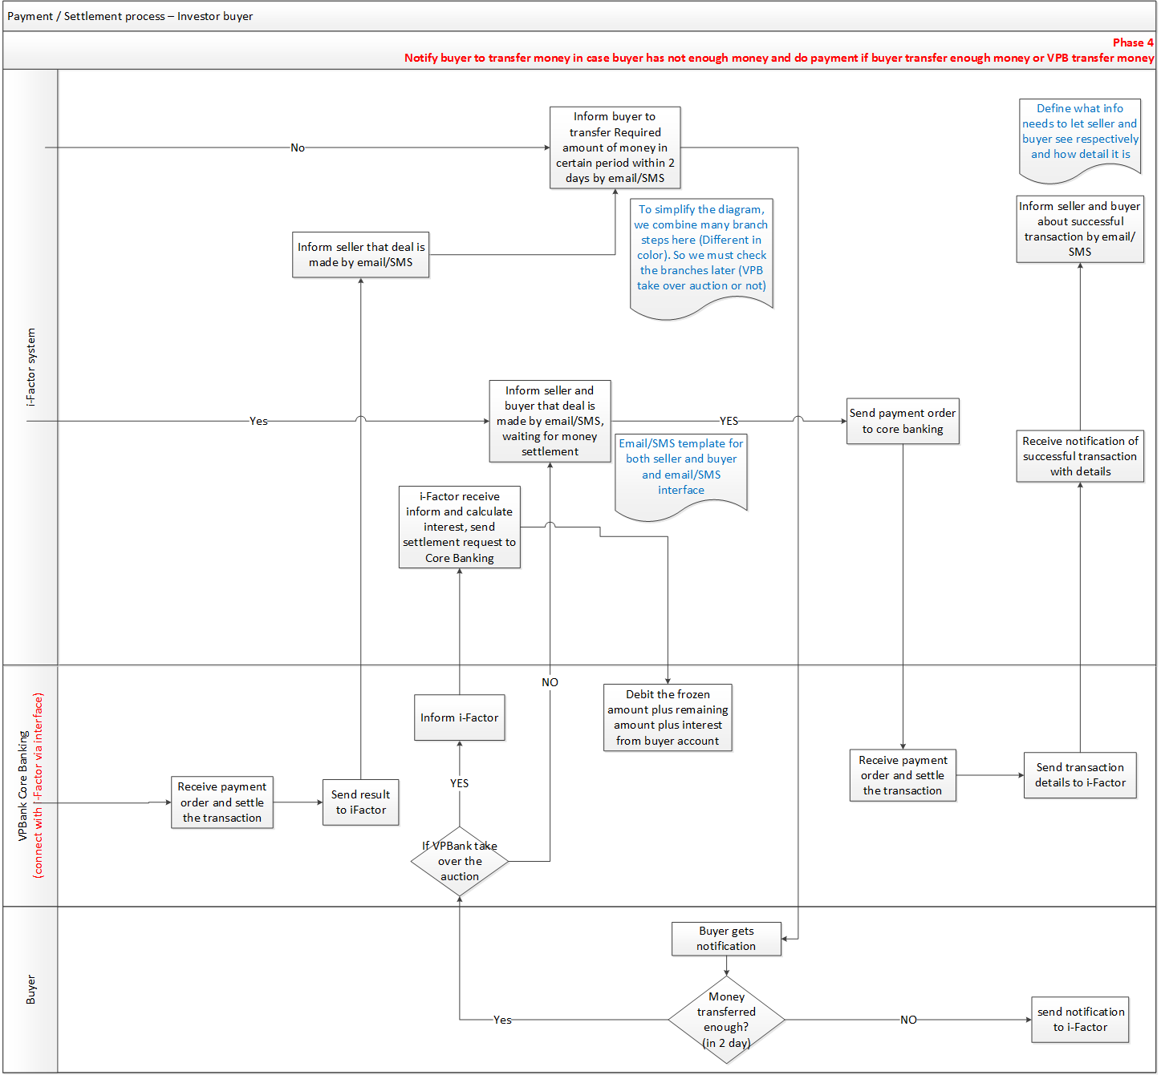 *Figure 7.5. Notify buyer to transfer money in case buyer has not enough money and do payment if buyer transfer enough money or VPB transfer money*  
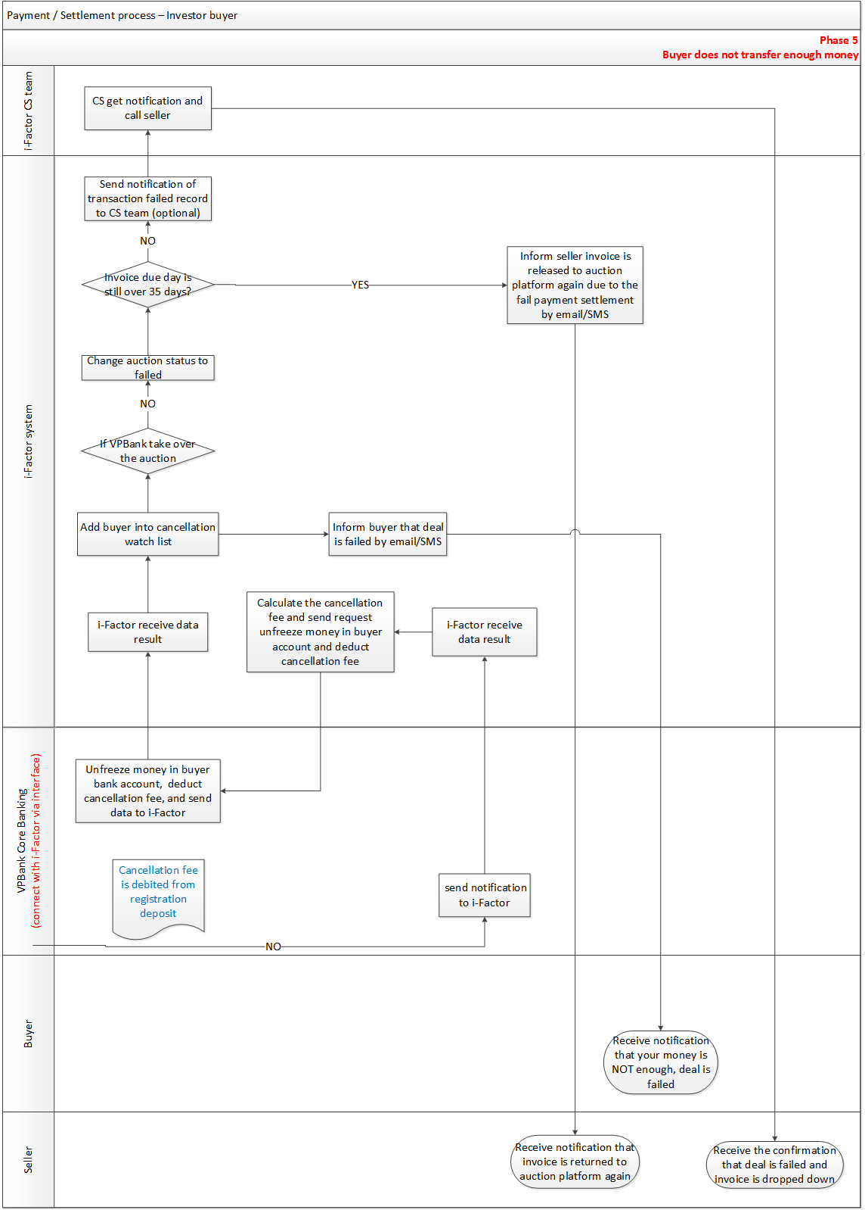

*Figure 7.6. Buyer does not transfer enough money*  
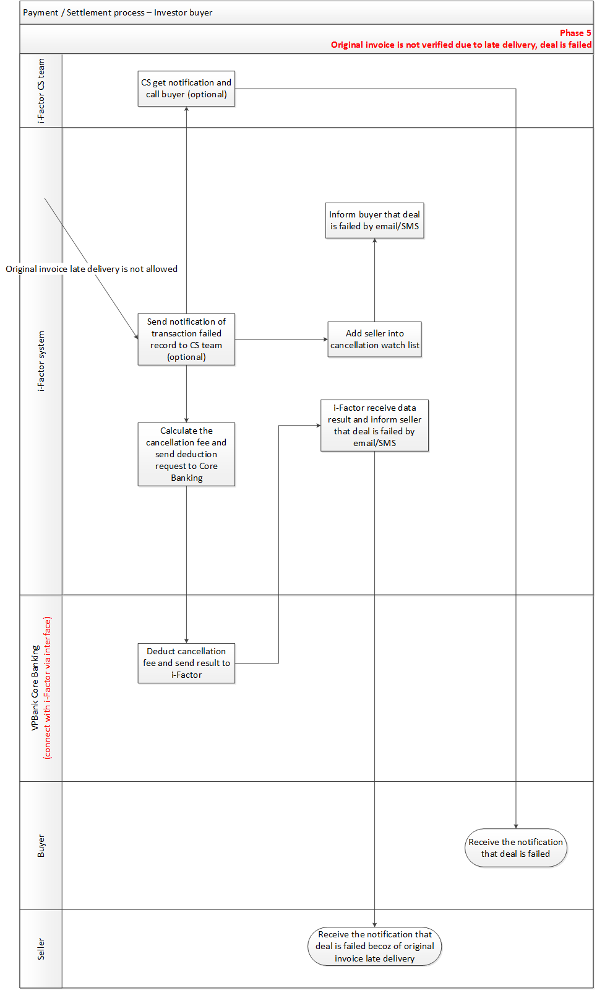  
*Figure 7.7. Original invoice is not verified. Deal is failed.*

# **Process description**

1. **Overall process (Figure 7.1)**  
   1. Start disbursement process  
   2. If sub-contract is not signed within 1 day from the day auction is dealt, transaction is failed  
   3. If sub-contract is signed within 1 day, continue to check verification status of original invoice.  
   4. If original invoice is not verified within 2 day from uploaded day, transaction is failed because seller does not delivery original invoice in time.  
   5. If original invoice is verified within 2 day from uploaded day, i-Factor check if buyer has enough money  
   6. If buyer has enough money, financing is transferred from buyer to seller. The disbursement process finish.  
   7. If buyer has not enough money, VPB decide they can take over the auction or not.  
   *8. If VPB decide to take over the auction, do transfer payment from VPB to seller first.*  
   8.1. If buyer does not transfer enough money within 2 days, VPB continue the auction with seller.  
   8.2. If buyer transfers enough money within 2 days, transfer financing amount from buyer to VPB account and charge interest from buyer. The disbursement process finish.  
   *9. If VPB does not take over the auction, waiting for the transferring from buyer*9.1. If buyer does not transfer enough money within 2 days, transaction is failed because buyer does not transfer enough money.  
   9.2. If buyer transfer enough money within 2 days, transfer financing amount from buyer to seller. The disbursement process finish.
2. **Phase 1: To calculate the disbursement amount**  
   1. I-Factor system receives deal details right after the auction is closed.  
   2. I-Factor system calculate the disbursement amount (Seller amount is financing amount deduct transaction fee. Buyer has transaction fee too).
3. **Phase 2: Check if sub-contract is signed (Figure 7.2)**  
   1. I-Factor check if seller and buyer has been signed the sub contract with VPB  
   *2. If seller and buyer has been signed the sub contract, continue to verify the original invoice (phase 3)*  
   *3. If seller or buyer has not been signed the sub contract, i-Factor Inform the verification team to wait for contract signing*  
   3.1. Verification team can decide to notify CS to call seller and buyer or not  
   *3.2. If buyer and seller sign the contract within 1 day, continue to verify the original invoice (phase 3)*  
   *3.3. If buyer/ seller does not sign the contract within 1 day, i-Factor add buyer/seller to cancellation*  
   3.3.1. i-Factor send cancellation fee charging request to Core Banking  
   3.3.2. Core Banking do the transaction and send result to i-Factor  
   3.3.3. i-Factor receive result and send buyer/seller notification about failed transaction via email/SMS
4. **Phase 3: To verify the original invoice (Figure 7.3)**1. I-Factor check if original invoice has been received and verified  
   2. *If original invoice has been received and verified, send disbursement request to Core Banking (Freeze buyer bank account request)*  
   3. *If original invoice has not been received or verified, i-Factor inform the underwriting team to verify the invoice*  
   3.1. Underwriting team receive inform and verify original invoice within 2 days since the day invoice is uploaded  
   *3.2. If the invoice is verified within 2 days, i-Factor send disbursement request to Core Banking, continue process of pre freeze the buyer account and checking if VPB can take over the auction (step 2)*3.3. *If the invoice is not verified within 2 days, underwriting team send notification to Customer Service (CS) team and request CS to call seller*3.3.1. CS get notification and call seller to ask for the reason of late invoice delivery.  
   3.3.2. CS get response from seller, write down the reasons and send to underwriting team supervisor.  
   3.3.3. Underwriting team make a final call to seller to decide to allow late original invoice delivery or not  
   *3.3.4. If original invoice late delivery is allowed, underwriting team wait seller 3 days maximum for original invoice verification  
   3.3.4.1. If original invoice is verified, i-Factor send disbursement request to Core Banking, continue process of pre freeze the buyer account and checking if VPB can take over the auction (step 2)  
   3.3.4.2. If original invoice is not verified, transaction is failed, i-Factor can send notification of transaction failed record to CS team (optional), continue process of transaction is failed because of seller.*  
   *3.3.5. If original invoice late delivery is not allowed, transaction is failed, i-Factor can send notification of transaction failed record to CS team (optional), continue process of transaction is failed because of seller.*
5. **Phase 4: Freeze buyer bank account and check if VPB can take over the auction in case buyer has not enough money (Figure 7.4)**1. I-Factor send disbursement information and deal information to Core Banking System (See step 2, phase 2)  
   2. Core Banking freeze money in buyer bank account and send result to i-Factor. The result must include the lacked money. If buyer has not enough money, the frozen amount is available amount in buyer bank account. If buyer has enough money, the frozen amount is financing amount of the auction plus transaction fee and the lacked money is equal 0.  
   3. I-Factor receive result from Core Banking and check if buyer has enough money (base on value of the lacked money in the result)  
   *4. If buyer account has enough money, i-Factor inform the seller and buyer that deal is made by email/SMS, notify them to wait for money settlement  
   5. If buyer account has not enough money, i-Factor check if the bid price is in acceptable range of VPB.*  
   *6. If the bid price is not in acceptable range of VPB, i-Factor inform buyer to transfer required amount of money within 2 days.*  
   *7. If the bid price is in acceptable range of VPB, check if VPB can take over the auction automatically  
   8. If VPB cannot take over the auction automatically, i-Factor send notification to Trading team.*  
   8.1. Trading team decide if VPB can take over this auction  
   *8.2. If VPB can take over the auction, trading team send notice to i-Factor System.*  
   8.2.1. i-Factor send settlement request to Core Banking System (Transfer money from VPB account to seller account. The value of transferring is value of the auction deduct transaction fee)  
   8.2.2 Core Banking receive the order and do settle the transaction.  
   *8.3. If VPB can’t take over the, trading team send notice to i-Factor System.*  
   8.3.1. i-Factor inform buyer to transfer required amount of money within 2 days.  
   *9. If VPB can take over the auction automatically, i-Factor sent settlement request to Core Banking System and repeat step from 8.2.1 to 8.3.1*
6. **Phase 5: Notify buyer to transfer money in case buyer has not enough money and do payment if buyer transfer enough money or VPB transfer money (Figure 7.5)**  
   1. Incase VPB took over the auction, Core Banking receive payment order and do settle the transaction (Step 7.2.2 phase 3)  
   1.2. Core Banking send result to i-Factor  
   1.3. I-Factor inform seller that deal is made by email/SMS  
   1.4. I-Factor inform buyer to transfer required amount of money within 2 days  
   2. Incase VPB did not take over the auction (step 6, 7.3.1 phase 3), i-Factor inform buyer to transfer required amount of money within 2 days (Note that if buyer has not enough money, i-Factor always inform buyer to transfer money regardless VPB take over the auction or not)  
   3. Buyer get notification and transfer money  
   *4. If buyer transfer enough money within 2 days*  
   *4.1. If VPB take over the auction*  
   4.1.1. Core banking inform i-Factor about the transfer (incase Core Banking does not support this function, i-Factor need check the transferring periodically)  
   4.1.2. i-Factor receive inform and calculate interest, send settlement request to Core Banking (Total amount is frozen amount (step 2 phase 3) plus remaining amount plus interest  
   4.1.3. Core banking debit money from buyer account and credit VPB account.  
   *4.2. If VPB does not take over the auction*  
   4.2.1. i-Factor inform seller and buyer that deal is made by email/SMS, waiting for money settlement  
   4.2.2. i-Factor send payment order to Core Banking (Transfer money from buyer to seller)  
   4.2.3. Core Banking receive payment order and settle the transaction  
   4.2.4. Core banking send result back to i-Factor  
   4.2.5. i-Factor receive notification and inform seller and buyer about successful transaction by email/SMS  
   *5. If buyer does not transfer enough money within 2 days*  
   5.1. i-Factor receive notification about that.
7. **Phase 6: Buyer does not transfer enough money (Figure 7.6)**1. If buyer does not transfer enough money, i-Factor receive notification about that (Step 5.1 phase 4)  
   2. I-Factor calculate the cancellation fee and send request to unfreeze money in buyer account and deduct cancellation fee  
   3. Core banking receive request and unfreeze money in buyer bank account, deduct buyer cancellation fee and send result to i-Factor.  
   4. I-Factor receive result and add buyer to cancellation watch list  
   5. I-Factor inform buyer that deal is failed by email/SMS  
   6. If VPbank does not take over the auction  
   6.1. i-Factor change auction status to failed  
   6.2. If invoice due date is still over 35 days, i-Factor inform seller invoice is released to auction platform again due to the failed payment from buyer by email/SMS  
   6.3. If invoice due date is below 35 days, i-Factor send notification of transaction failed record to CS team (optional)  
   6.3.1. CS get notification and call the seller to inform about failed transaction
8. **Phase 7: Original invoice is not verified. Deal is failed (Figure 7.7)**1. If original invoice late delivery is not allowed (step 3.3.5, phase 2), i-Factor can send notification of transaction failed record to CS team (optional)  
   2. CS receive notification and call buyer  
   3. I-Factor add seller into cancellation watch list  
   4. I-Factor inform buyer that deal is failed by email/SMS  
   5. I-Factor calculate the cancellation fee and send deduction request to Core Banking  
   6. Core Banking deduct cancellation fee and send result to i-Factor  
   7. I-Factor receive result and inform seller that deal is failed by email/SMS

# **Business rules**

1. Email/SMS template must be defined for each situation.
2. Period for verifying invoice should be defined in the system (by VPBank).
3. Period for waiting buyer transfer money should be defined in the system (by VPBank).
4. The formula of transaction fee, cancellation fee calculation should be set in i-Factor system. The fee must be calculated automatically.
5. The period for transferring money from buyer should be configured automatically in system.

# **Inputs and Outputs**

**Chapter 8 Payment Process for Debtor**

* 1. **Reminding phase**
  2. **Function description**

That process is designed to have early alarm to Seller about expectation date is coming. This process is divided into 2 phase:

- Phase 1: send remind notification 5 days before to expectation date.

- Phase 2: send remind notification 1 days before to expectation date.

* 1. **Operation process**



* 1. **Process description**

Phase 1 – 5 days remind

1. I-Factor periodically find the invoices that theirs exactly remaining day before expectation date is 5 working days  
2. I-Factor send notification to Seller by email/SMS to request to contact with debtor for payment   
3. I-Factor sends notification to i-Factor CS team. Then the CS calls the seller to notice to contact the debtor.  
Phase 2 – 1 day remind

1. I-Factor periodically find the invoices that theirs exactly remaining day before expectation date is 1 working day.  
2. I-Factor send notification to Seller by email/SMS to request to contact with debtor for payment   
3. I-Factor sends notification to i-Factor CS team. Then the CS calls the seller to notice to contact the debtor.

* 1. **Business rules**
  2. **Inputs and Outputs**
  3. **Settlement phase**

1. 1. **Function description**

That process is designed for settlement between Bank – Seller, Bank – Buyer and Bank - Debtor. At the expectation date registered by Seller before, Debtor will transfer money to Seller’s account at VPBank (a special account). Platform will do the settlement to others: Buyer’s account, Seller’s account.

* 1. **Operation Process**



* 1. **Process description**

1. Periodically find the invoices that overdue 10 days than expectation date. This checking is automatically daily by system. After that update the seller list to watch list.

2. Based on reconciliation report, periodically find received amount on Seller’s working account. After that it is checking condition ‘what if Received amount matches with Invoice ID’.

2.1 If ‘No’, i-Factor system send result to i-Factor Payment team. This team receive and manually check case by case. Finally, i-Factor Payment team updates into system case by case as the time they got result.

2.2 If ‘Yes’, i-Factor automatically calculate the amount of interest earning, late payment penalty charge (if any). And move to the next step to check condition ‘what if the invoice is paid 100% by debtor’

*2.2.1 If ‘Yes’, i-Factor system send Settlement request to Core Banking.*

2.2.1.1 Core Banking will do settlement and send back result to i-Factor system.

2.2.1.2 i-Factor platform receives data result.

2.2.1.3 i-Factor platform updates settlement status on system.

2.2.1.4 Together system will inform Seller and Buyer about successful transaction by email/SMS.

*2.2.2* *If ‘No’, continue check condition ‘ what if the invoice is paid less than 100% but enough for minimal require’*

*2.2.2.1 If ‘Yes’, i-Factor system send Settlement request to Core Banking.*

*2.2.2.2* Core Banking will do settlement and send back result to i-Factor system.2.2.2.3 i-Factor platform receives data result.

2.2.2.4 i-Factor platform updates settlement status on system.

2.2.2.5 Together system will inform Seller and Buyer about successful transaction by email/SMS.

*2.2.2.2 If ‘No’, i-Factor* send notification to CS if invoice is at expectation date. Together, it creates collection profile, inform collection team.

2.2.2.3 After receive notification, CS call the seller immediately.

2.2.2.4 Collection team receives profile and follow Collection process by VPBank. This step is parallel with CS team.

3. Periodically find the invoices reaches their expectation date. This checking is automatically daily by system. After that, i-Factor send request Core Banking to check the transaction status automatically.

3.1 Core Banking right after check the invoice payment and send result to i-Factor.

3.2 i-Factor system will calculate the amount of interest earning, late payment penalty charge (if any). After that the workflow is processing is as the same as step 1.2.2

* 1. **Business rules**

1. Each Seller has one special unique account for receiving money from debtor. Seller can inquiry the balance but cannot withdraw from this account.
2. Seller’s working account is created by Bank system to control the cash flow in/out as disbursement or settlement.
3. The debtor was informed to transfer invoice amount to that account as Seller/bank request.
4. Seller is unable to withdraw money from this account.
5. The balance of Working account is enable to update daily or by request to platform.
   1. **Inputs and Outputs**
   2. **Collection Management process**

8. 1. **Function description**

For all the cases that debtor did not transfer money or Seller together did not buy back the invoice and pay back money to Seller’s working account. As the result of debtor does not transfer money, Buyer did not receive initial investment and/or interest earning. I-Factor system creates the Collection profile and send to Collection team of Bank to follow. After collection processing by Bank, the result will be updated in system. This process is designed to guide how to update result into platform.

* 1. **Operation process**



* 1. **Process description**

1. After finish the Collection process, the Collection team inform result to i-Factor.

2. i-Factor system receives result and update system. After that it is checking condition ‘what if successful collection?’

3.1. If ‘Yes’, i-Factor system calculate the amount of interest earning, late payment penalty charge (if any).

3.1.1. i-Factor system send Settlement request to Core Banking.

3.1.2. Core Banking do settlement and send result to i-Factor.

3.1.3. i-Factor system receive result and update status of auction.

3.1.4. Platform send email/SMS to inform buyer/seller.

3.2. If ‘No’, Platform send email/SMS to inform buyer/seller about failed collection. Buyer will take over the document and collection profile.

* 1. **Business rules**
  2. **Inputs and Outputs**

**Chapter 9 other functions for seller/buyer**

1, calculator

the detail as below,



2. rules

For the profit calculator, need to have the following inputs:

A.Invoice amount

B. Financing percentage

C. Invoice Term (by number of days)

D. Monthly interest rate

The output should be:

A. Amount needs to be transferred by Buyer (Financing amount plus transaction fees) = Invoice Amount*Financing percentage*(1+0.005)

B. Estimated Profit from interest if the debtor pays on the expected payment date = Invoice Amount*Financing percentage*(Monthly interest rate/30)*Invoice Term

For the cost calculator, the inputs are the same, and the output should be:

A.  Amount to be received by seller (Financing amount minus transaction fees) = Invoice Amount*Financing percentage*(1-0.015)

B. Estimated Interest amount if the debtor pays on the expected payment date = Invoice Amount*Financing percentage*(Monthly interest rate/30)*Invoice Term